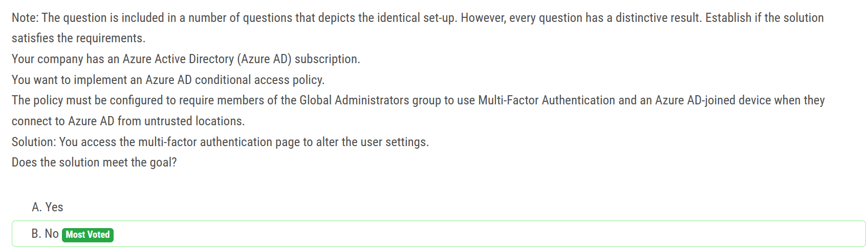

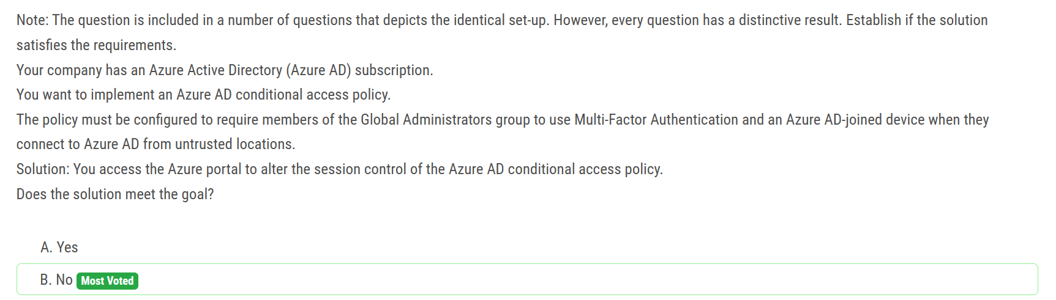

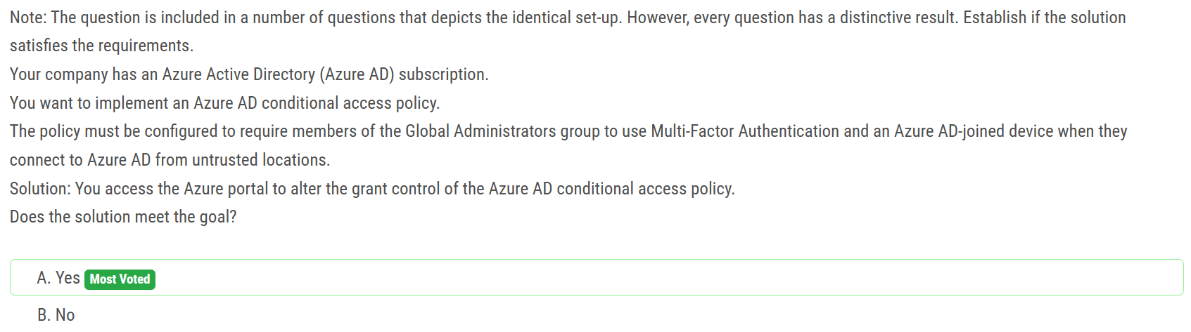

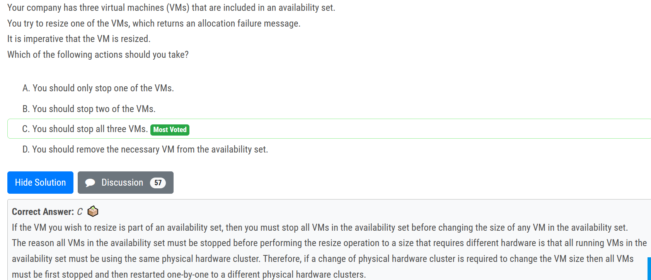

When a VM is running it is deployed to a physical server. The physical servers in Azure regions are grouped together in clusters of common physical hardware. A running VM can easily be resized to any VM size supported by the current cluster of hardware supporting the VM. You can determine which VM sizes are supported by the current physical hardware hosting your VM

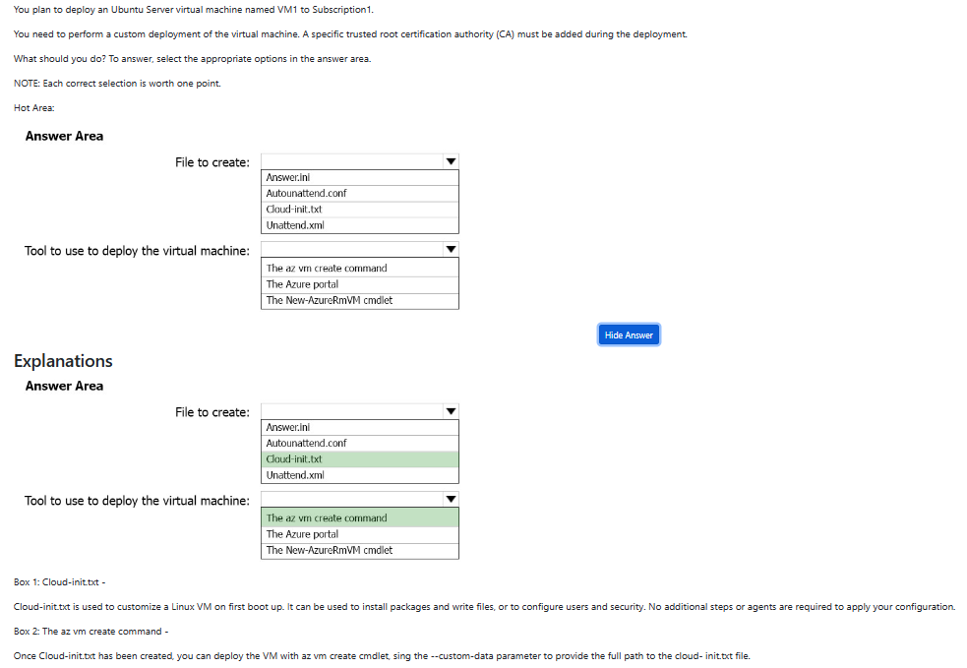

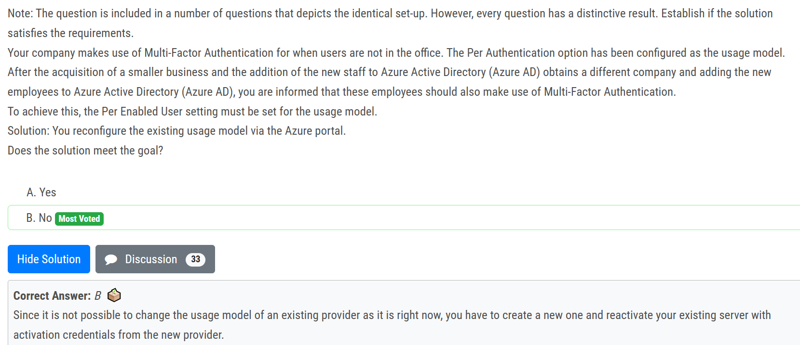

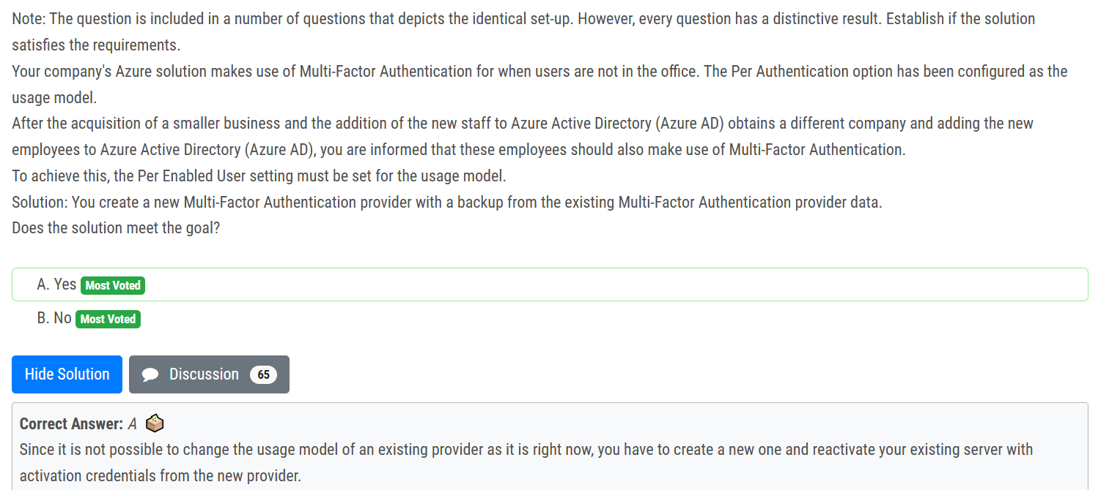ans is A

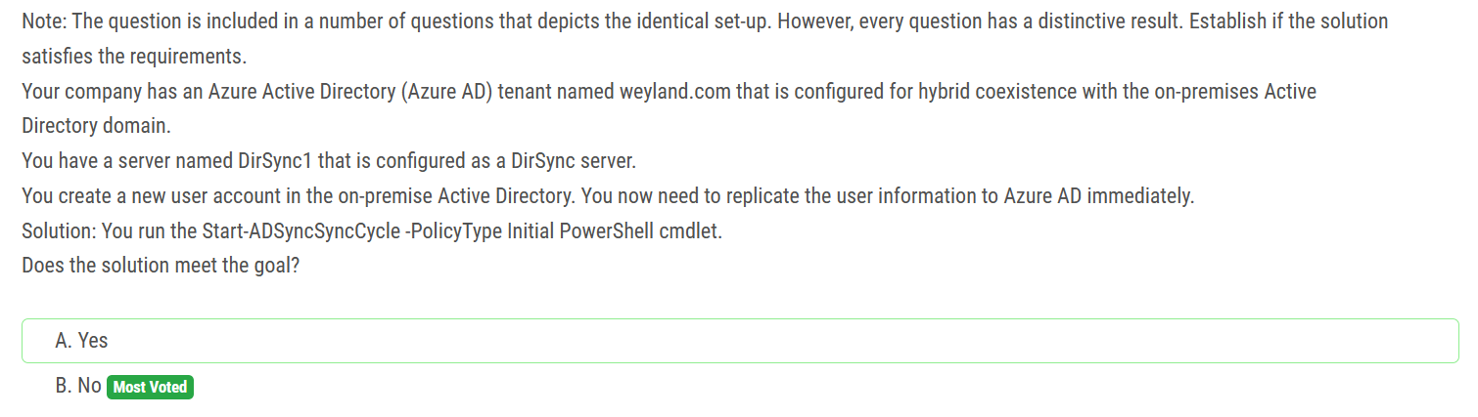

Answer is B ( No ) Initial will perform a full sync and add the user account created but it will take time, Delta, will kick off a delta sync and bring only the last change, so it will be "immediately" and will fulfill the requirements.

The answer is A (YES), since the question did not mention the initial sync has been already done. A is correct

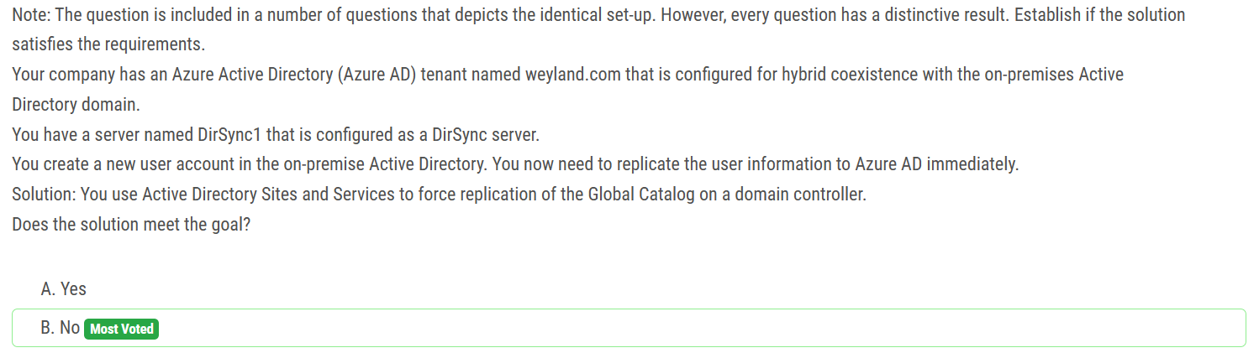

On a server with Azure AD Connect installed, navigate to the Start menu and select AD Connect, then Synchronization Service.

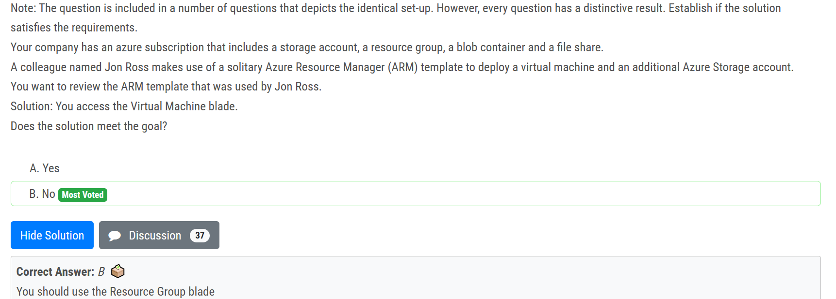

Answer must be No, as questions talk about VM and storage account both which can only be reviewed at RG level.

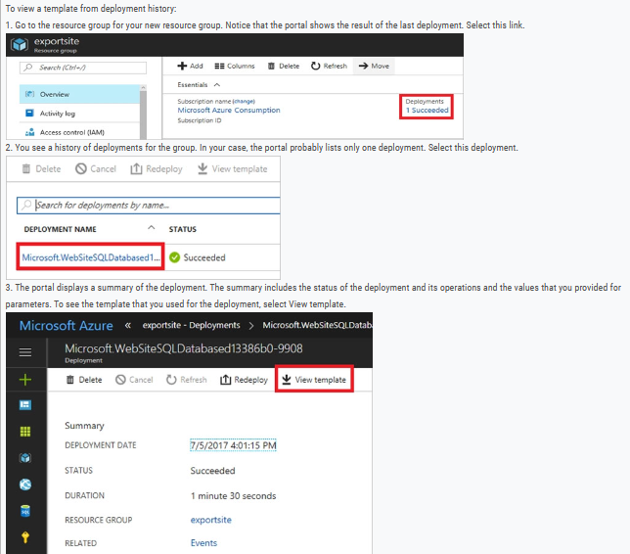

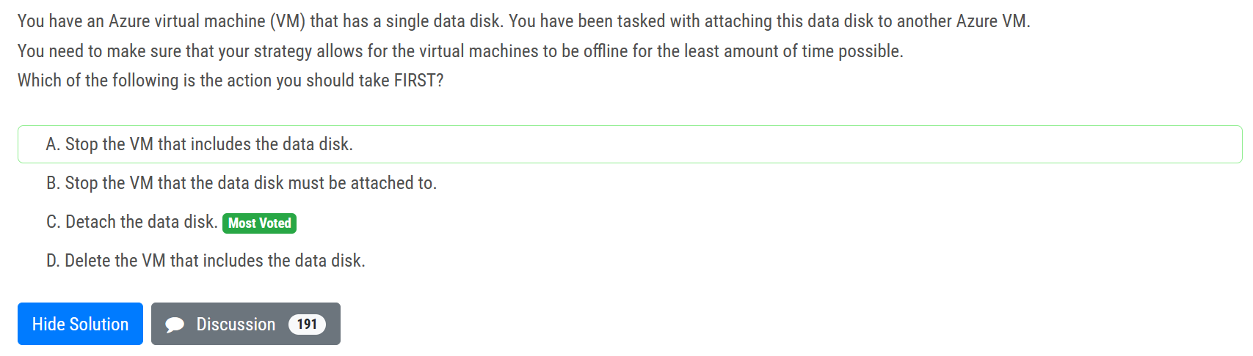

Ans is C

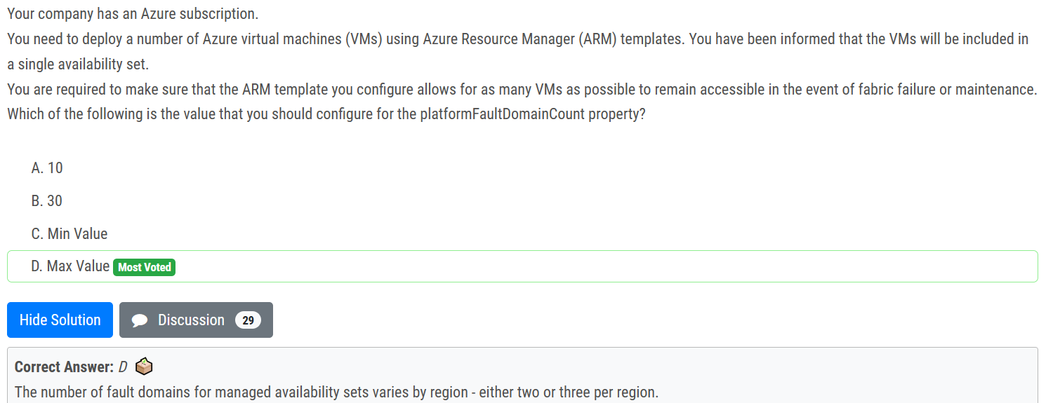

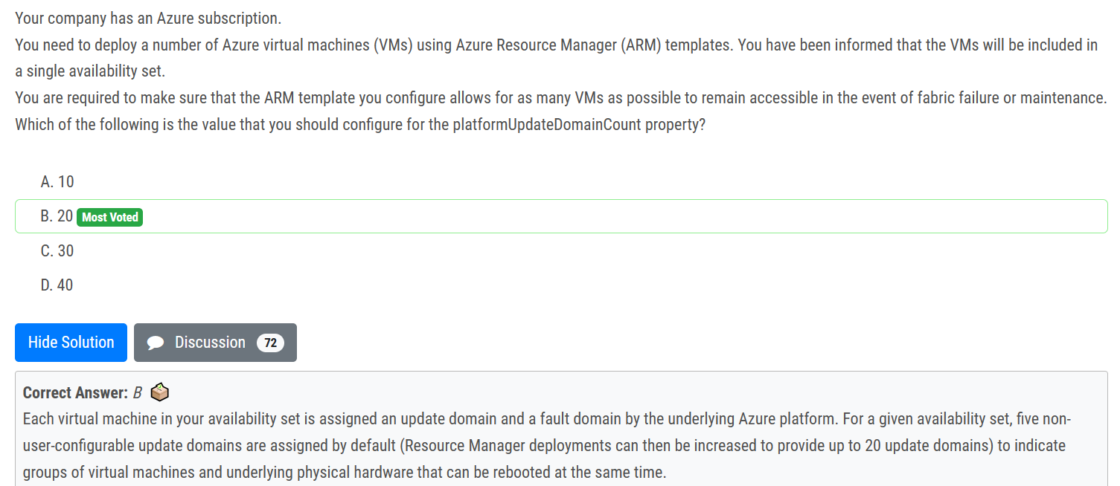

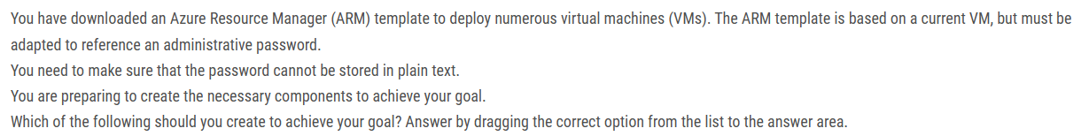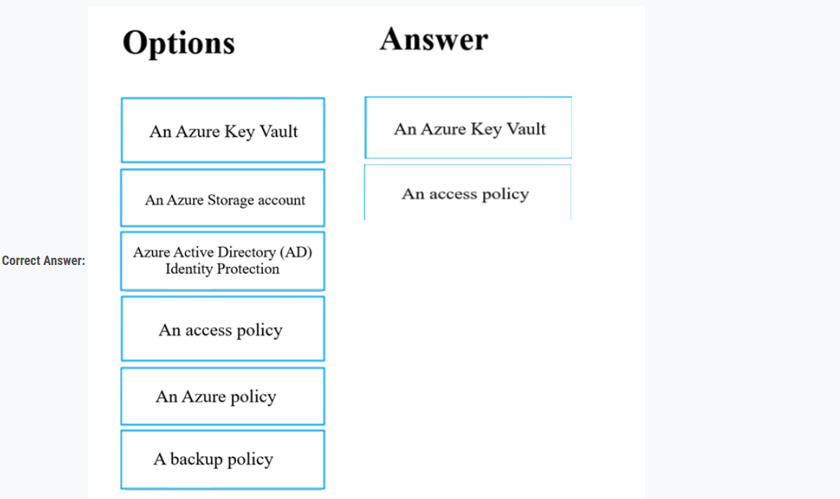

RBAC can be used instead of access policy

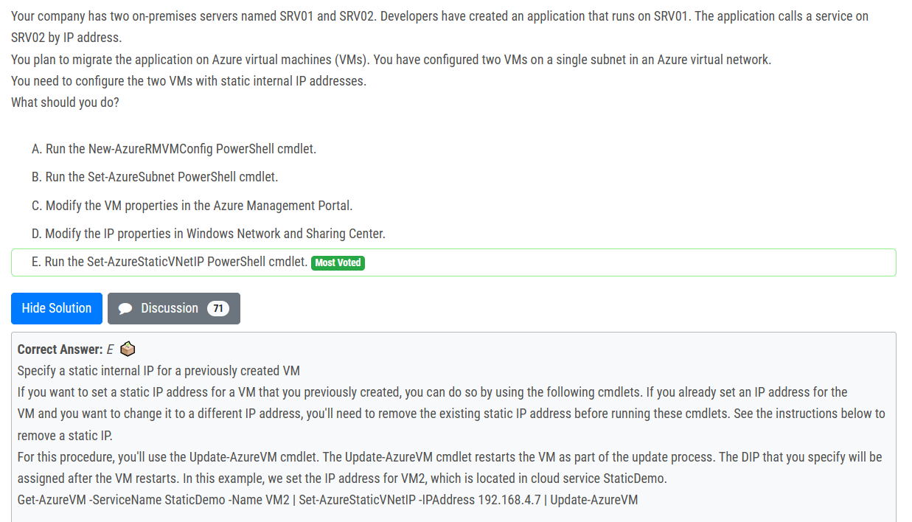

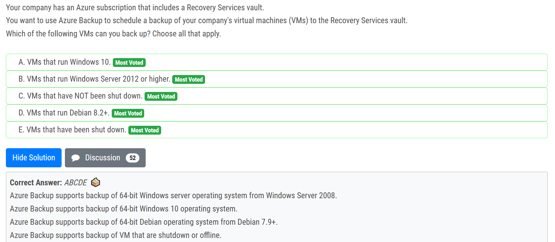

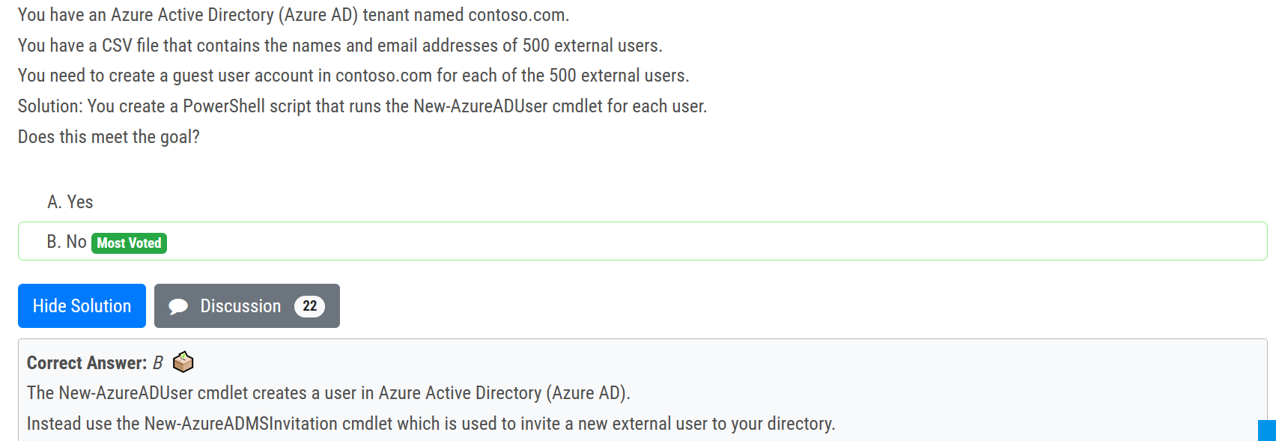

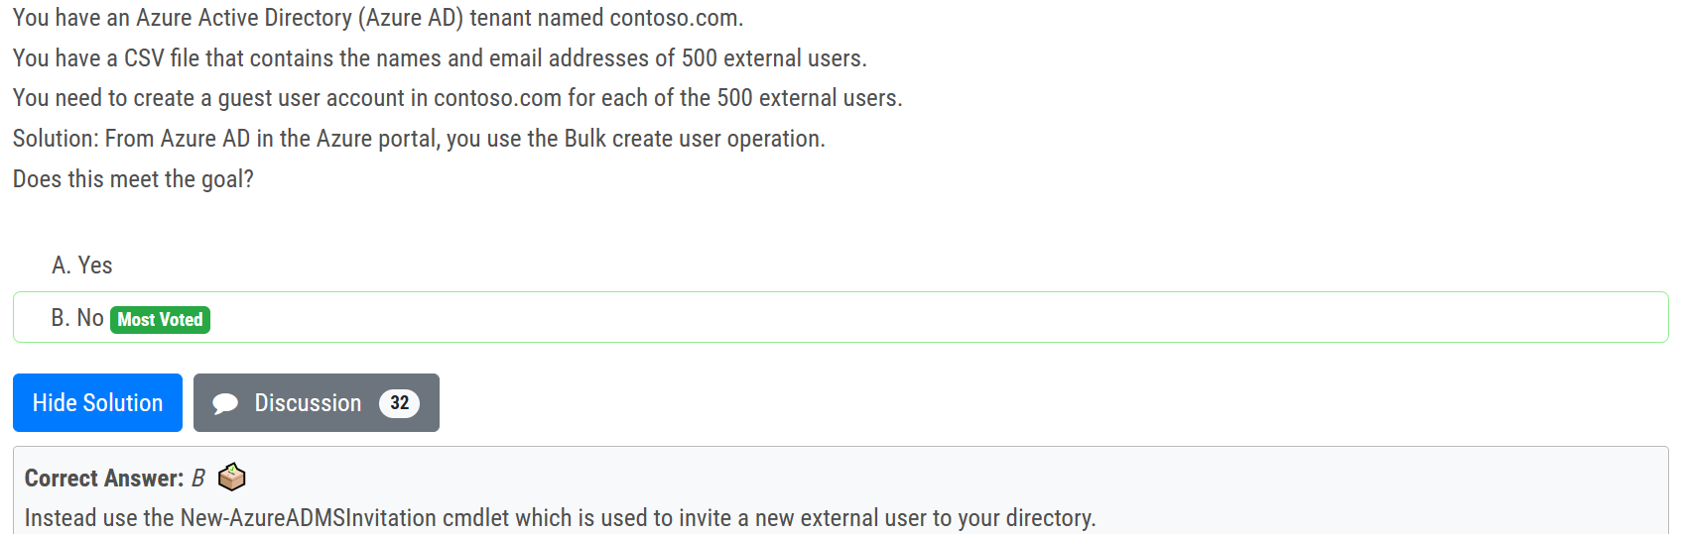

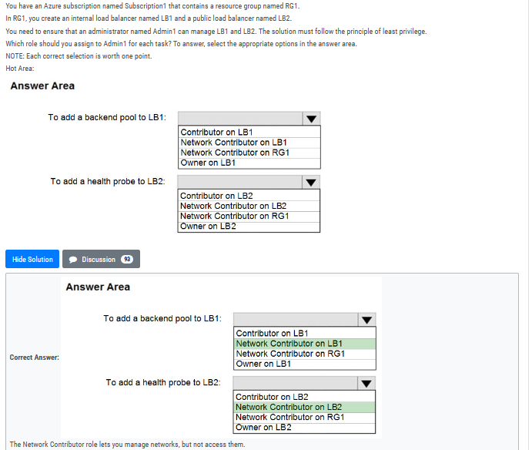

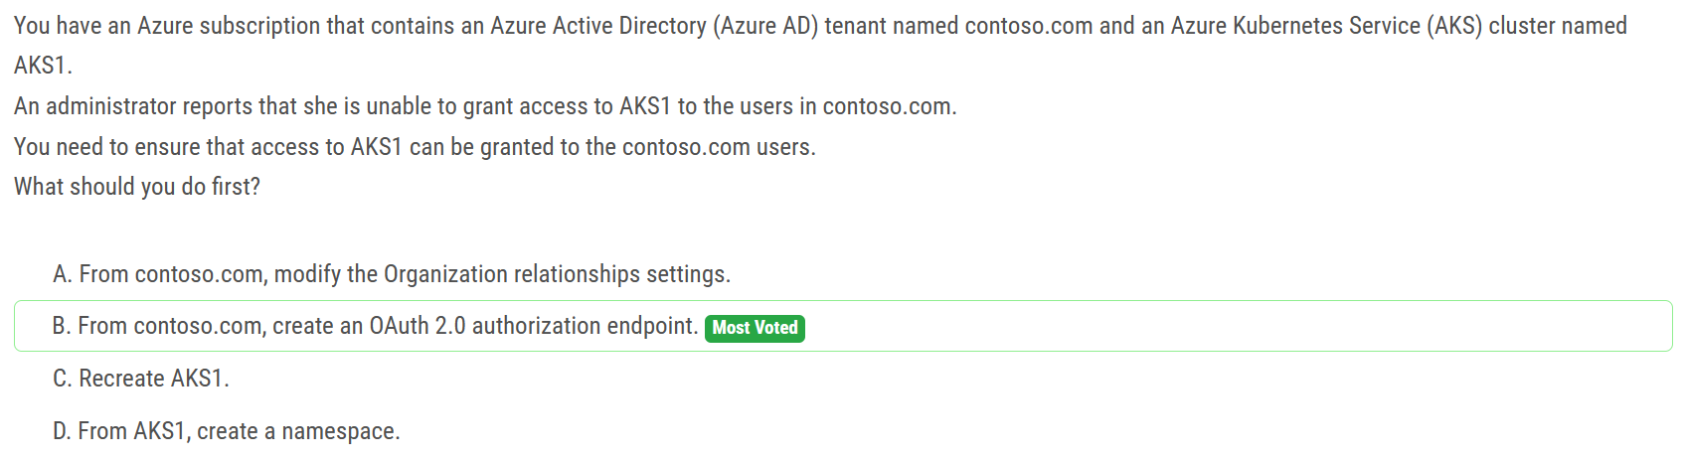

Cluster administrators can configure Kubernetes role-based access control (Kubernetes RBAC) based on a user's identity or directory group membership. Azure AD authentication is provided to AKS clusters with OpenID Connect. OpenID Connect is an identity layer built on top of the OAuth 2.0 protocol

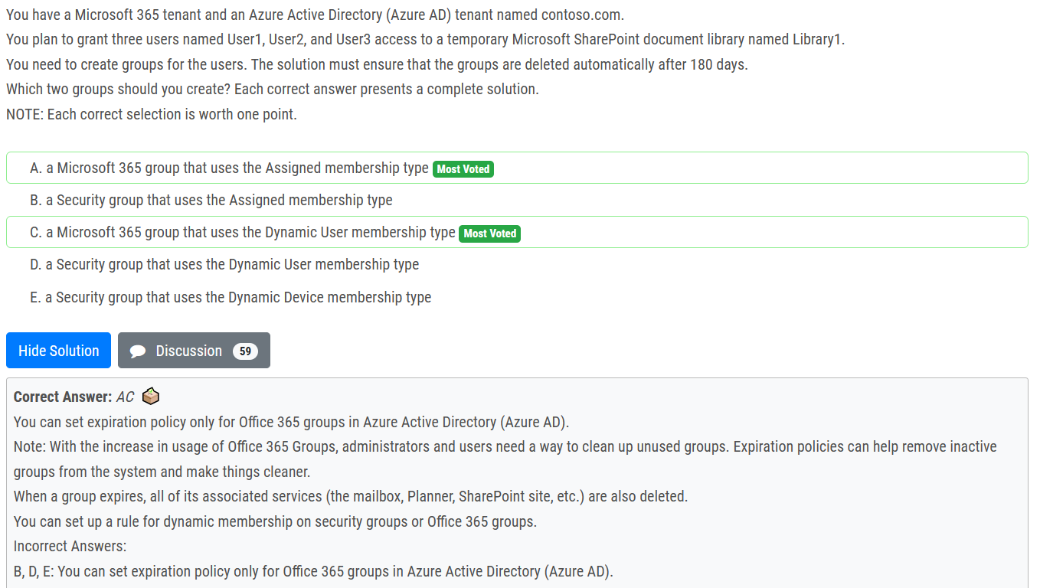

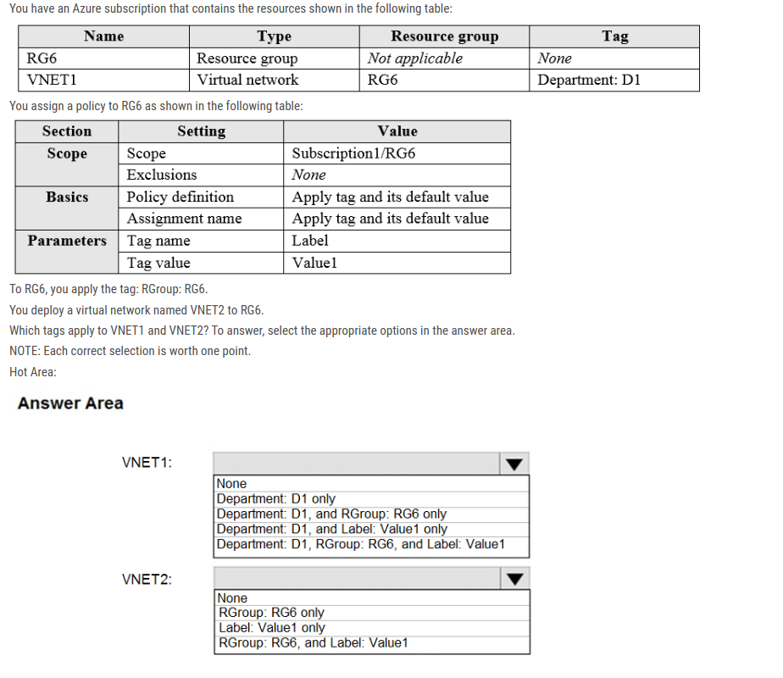

VNET1 will only have Department: D1 tag & VNET 2 will only have Label : Value1 tag, By default, this assignment of newly create policy will only take effect on newly created resources. Existing resources can be updated via a remediation task after the policy is assigned.

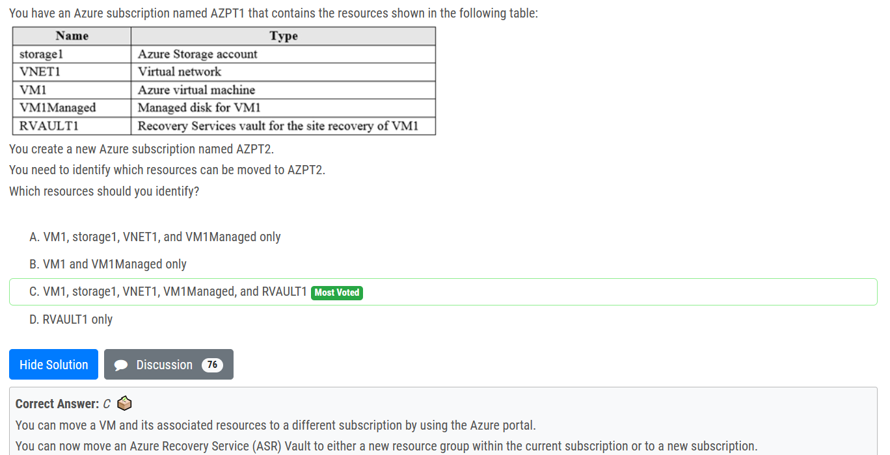

Moving a resource only moves it to a new Resource Group or Subscription. It doesn't change the location of the resource.

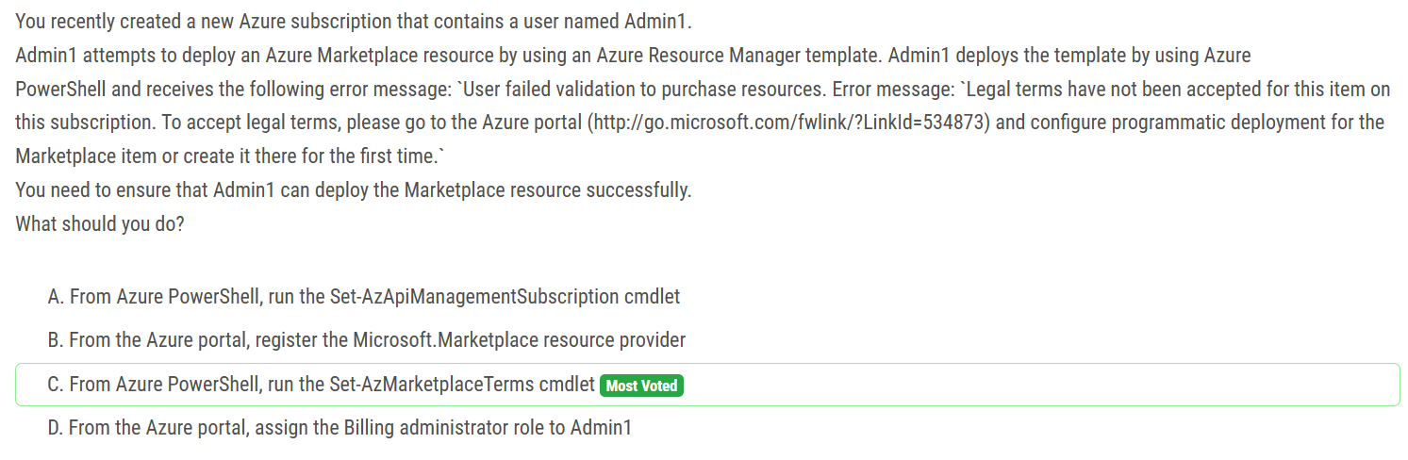

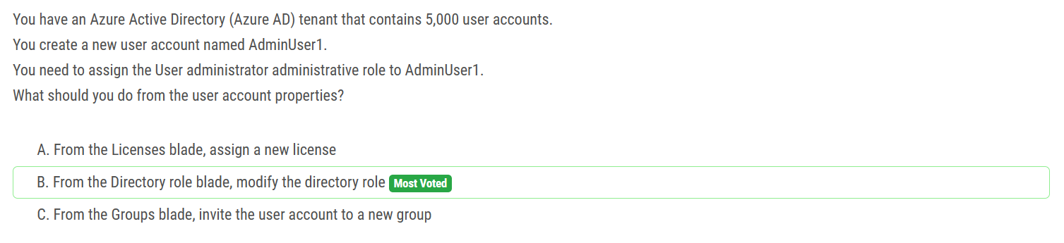

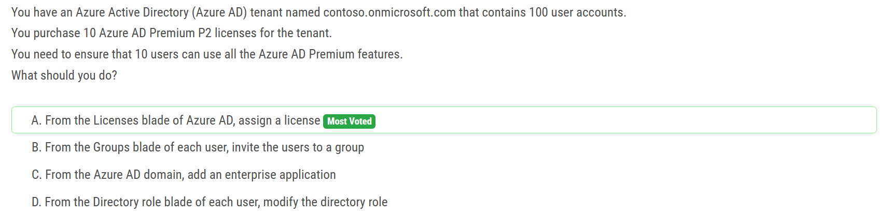

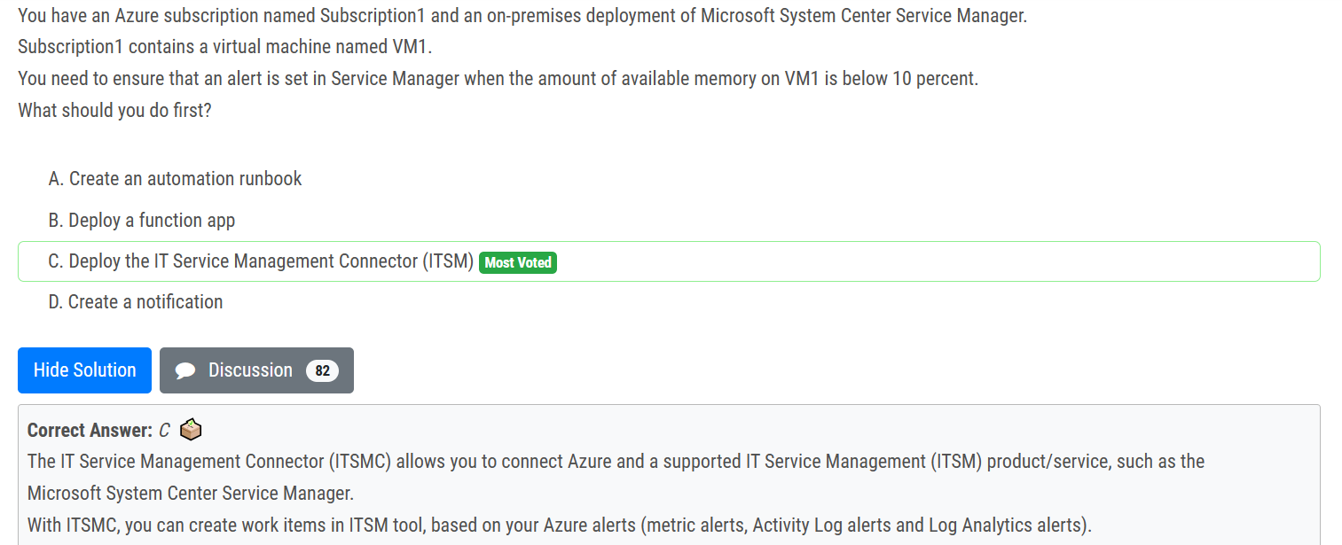

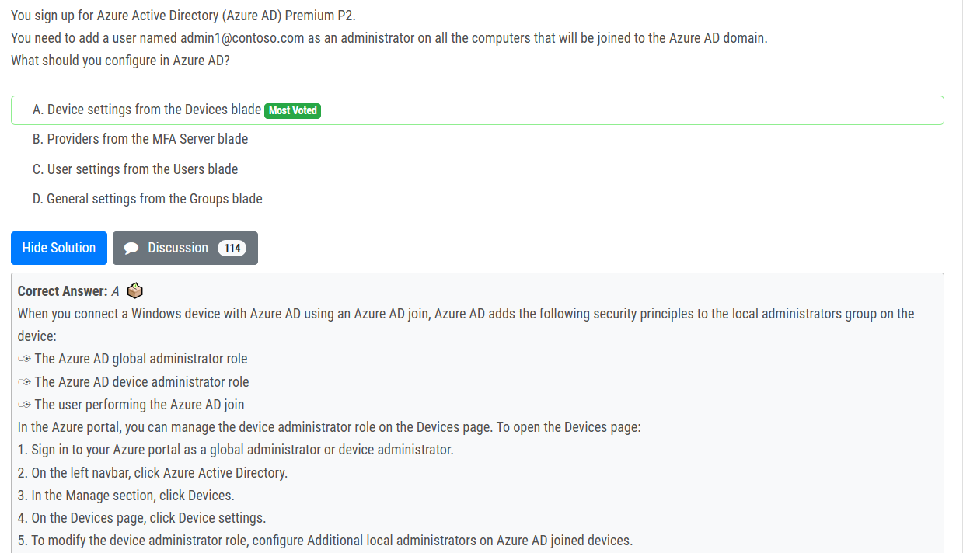

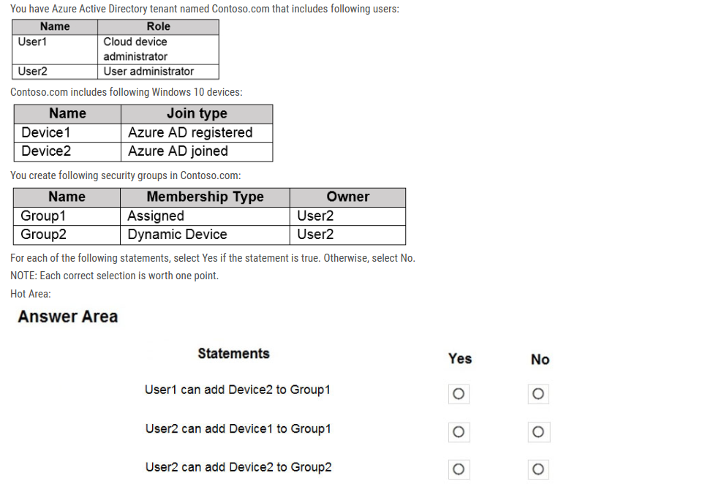

N: Cloud device admin can't add device to a group using this role.

Y: User2 is the owner of Group1.

N: Group2 is a dynamic group.

Cloud device admin : "Users in this role can enable, disable, and delete devices in Azure AD and read Windows 10 BitLocker keys (if present) in the Azure portal. The role does not grant permissions to manage any other properties on the device."

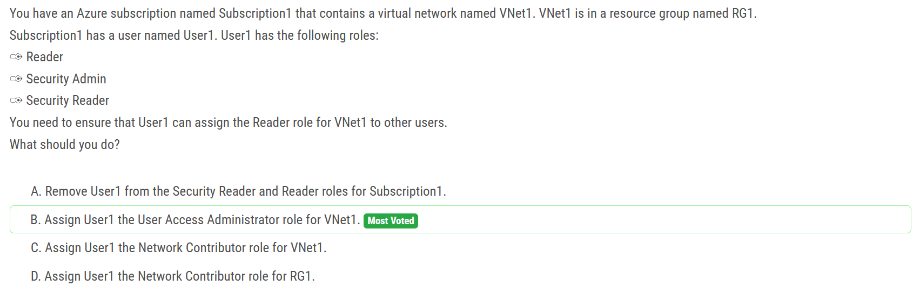

The User Access Administrator role allows users to manage user access to Azure resources, but it does not provide the ability to assign roles to other users. The Network Contributor role grants users the ability to manage networks, but it also does not provide the ability to assign roles to other users.

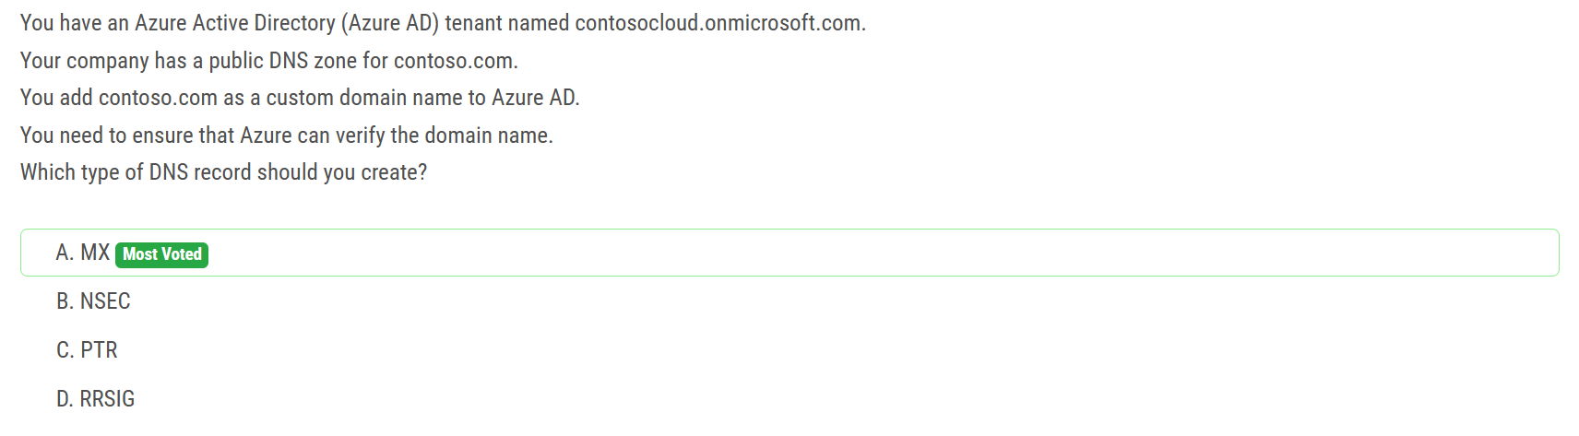

TXT and MX are valid answers.

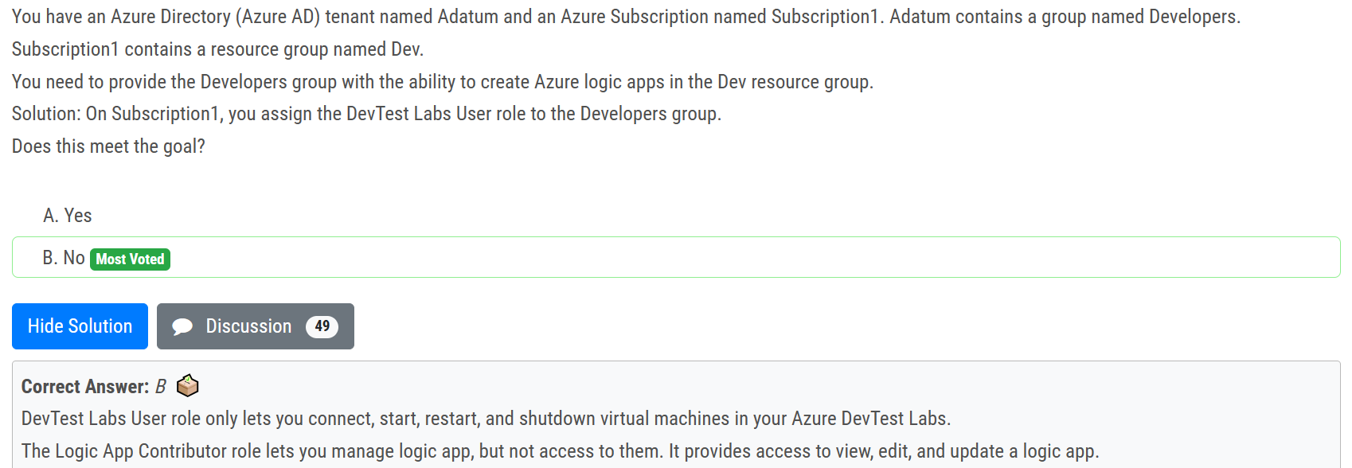

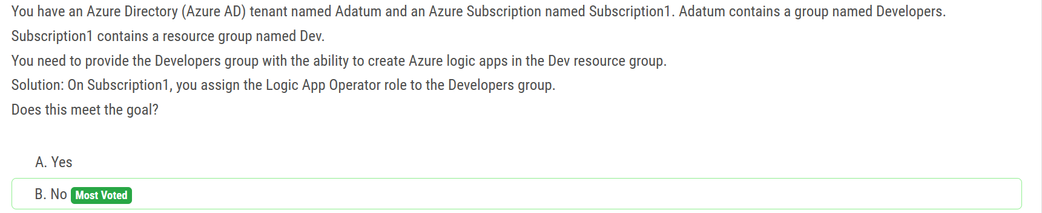

Logic App Operator - Lets you read, enable, and disable logic apps, but not edit or update them. Logic App Contributor - Lets you create, manage logic apps, but not access to them.

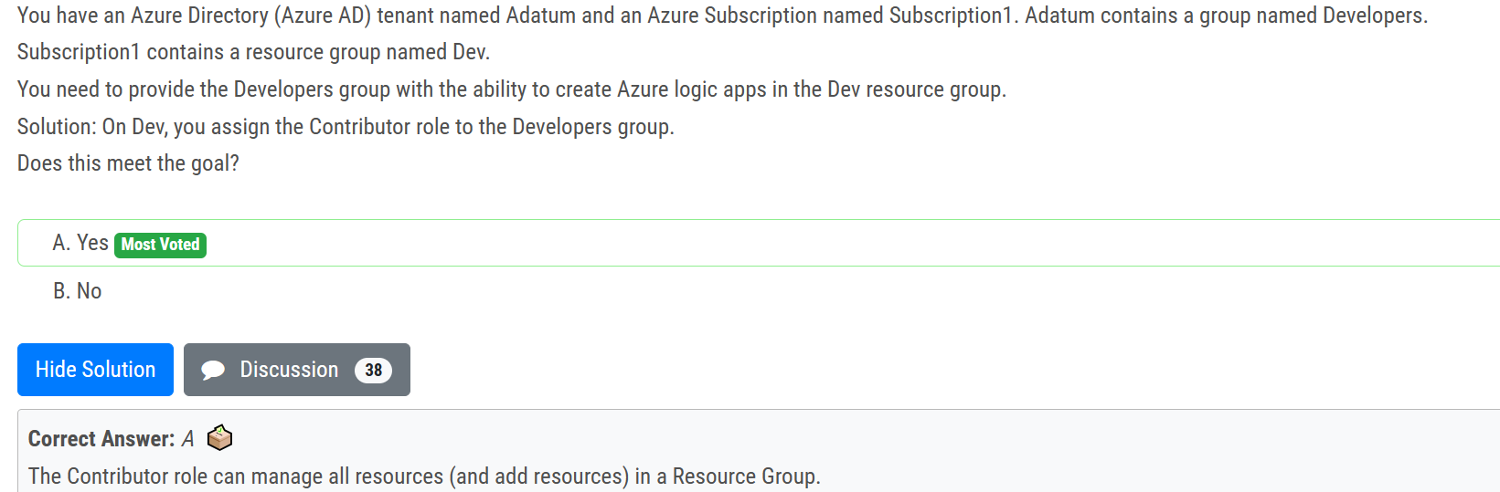

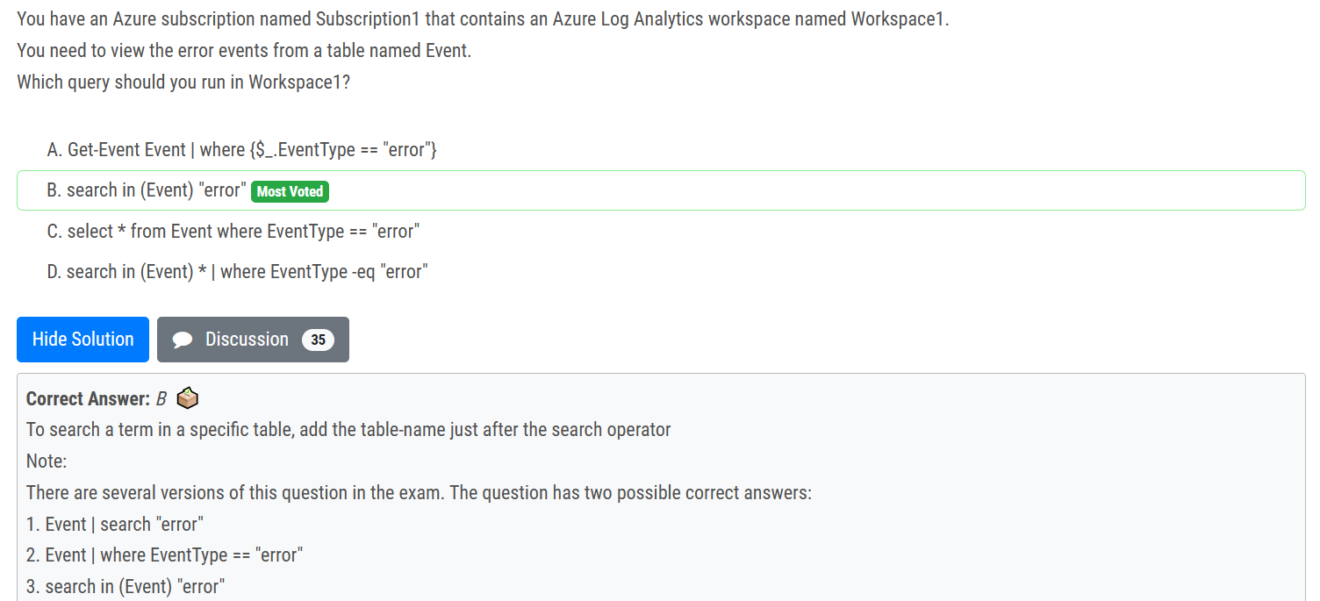

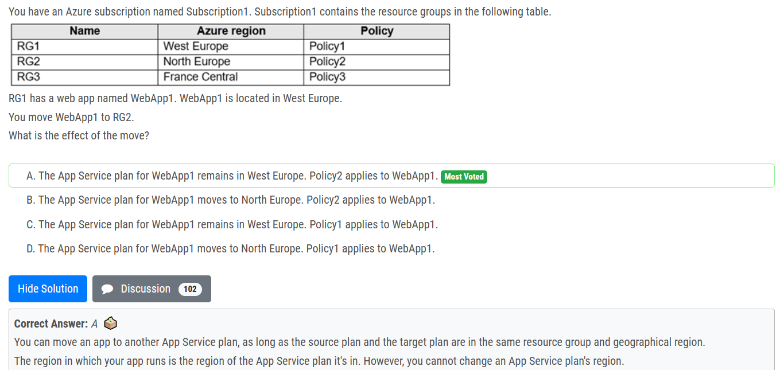

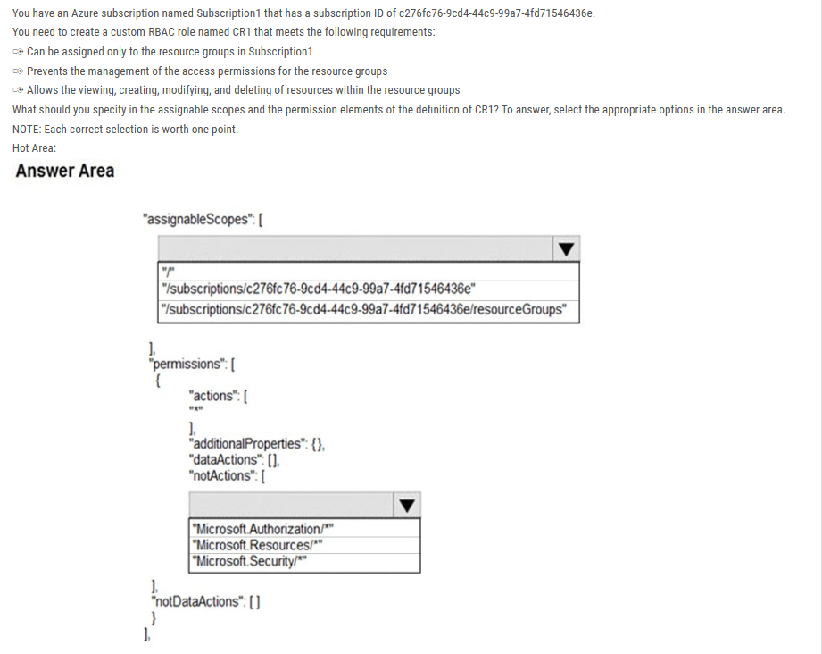

ans

“/subscriptions/c276fc76-9cd4-44c9-99a7-4fd71546435e”

“Microsoft.Authorization/”

First part should be "/Subscription/subcription_id" only. There is nothing called "resourceGroups" only or "resourceGroups/*" . You can specify either a subscription, specific resource group, management group or specific resource. for example it should "/subcription/subcription_id/resourceGroups/resource_group_name"

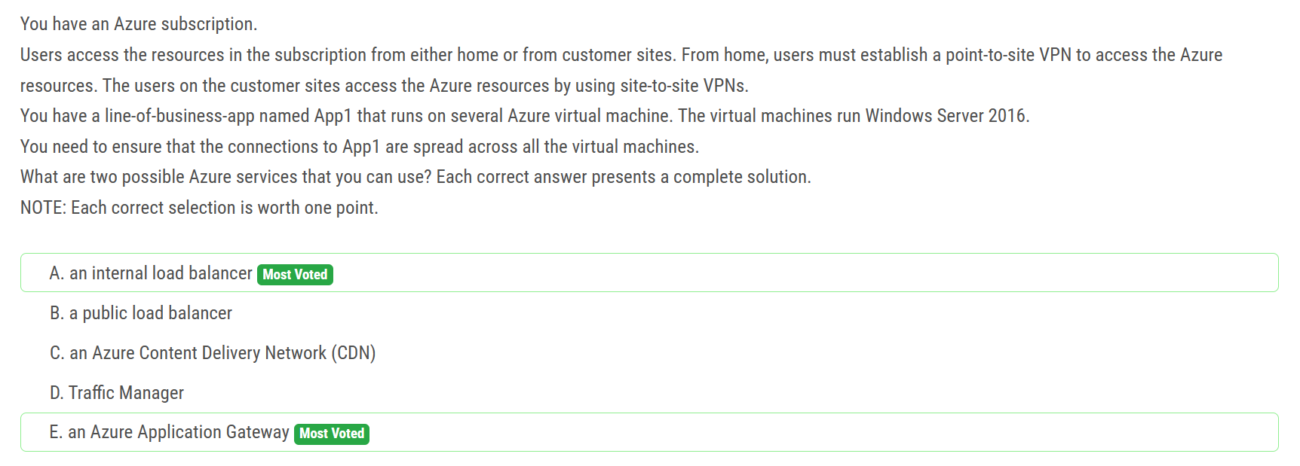

Correct Answer: A and E A: The customer sites are connected through VPNs, so an internal load balancer is enough. B: The customer sites are connected through VPNs, so there's no need for a public load balancer, an internal load balancer is enough. C: A CDN does not provide load balancing for applications, so it not relevant for this situation. D: Traffic manager is a DNS based solution to direct users' requests to the nearest (typically) instance and does not provide load balancing for this situation. E: Azure Application Gateway is a valid option, as it provides load balancing in addition to routing and security functions

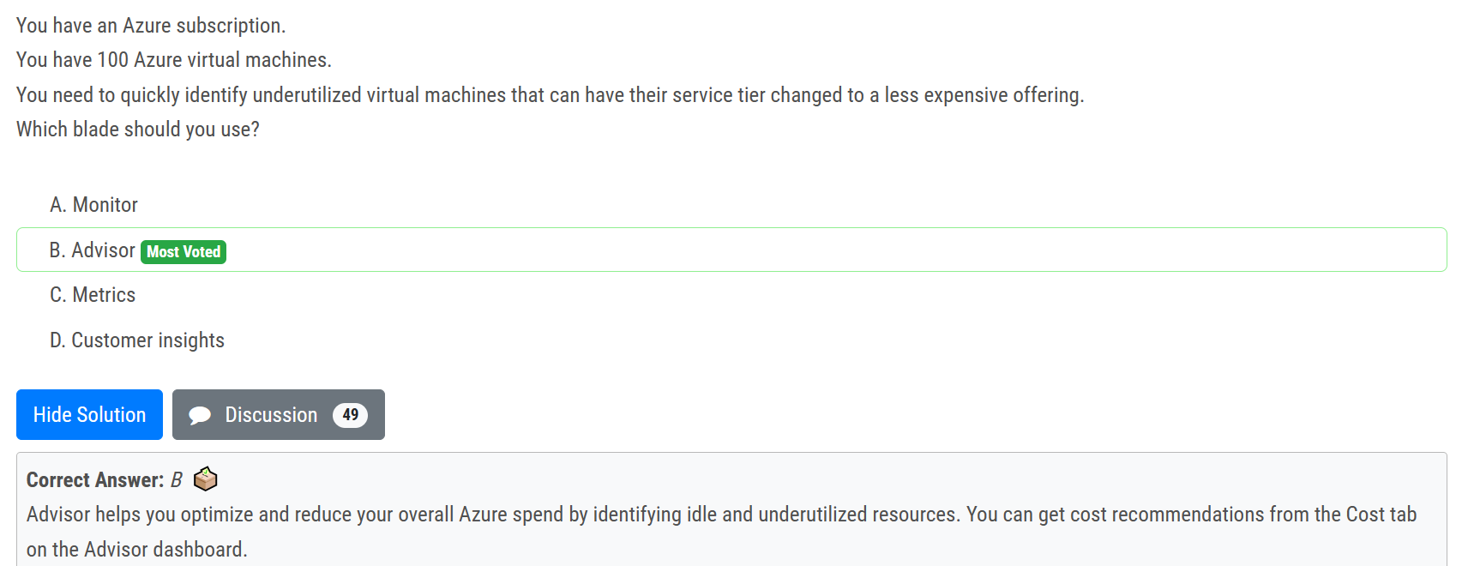

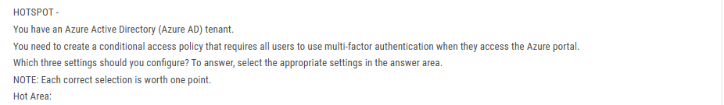 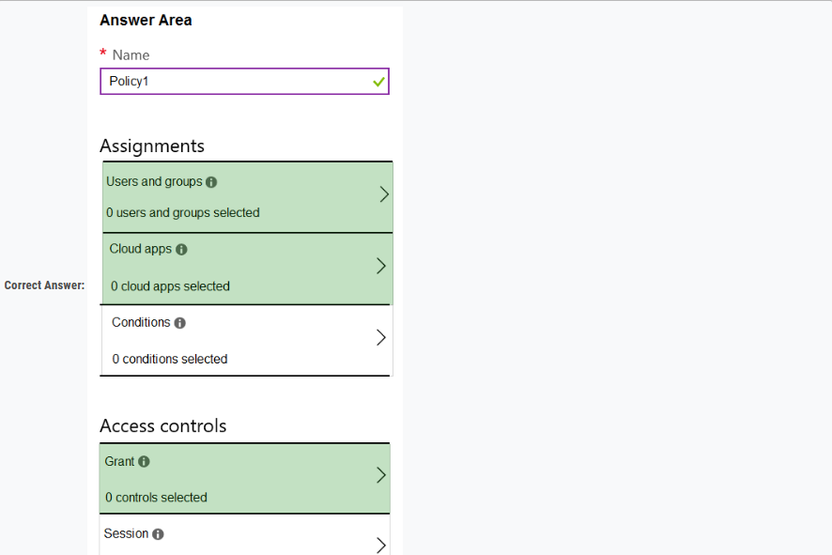

- Select Users & Groups : Where you have to choose all users. - Select Cloud apps or actions: to specify the Azure portal - Grant: to grant the MFA. Those are the minimum requirements to create MFA policy. No conditions are required in the question.

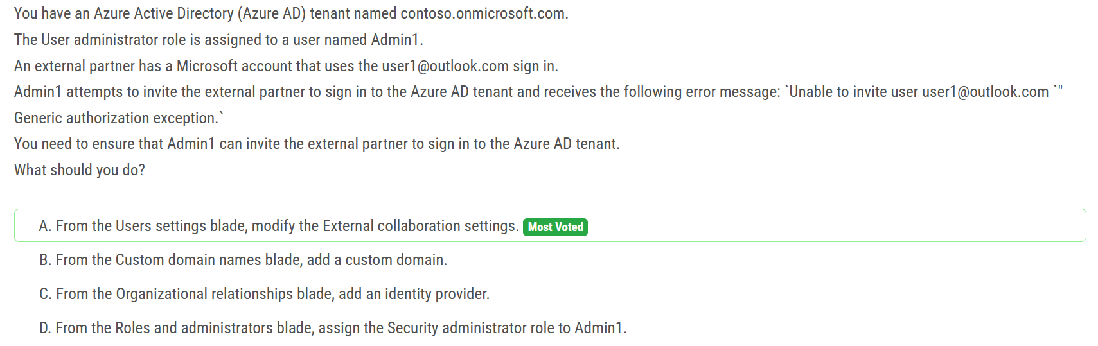

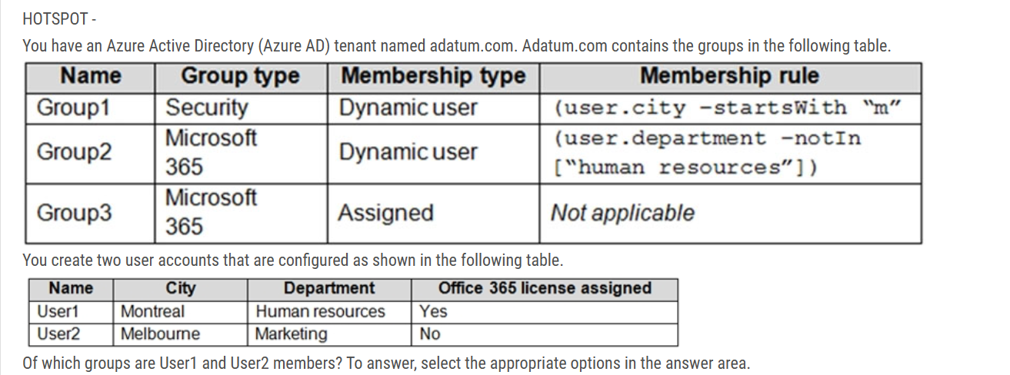

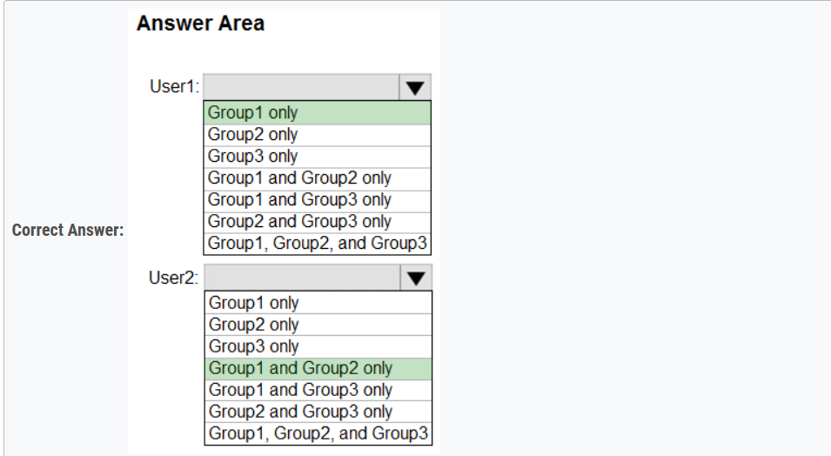

You don't have to assign licenses to users for them to be members of dynamic groups, but you must have the minimum number of licenses in the Azure AD organization to cover all such users. For example, if you had a total of 1,000 unique users in all dynamic groups in your organization, you would need at least 1,000 licenses for Azure AD Premium P1 to meet the license requirement.

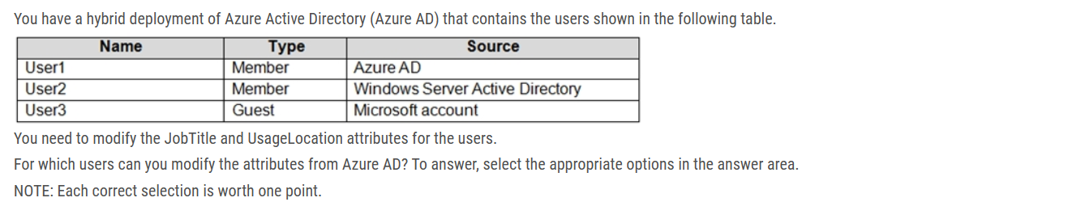

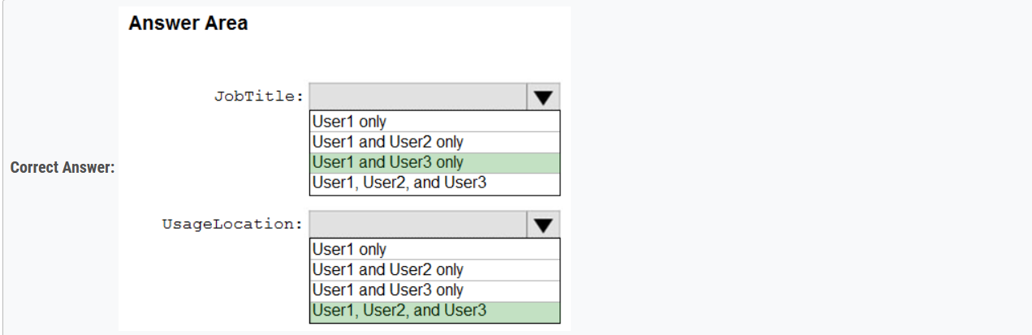

Box 1:User1 and User3 only You must use Windows Server Active Directory to update the identity, contact info, or job info for users whose source of authority is Windows Server Active Directory. Box 2: User1, User2, and User3 Usage location is an Azure property that can only be modified from Azure AD (for all users including Windows Server AD users synced via Azure AD Connect).

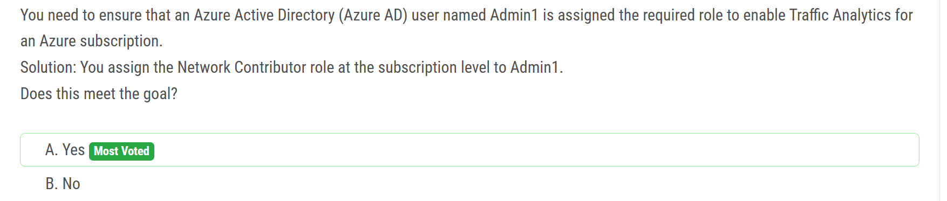Your account must meet one of the following to enable traffic analytics:  
Your account must have any one of the following Azure roles at the subscription scope: owner, contributor, reader, or network contributor.

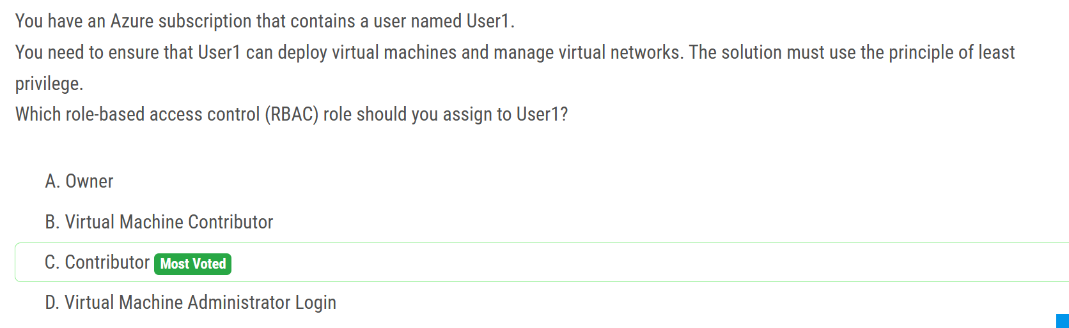

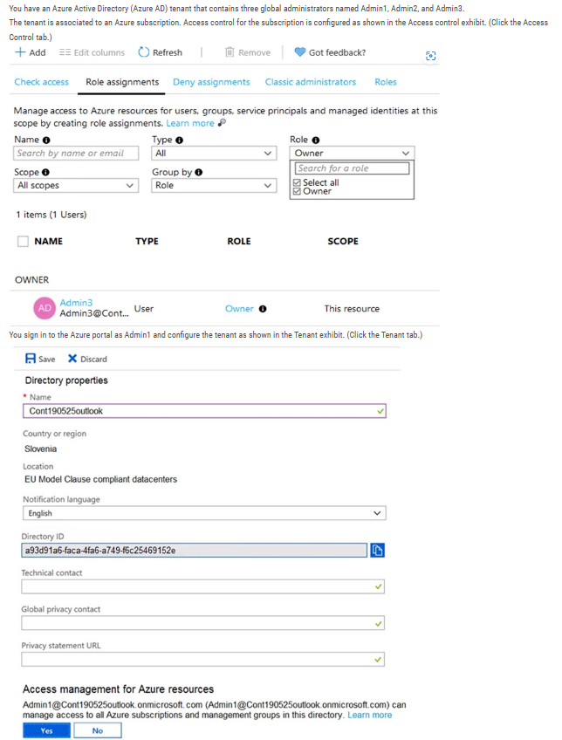

Box 1: Yes Admin1 has elevated access, so he is User Access Admin. This is valid.

Box 2: Yes Admin3 is Owner of the Subscription. This is valid.

Box 3: No Admin2 is just a GA in Azure AD scope. He doesn’t have permission in the Subscription.

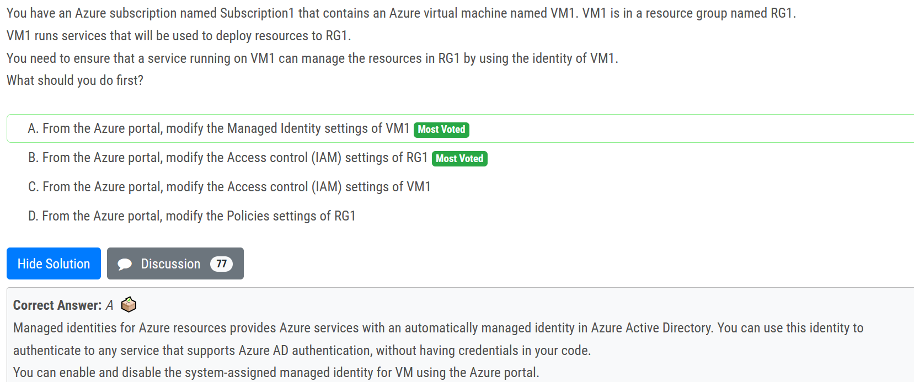

ans: A

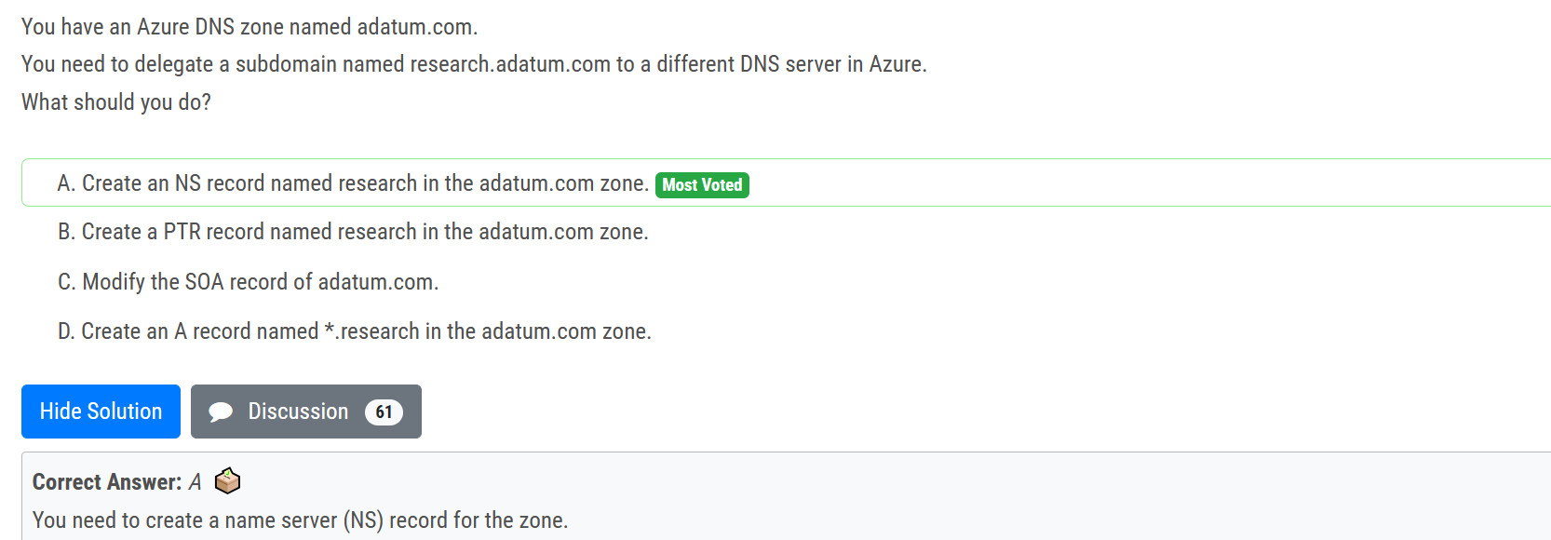

An NS record or (name server record) tells recursive name servers which name servers are authoritative for a zone. You can have as many NS records as you would like in your zone file. The benefit of having multiple NS records is the redundancy of your DNS service.

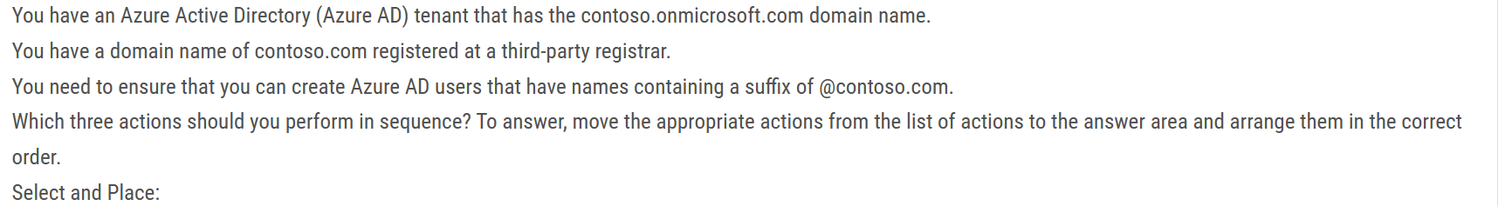

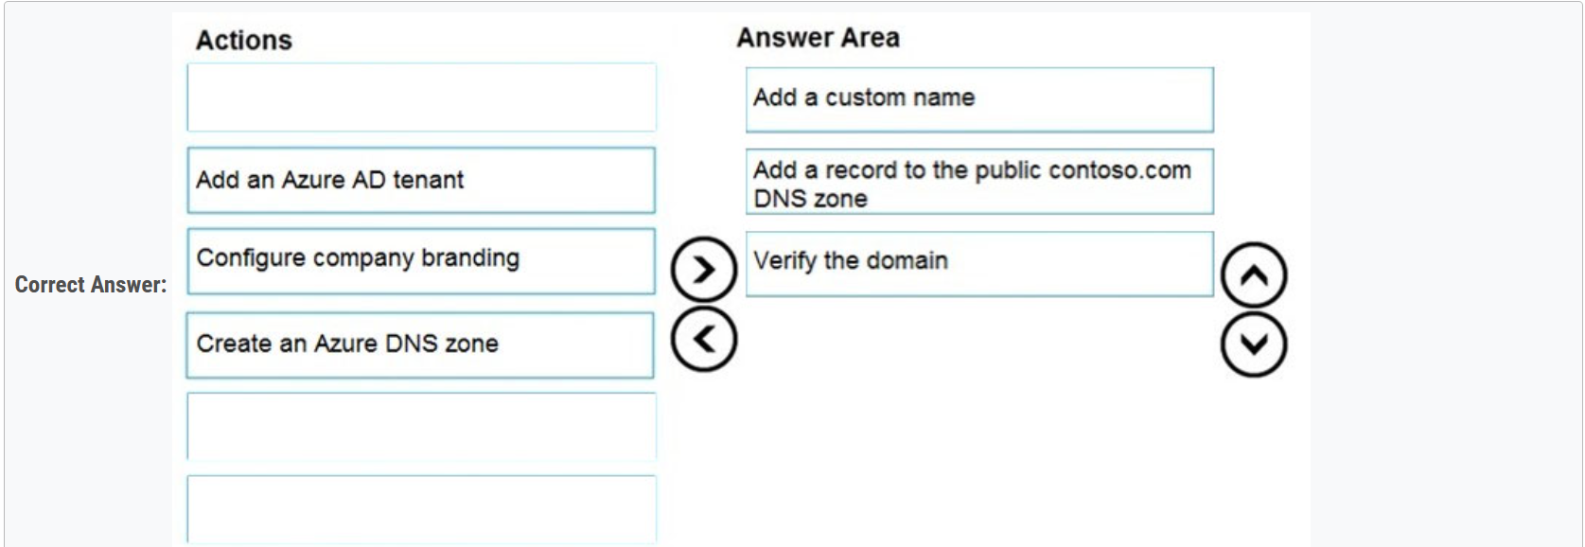

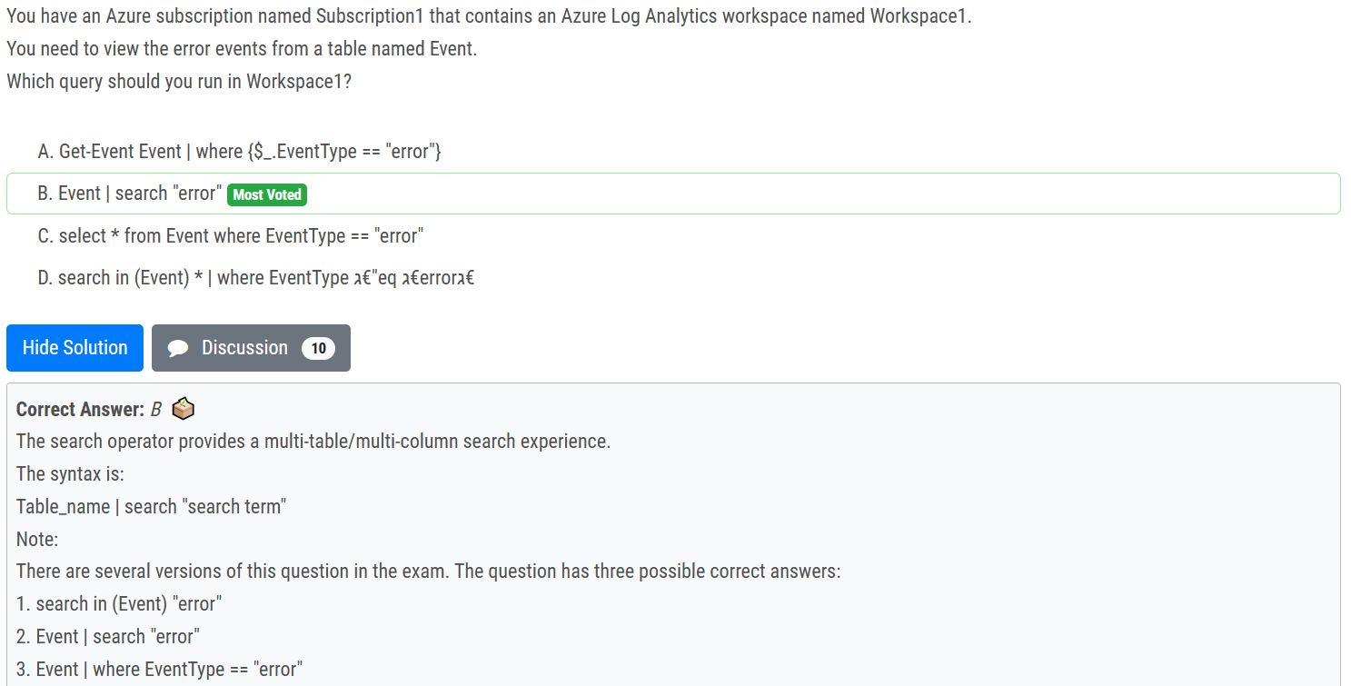

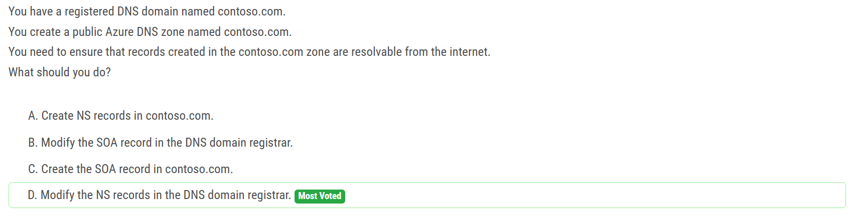

When you create a public Azure DNS zone named contoso.com, Azure assigns a set of NS records for that zone. These NS records specify the name servers responsible for handling DNS queries for the contoso.com domain. To make the records in the Azure DNS zone resolvable from the internet, you need to update the NS records at the DNS domain registrar to point to the name servers provided by Azure.

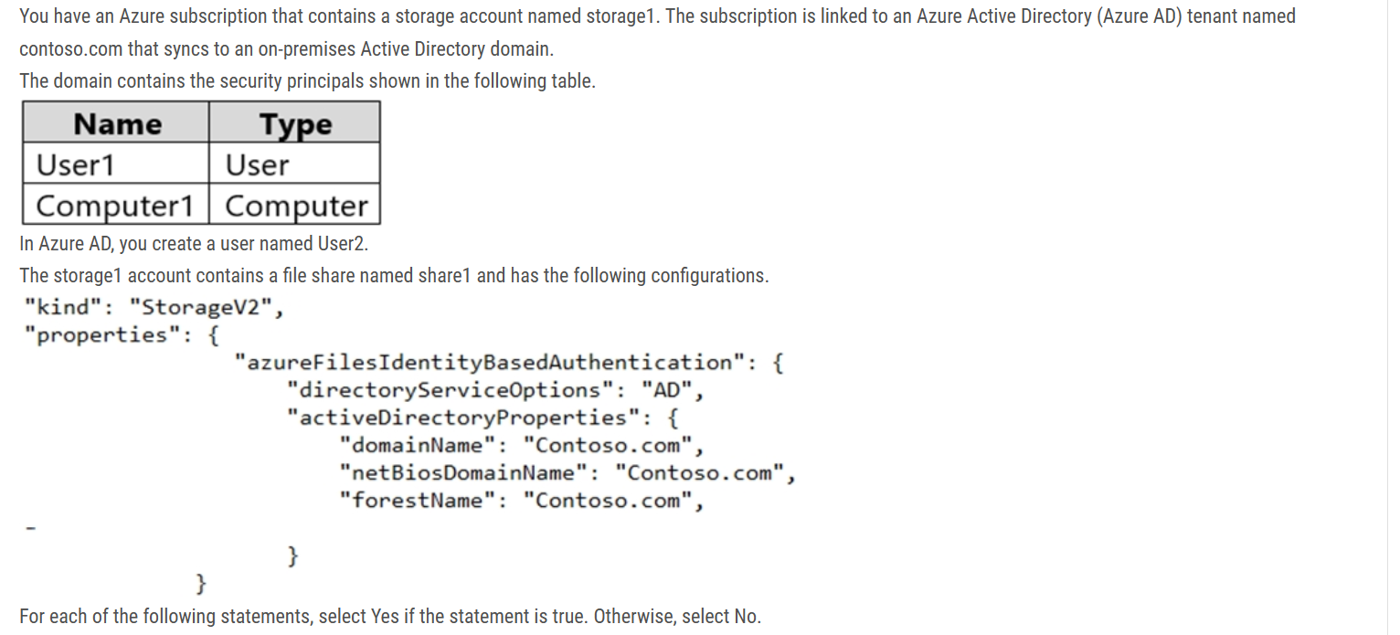

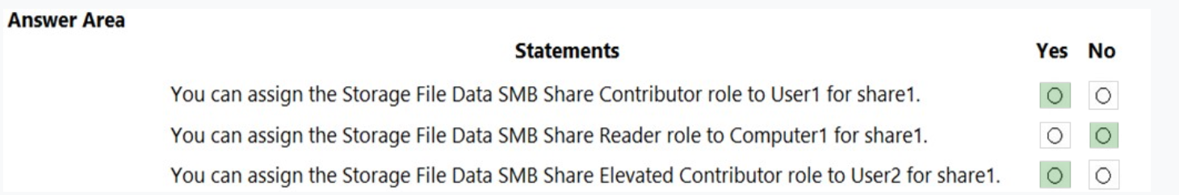

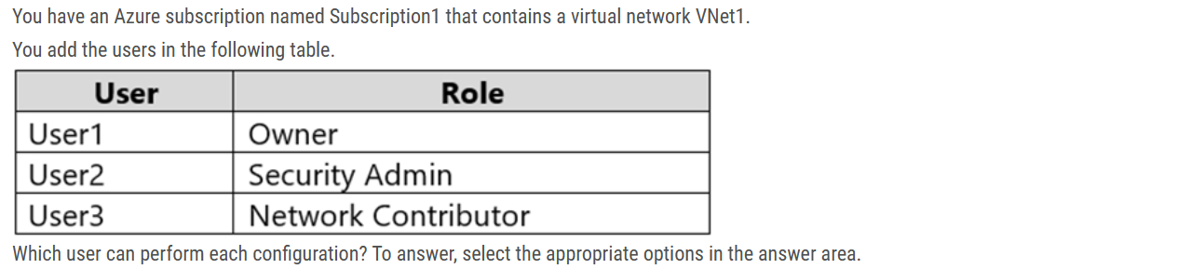

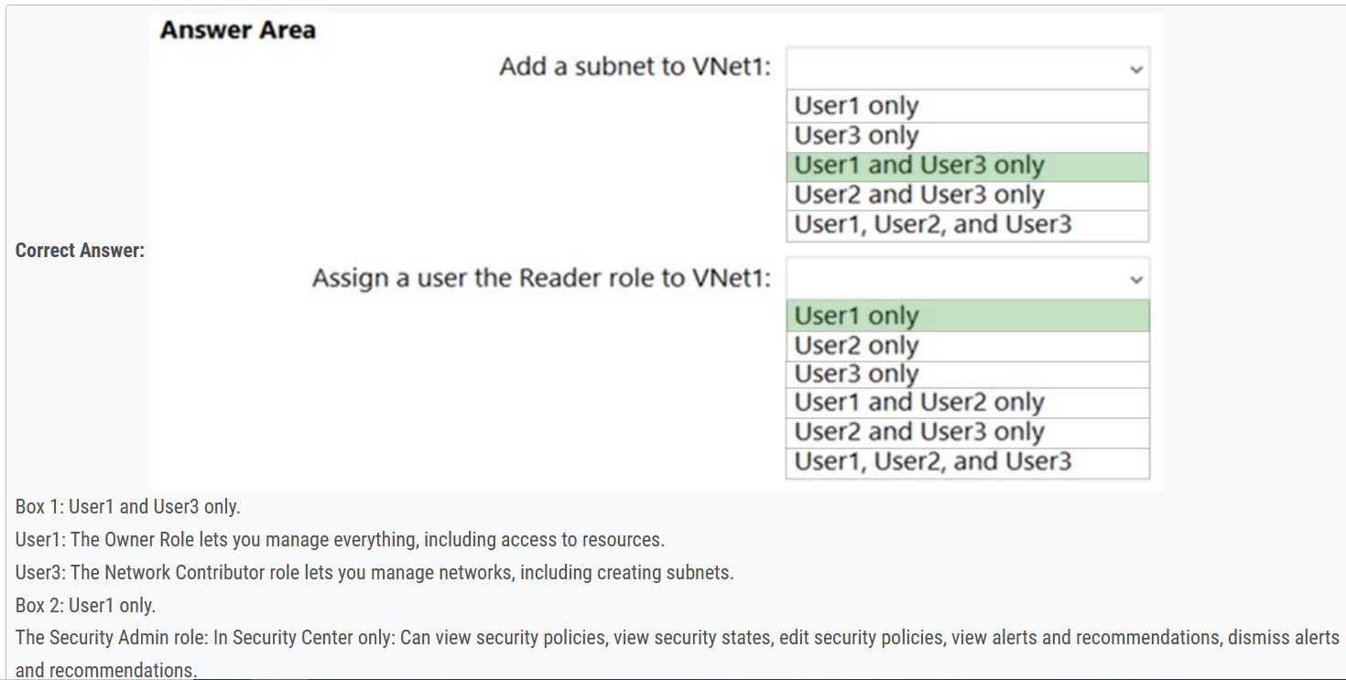

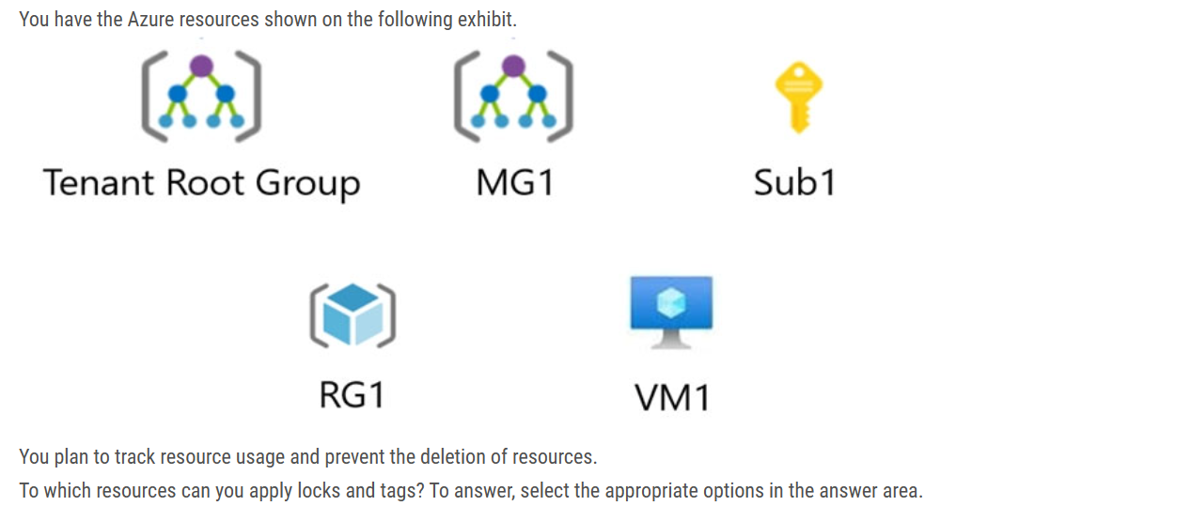

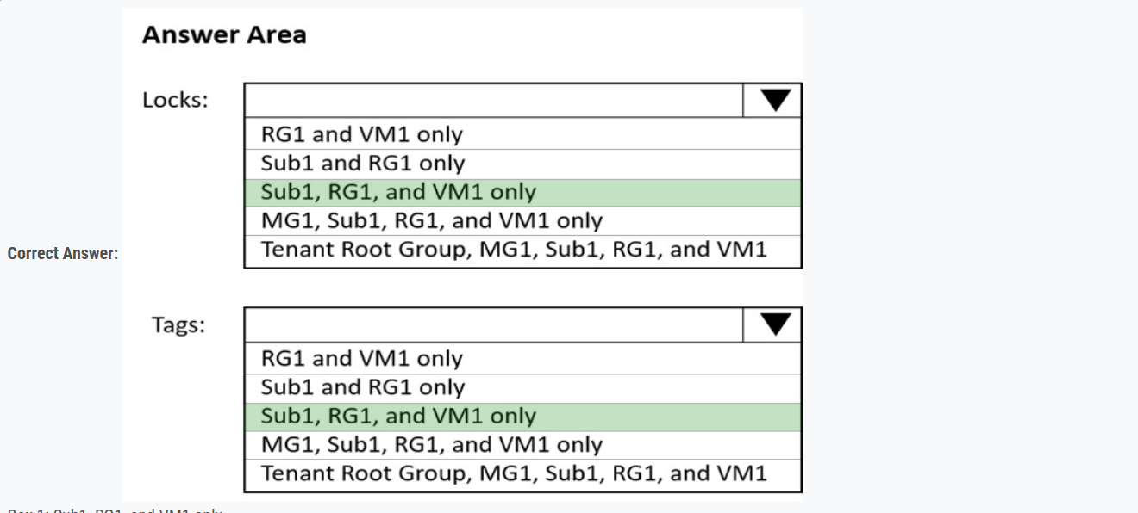

Only can assign locks and tags to subscriptions, resource groups and resources

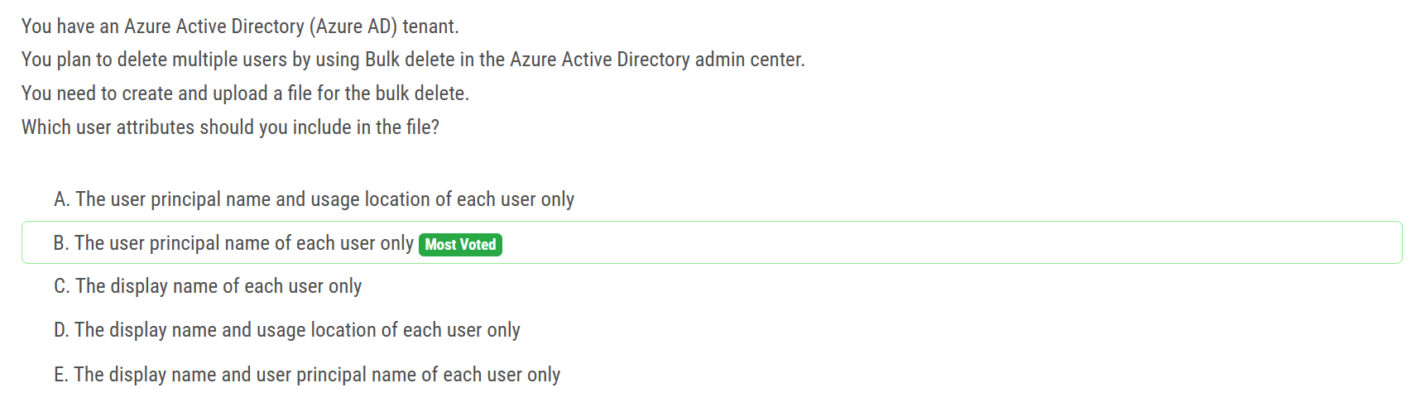

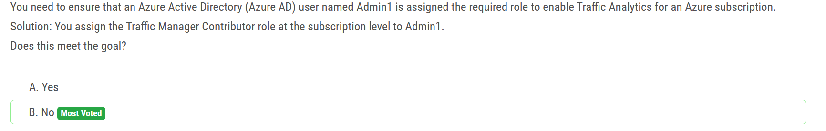

Reader role is not applicable anymore. Only correct answers are 'owner, contributor, or network contributor'.

The Traffic Manager Contributor role is specifically for managing Traffic Manager profiles and does not provide the necessary permissions to enable Traffic Analytics.

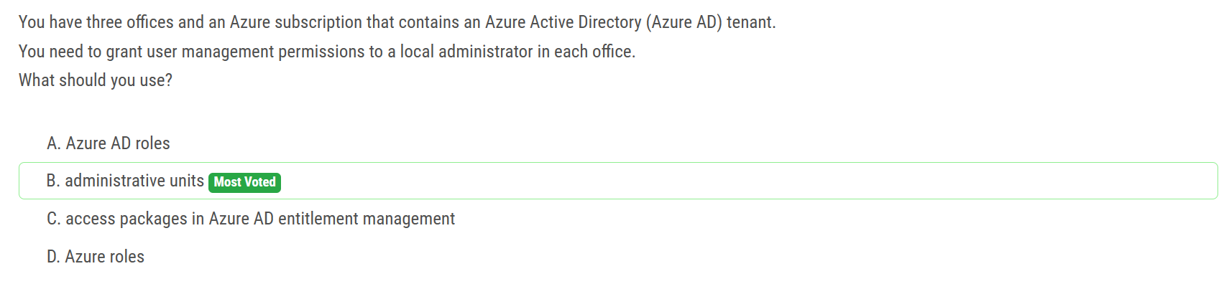

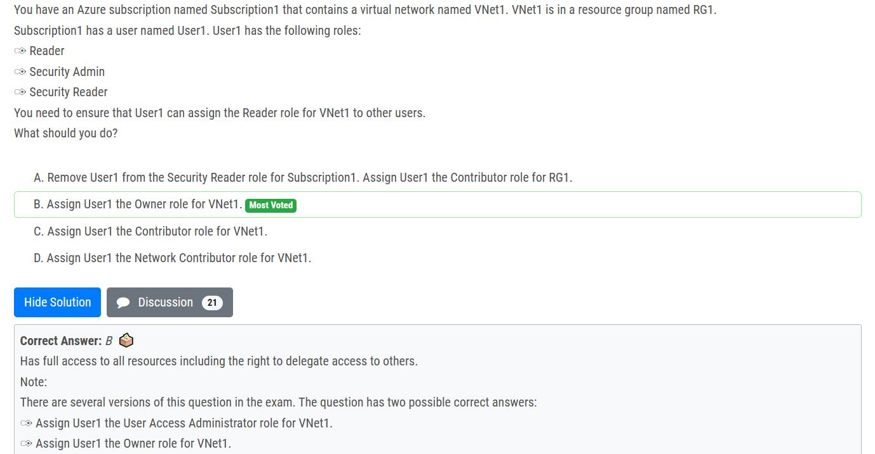

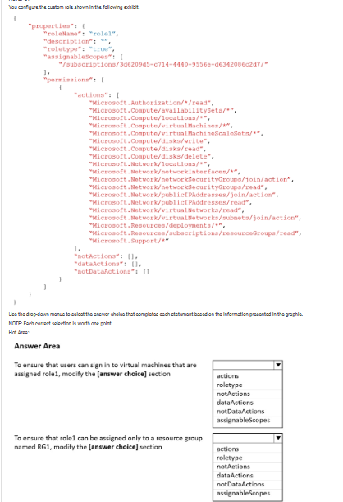

Correct answer is dataActions and assignableScope.

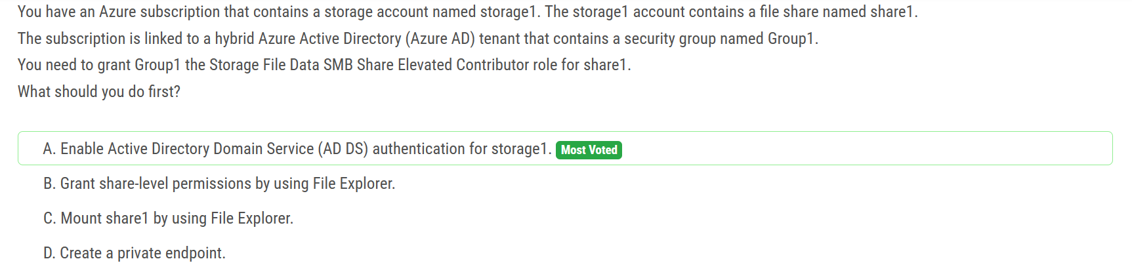

By enabling AD DS authentication, you allow Azure AD security groups to be used for granting access control to file shares in the storage account. This enables you to assign roles, such as the Storage File Data SMB Share Elevated Contributor role, to the security group Group1 for the specific file share share1.

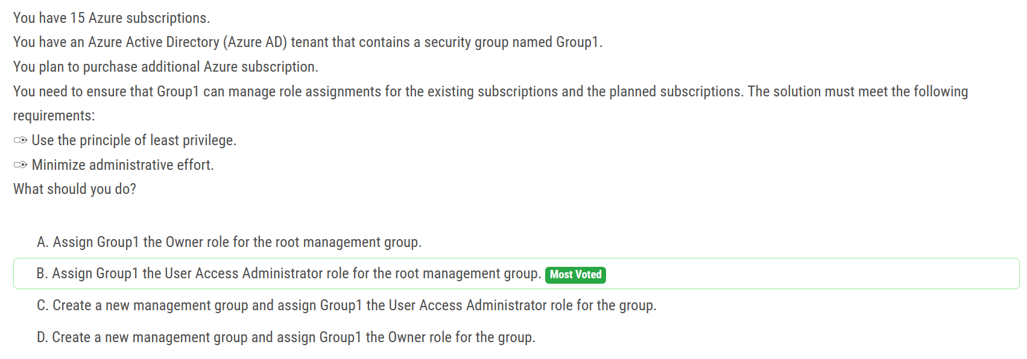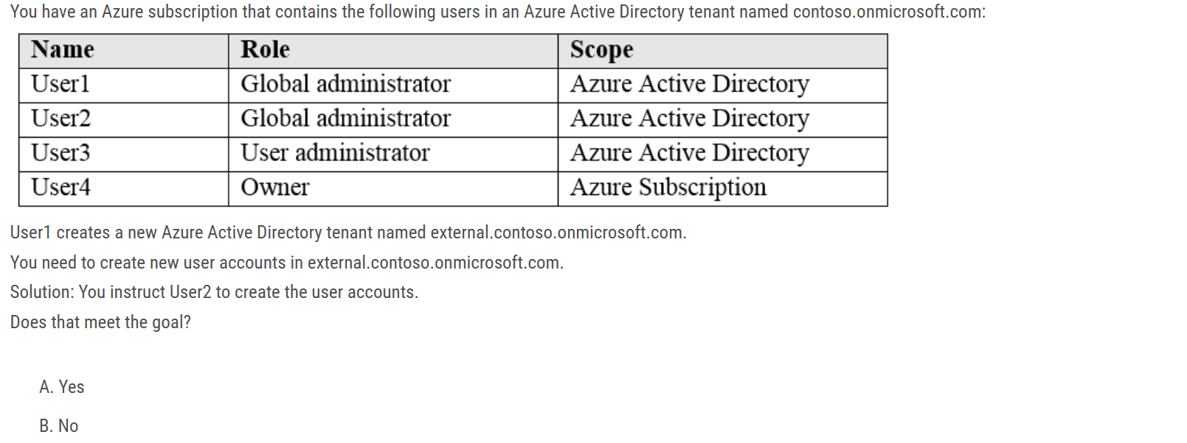

Ans: B - NO

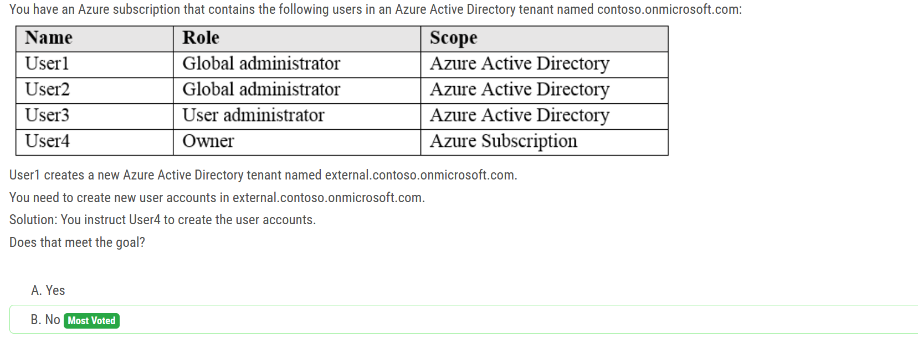The scope of Azure AD roles is at the tenant level, whereas the scope of Azure roles can be specified at multiple levels including management group, subscription, resource group, resource.

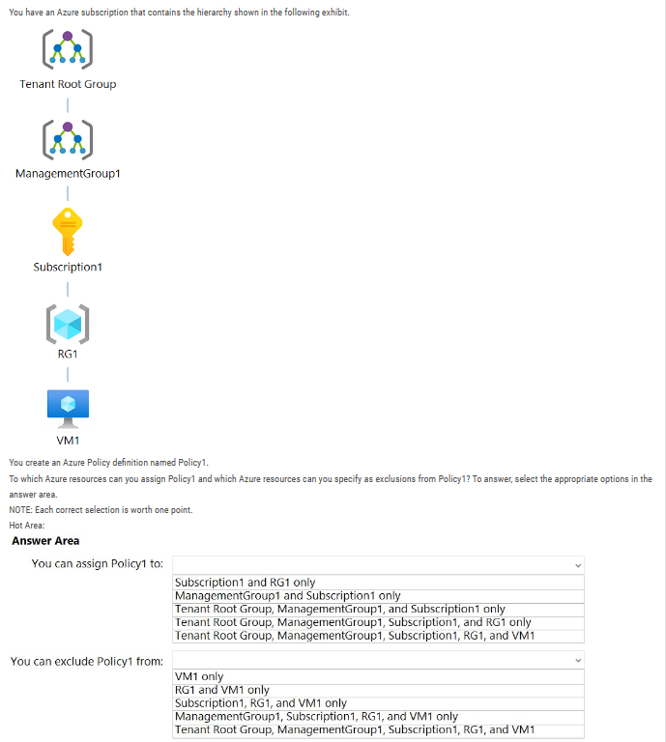

1. You can assign policy to : Root Tenant Group , MGMT Group, Subscriptions and resource group , but you can't assign to resources.
2. You can exclude policy : MGMT Group, Subscriptions and resource group including Resources (VM1), but you can't exclude the Root mgmt. group

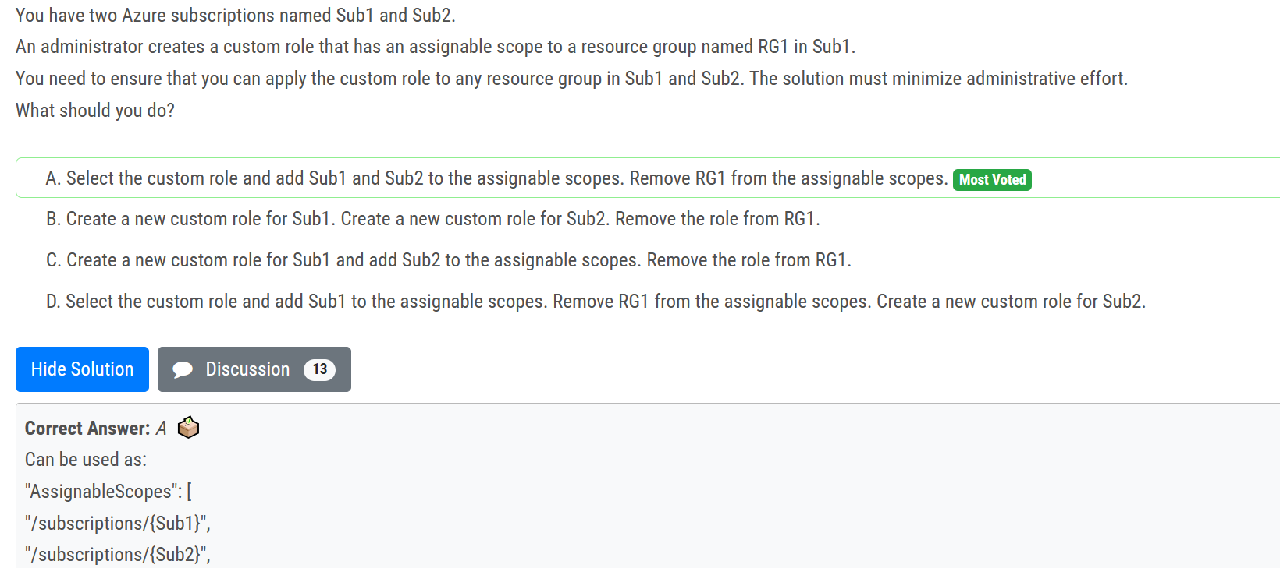

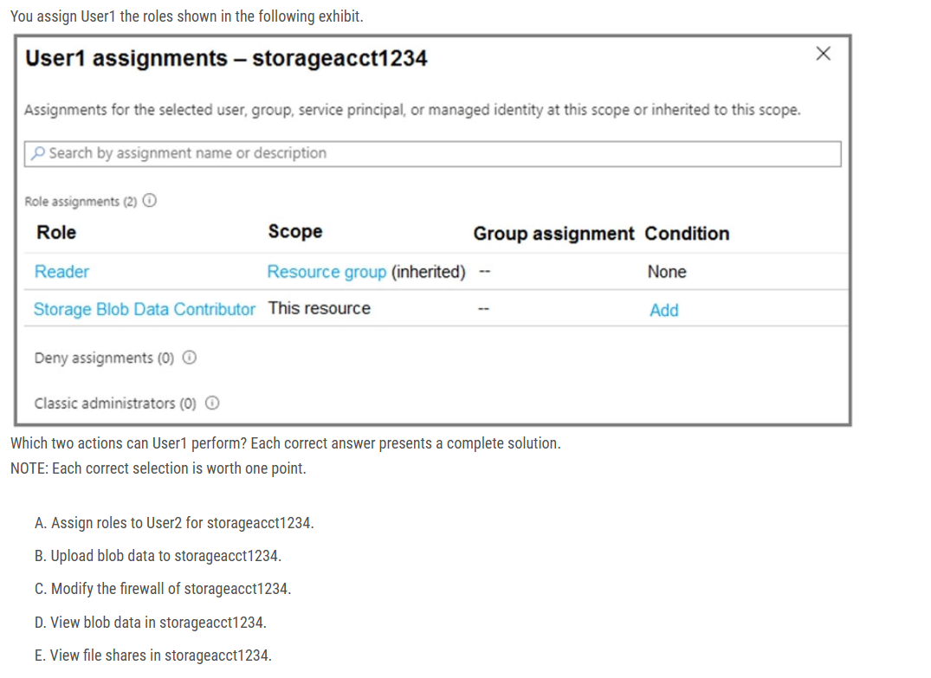

Ans: B and D

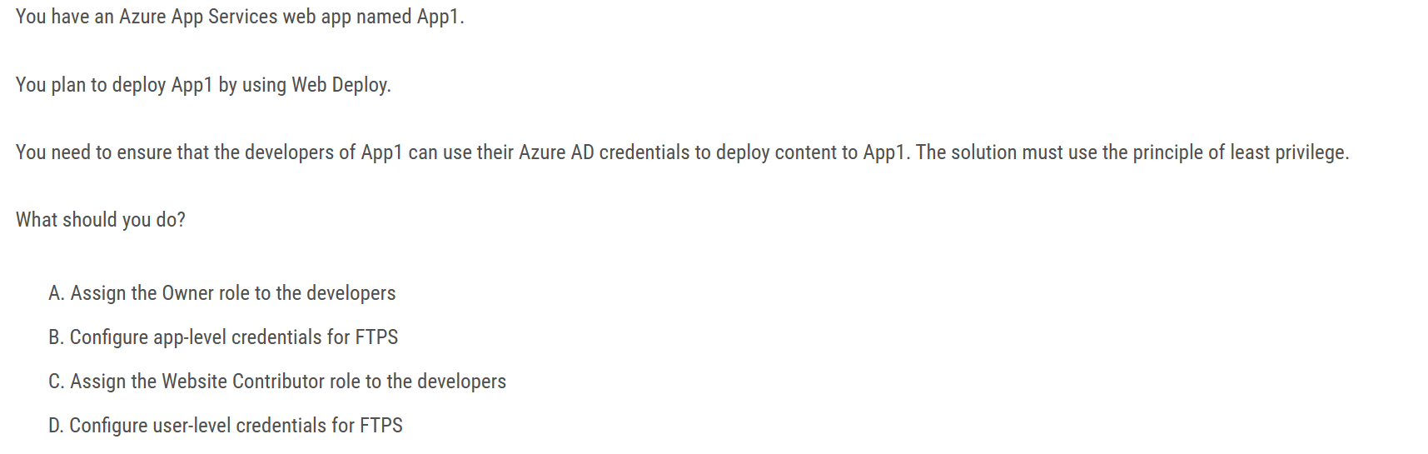

Ans : C

Option B and D are not relevant to the scenario as the question is specifically asking for how to use Azure AD credentials for Web Deploy, not FTPS.

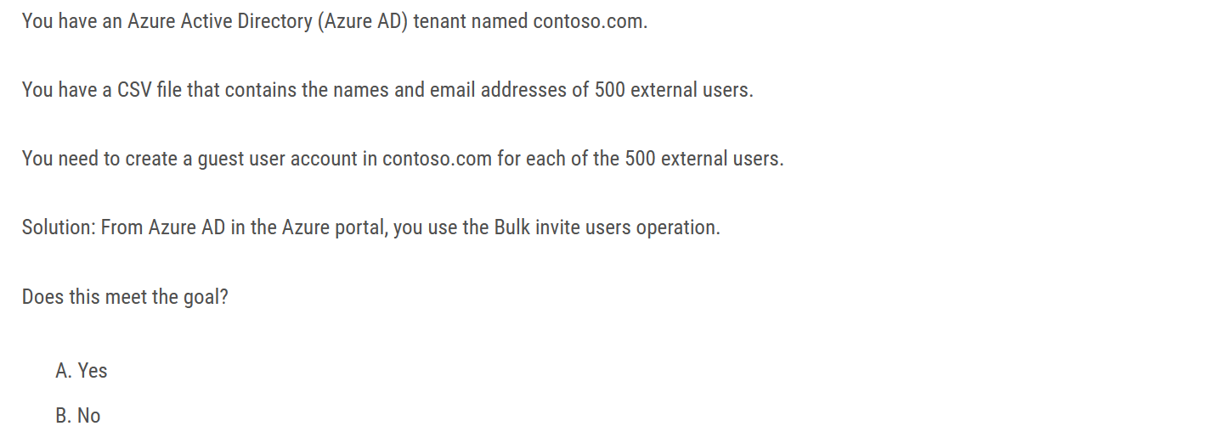

Ans : No

The Answer is NO. In the question say "In the Azure Portal" when you use the Azure portal, the template must have Email and Redirection URL. but if you use powershell the redirection is not required

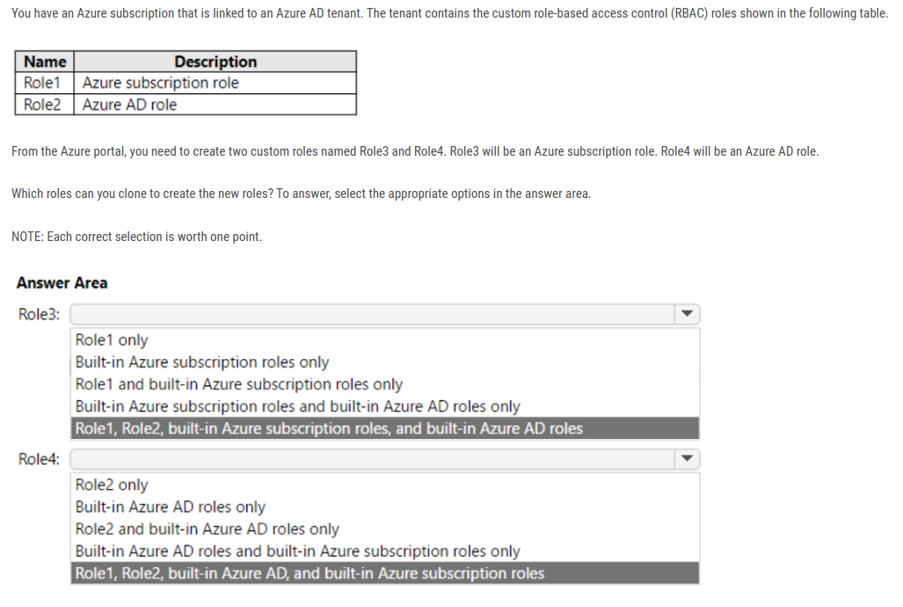

Role3: Role1 and built-in Azure subscription roles only

Role4: Role2 only - For Azure AD role, you can only clone from custom role like Role 2 and connot clone from built-in role.

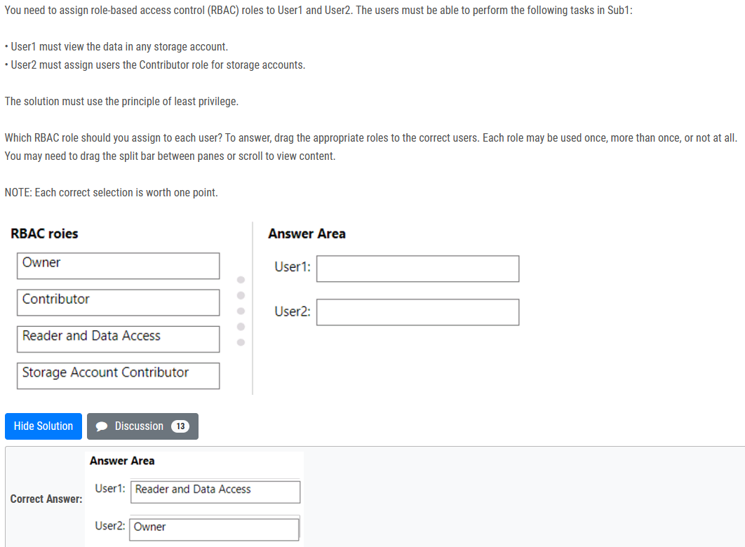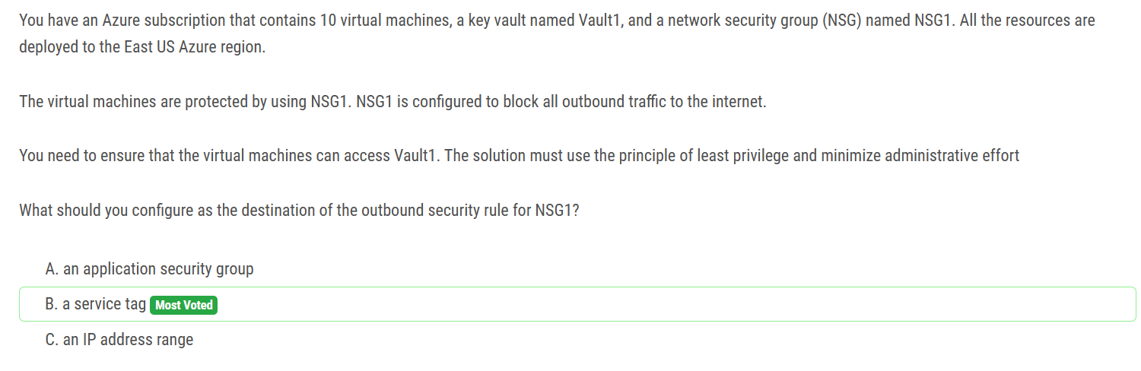

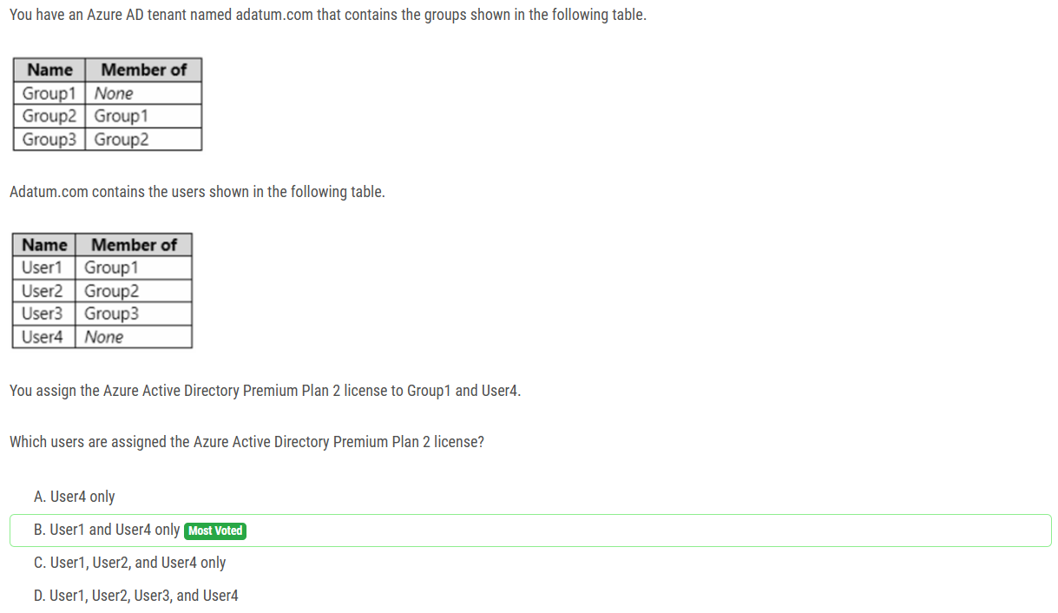

Group-based licensing currently doesn't support groups that contain other groups (nested groups). If you apply a license to a nested group, only the immediate first-level user members of the group have the licenses applied

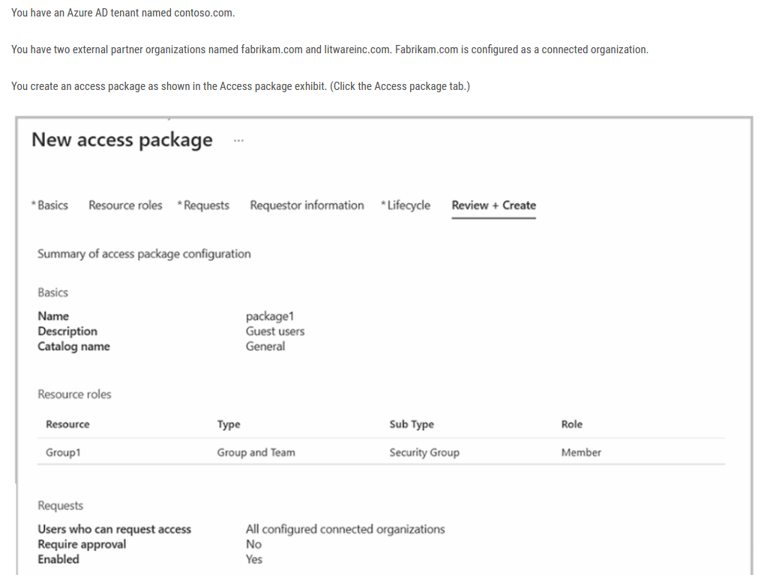

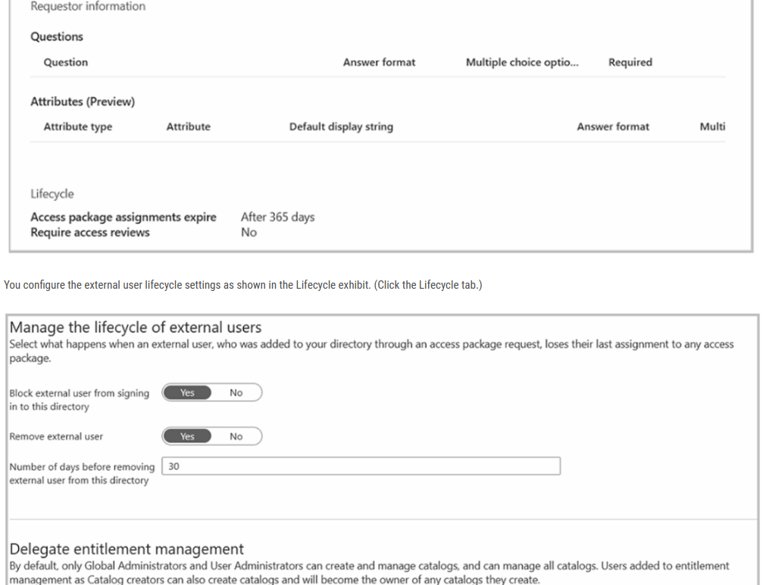

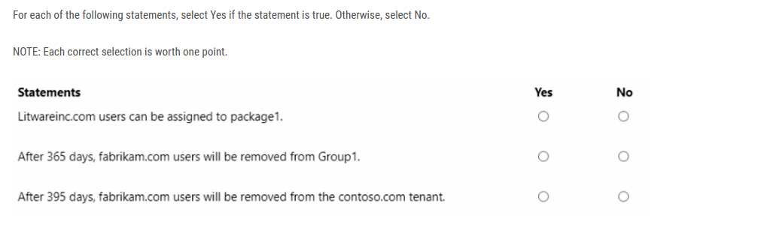

N not a connected organisation

N expired not remove

Y 365 + 30 = 395 removed

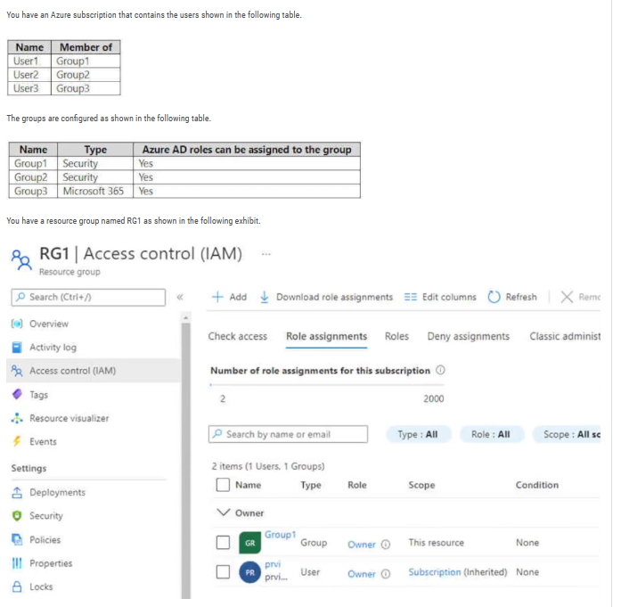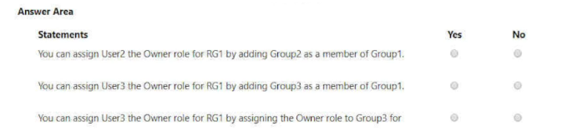

Y - it is possible to add Group2 as a member of Group1 and the Owner Role gets inherited

N - it is not possible to add M365 group as a member of Security group

Y - it is possible to add an Owner role for RG1 to Group3

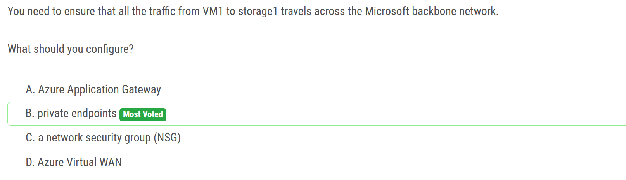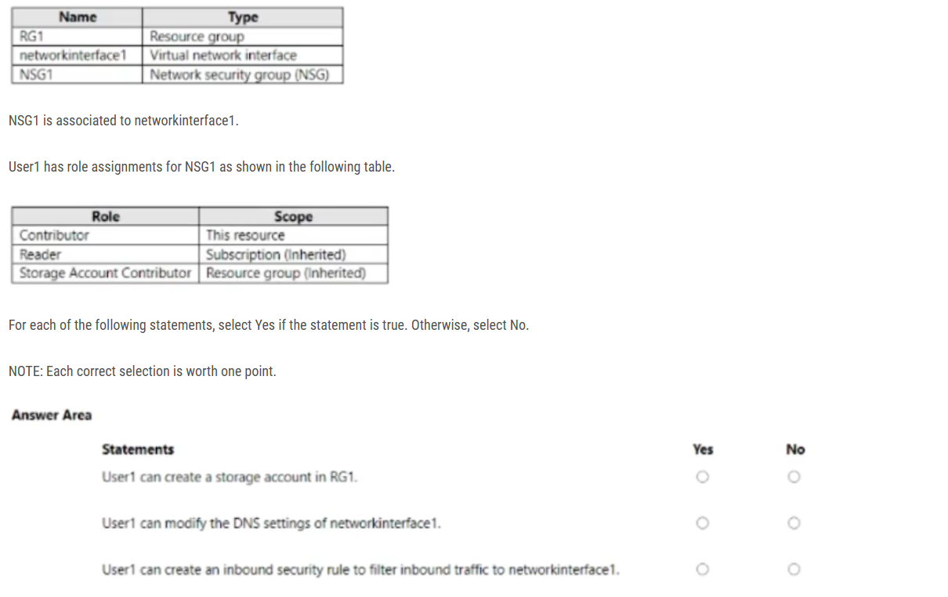

ans : Y N Y

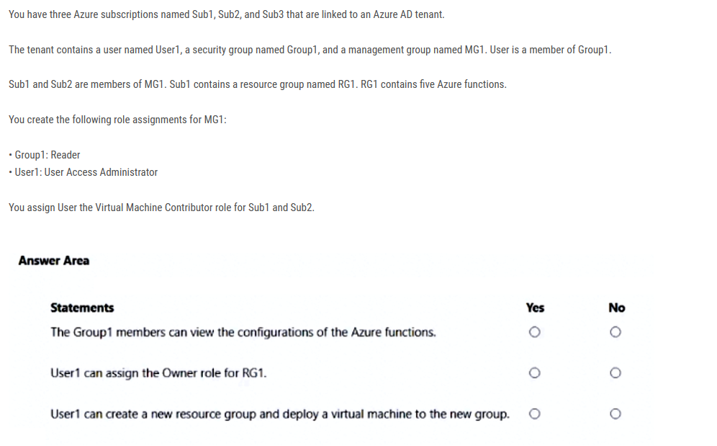

1) Y: GROUP1 Reader access, provides access to view all items, except secrets

2) N: To Assign OWNER role, you need to either Owner role or User Administrator Access Role

3) N: The Virtual Machine Contributor role allows User1 to manage virtual machines, but it does not provide permissions to create new resource groups. Additionally, User Access Administrator and Reader roles do not grant permission to create resources or resource groups

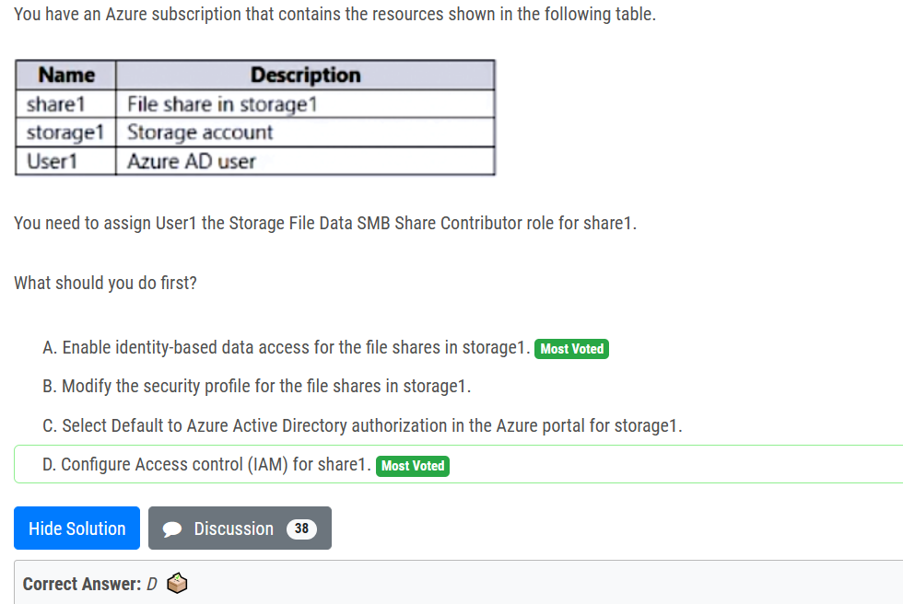

These are all just in Azure AD, so the answer points to D. If we need to authenticate with an Active Directory (or hybrid) source then the answer becomes A, because we then need to enable identity-based authentication before using IAM

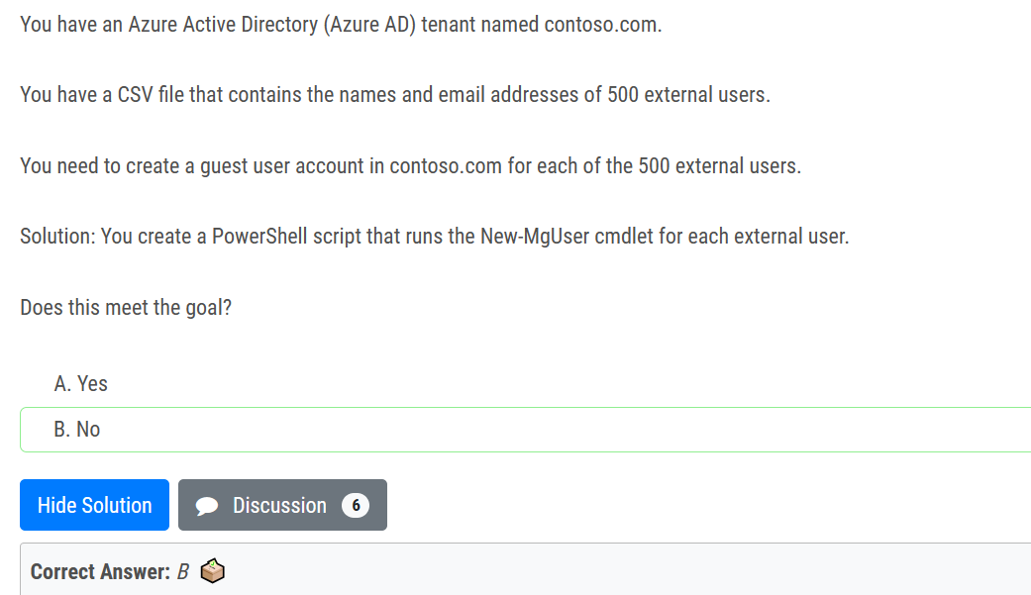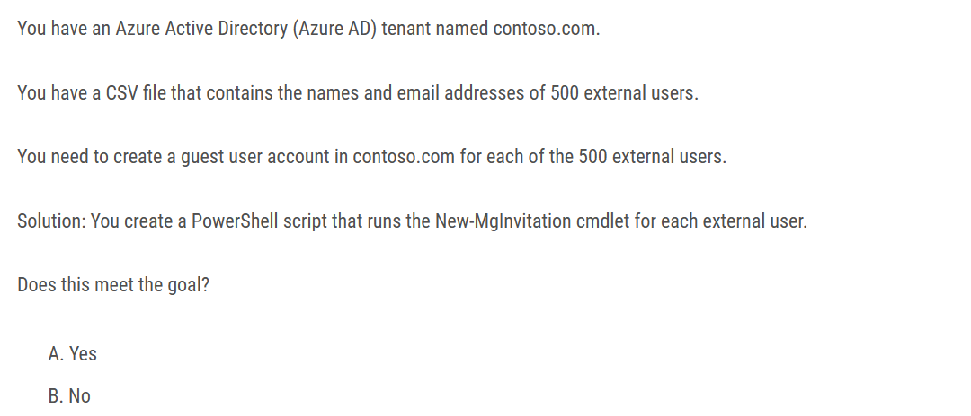

ans : A

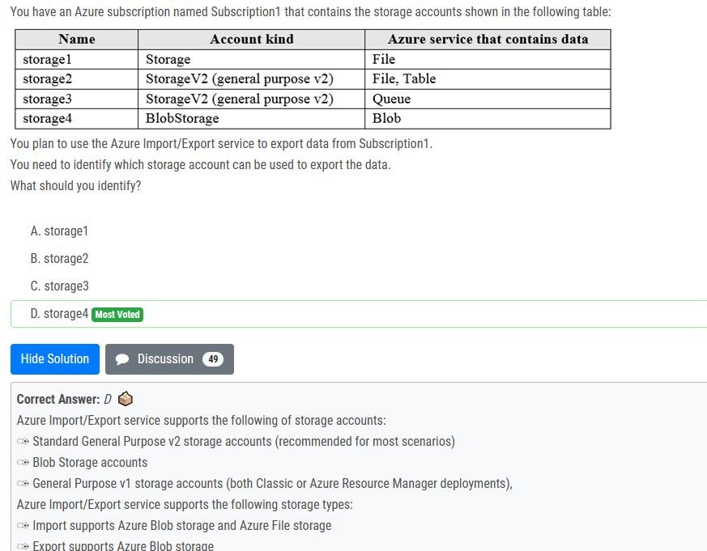

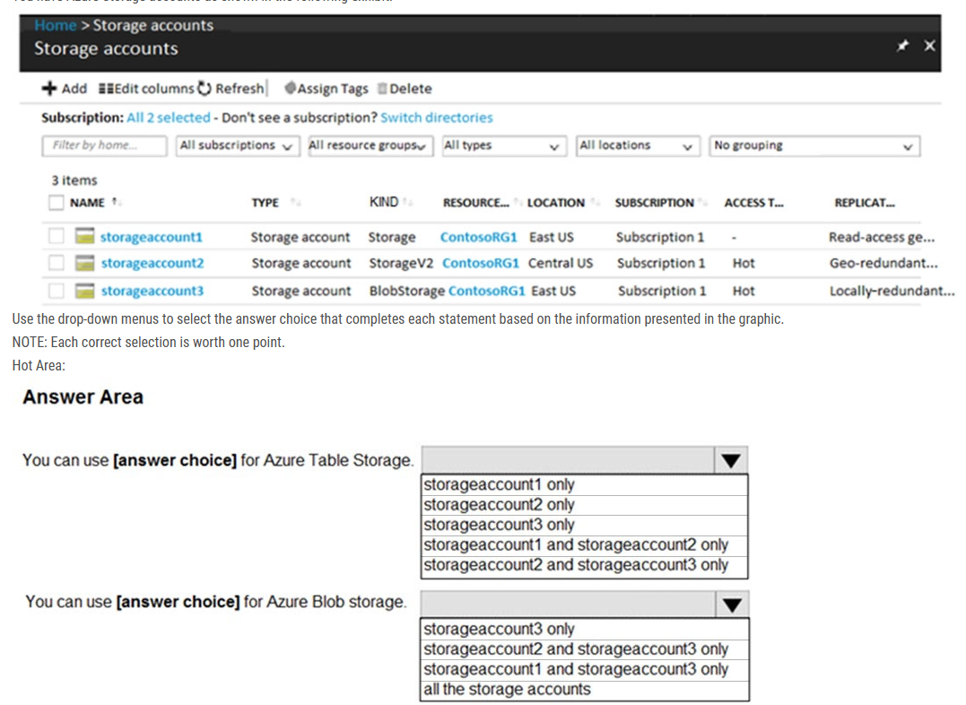

- Storage account 1 & 2 only

- All storage accounts.

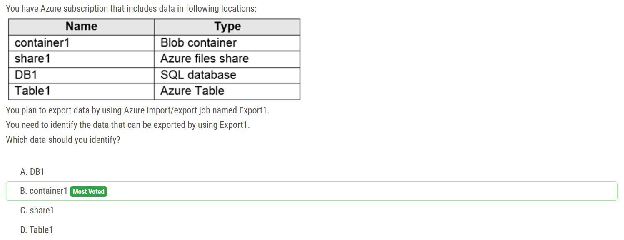

Blobs are only type of storage which can be exported.

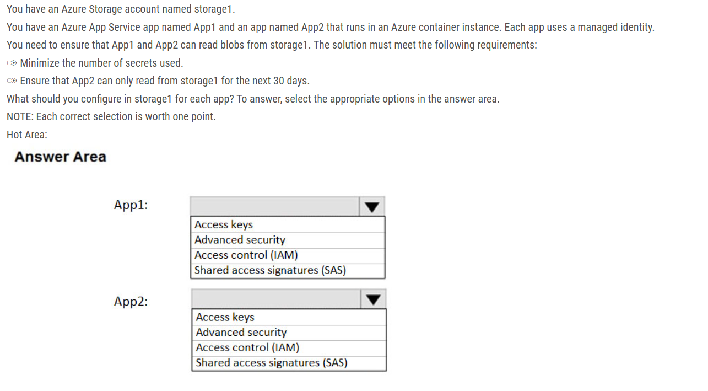

Box 1: Access Control (IAM) Since the App1 uses Managed Identity, App1 can access the Storage Account via IAM. As per requirement, we need to minimize the number of secrets used, so Access keys is not ideal.

Box 2: Shared access signatures (SAS) We need temp access for App2, so we need to use SAS.

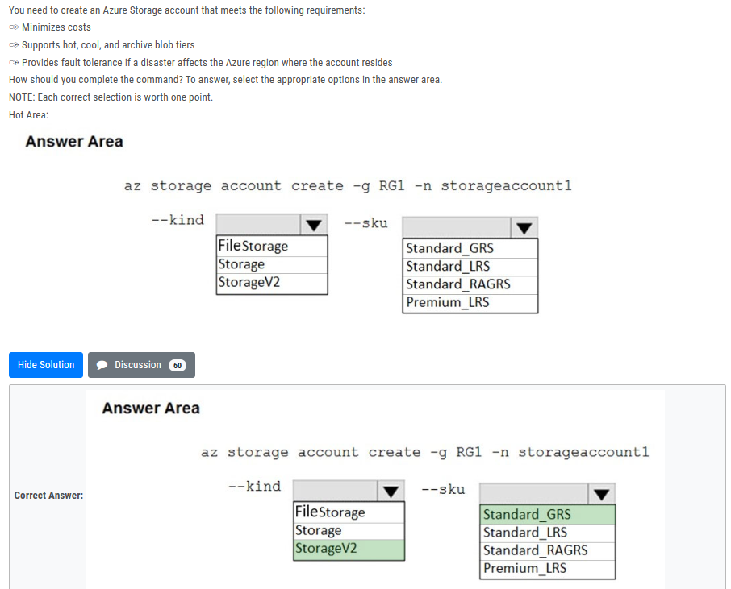

You may only tier your object storage data to hot, cool, or archive in Blob storage and General Purpose v2 (GPv2) accounts. General Purpose v1 (GPv1) accounts do not support tiering.  
General-purpose v2 accounts deliver the lowest per-gigabyte capacity prices for Azure Storage, as well as industry-competitive transaction prices.

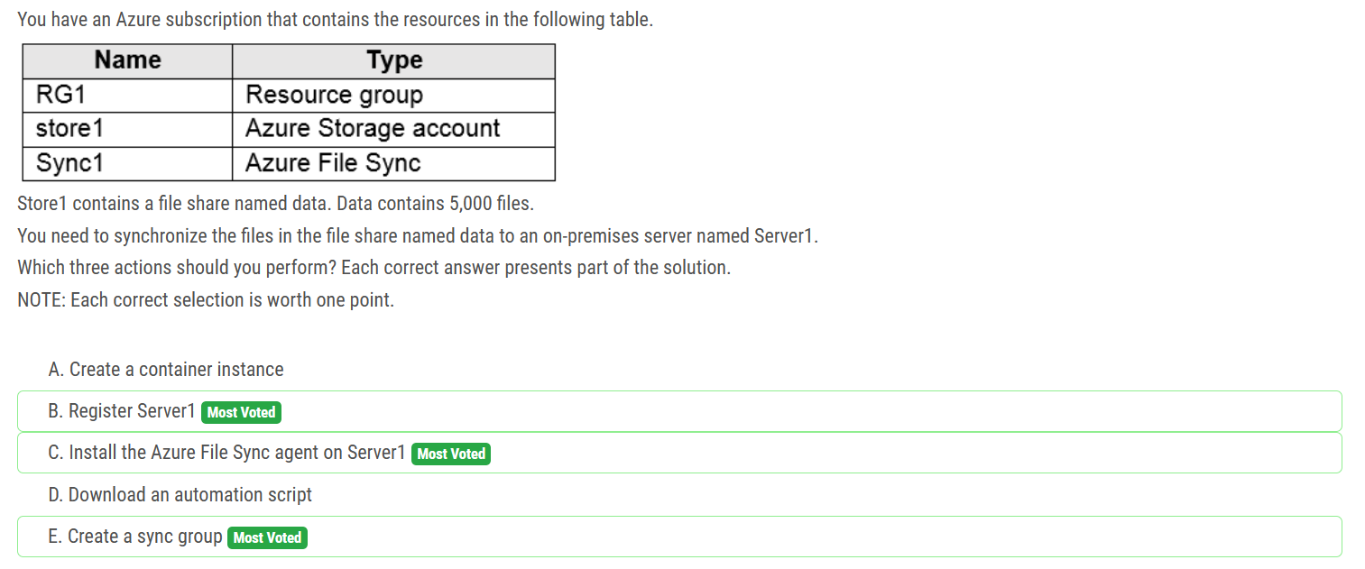

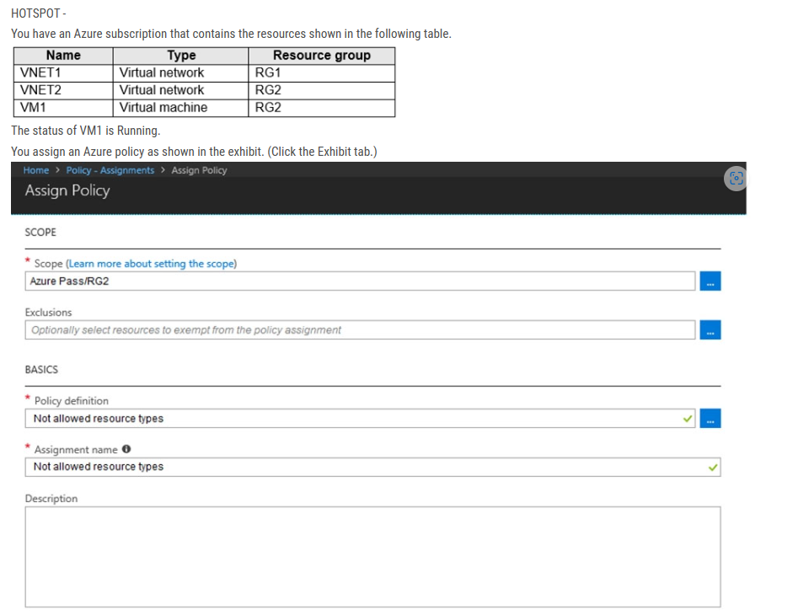

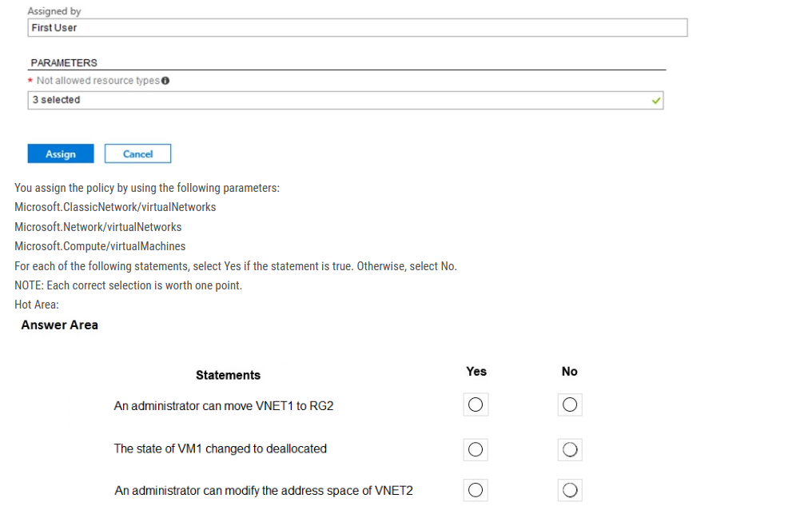

ANS : NO NO NO

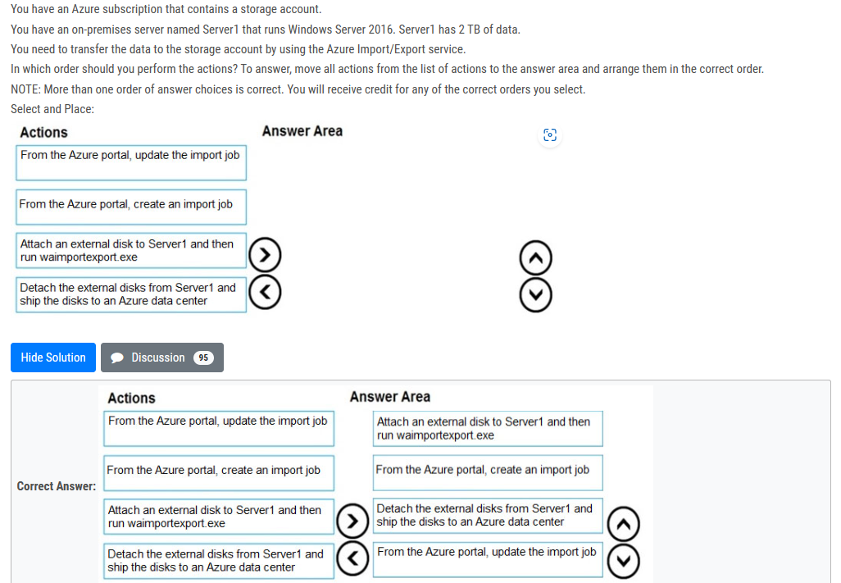

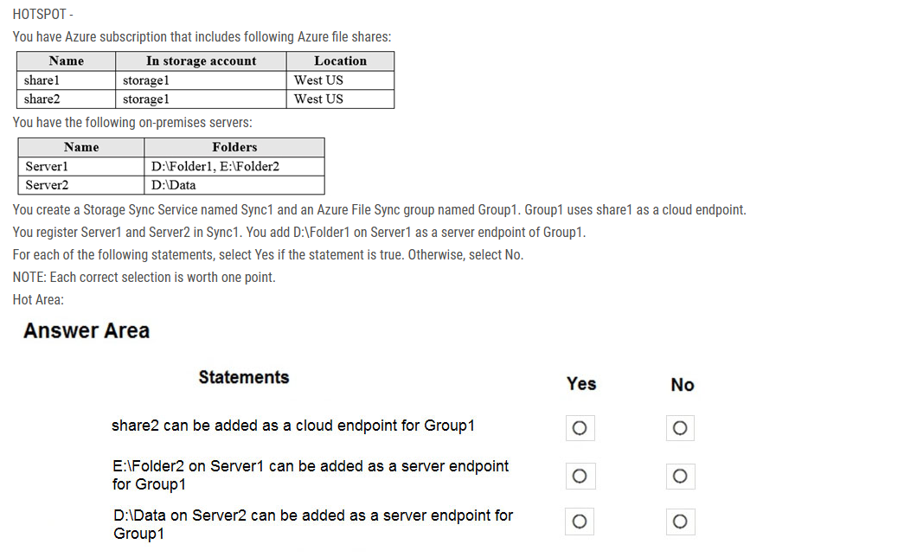

Box 1: No A sync group contains one cloud endpoint, or Azure file share, and at least one server endpoint.

Box 2: No Azure File Sync does not support more than one server endpoint from the same server in the same Sync Group.

"A registered server can support multiple server endpoints, however, a sync group can only have one server endpoint per registered server at any given time. Other server endpoints within the sync group must be on different registered servers.

Box 3: Yes Multiple server endpoints can exist on the same volume if their namespaces are not overlapping (for example, F:\sync1 and F:\sync2) and each endpoint is syncing to a unique sync group.

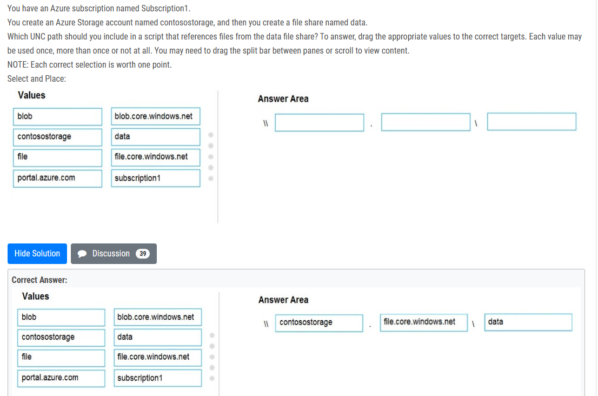

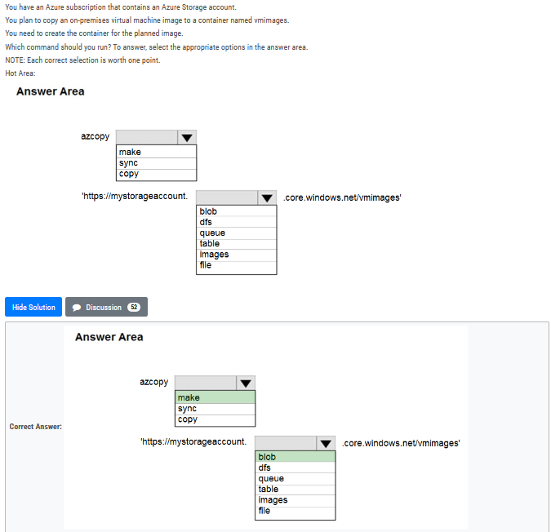

Similar to OS Images, a VM Image is a collection of metadata and pointers to a set of VHDs (one VHD per disk) stored as page blobs in Azure Storage

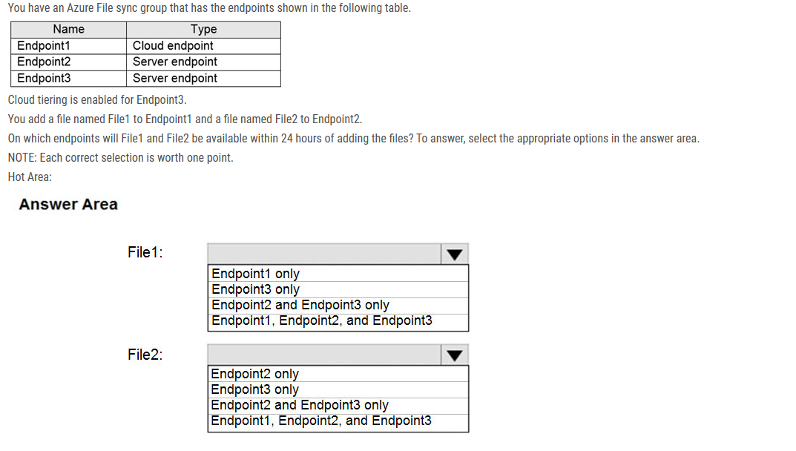

File1: Endpoint1 only It is a cloud endpoint, and it is scanned by the detection job every 24 hours.

File2: Endpoint1, Endpoint2 and Endpoint3 With the on-premises servers the file is scanned and synced automatically after it's being added.

Note: They changed the question in Exam from "within 24 hours" to "after 24 hours". So, the answer is: File1: Endpoint1, Endpoint2 and Endpoint3

File2: Endpoint1, Endpoint2 and Endpoint3

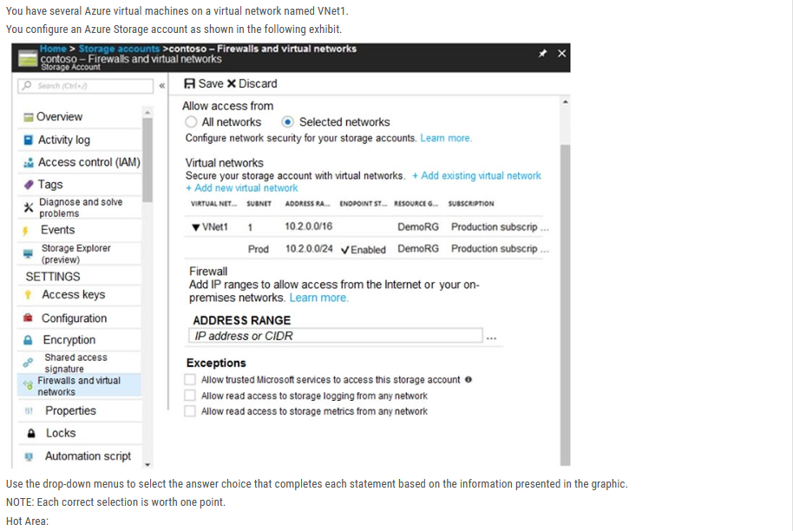

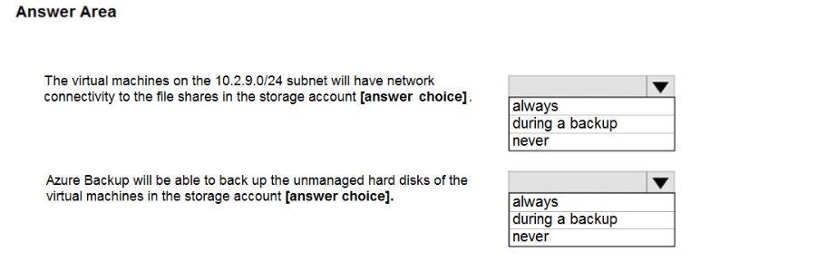

Box1: Never - The 10.2.9.0/24 subnet is not whitelisted.

Box2: Never - Allow trusted Microsoft services to access this storage account - NOT CHECKED "this will enable Azure Backup service to access the network that restriced storage account"

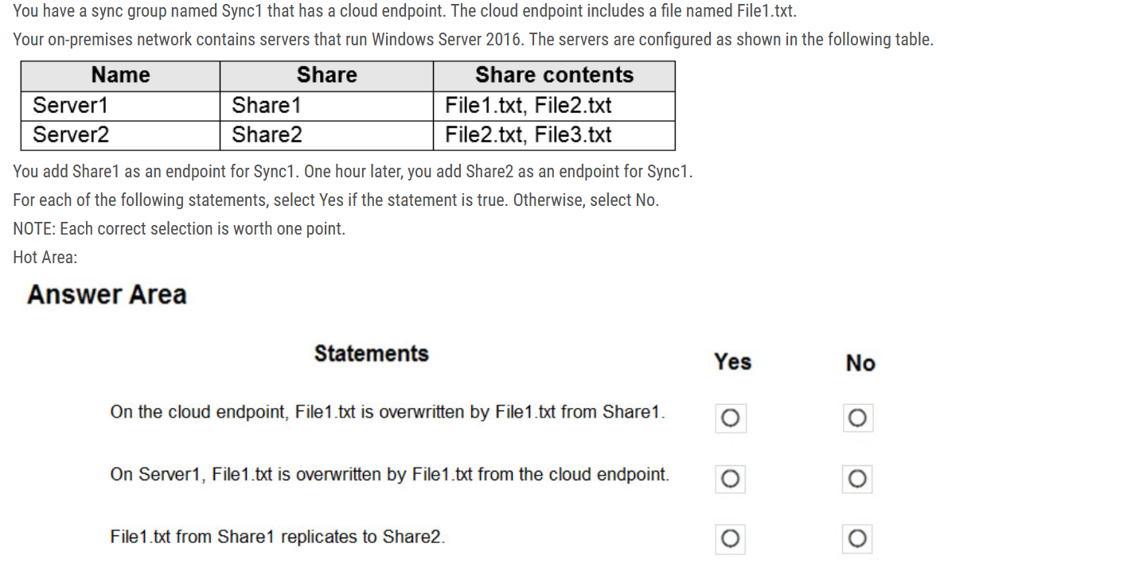

Answer is NO, NO, YES: Azure File Sync uses a simple conflict-resolution strategy: we keep both changes to files that are changed in two endpoints at the same time. The most recently written change keeps the original file name. The older file (determined by LastWriteTime) has the endpoint name and the conflict number appended to the filename. For server endpoints, the endpoint name is the name of the server. For cloud endpoints, the endpoint name is Cloud

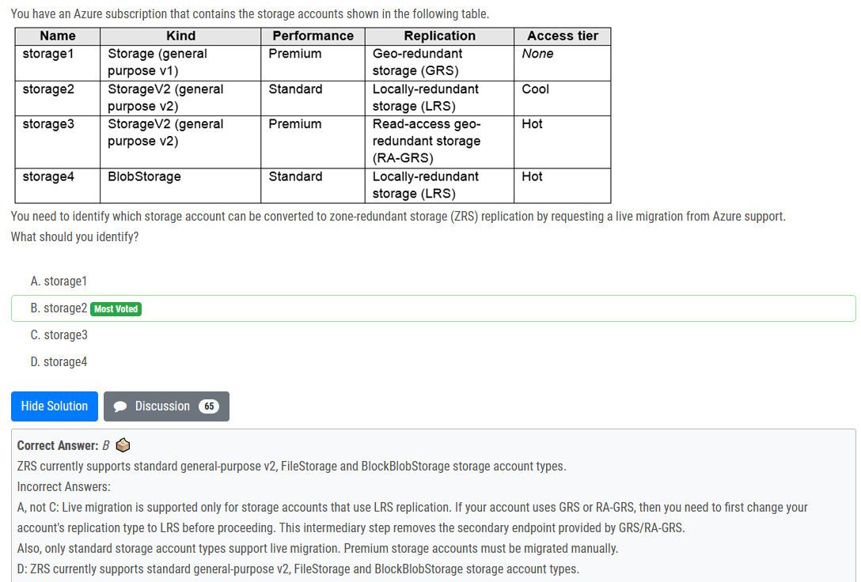

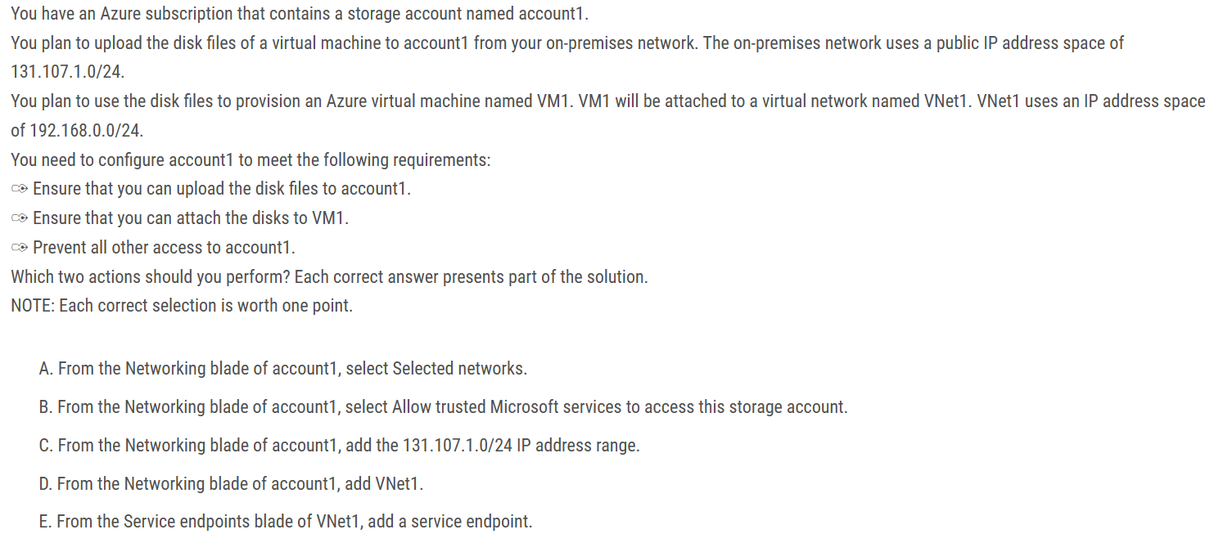

ans: A , C

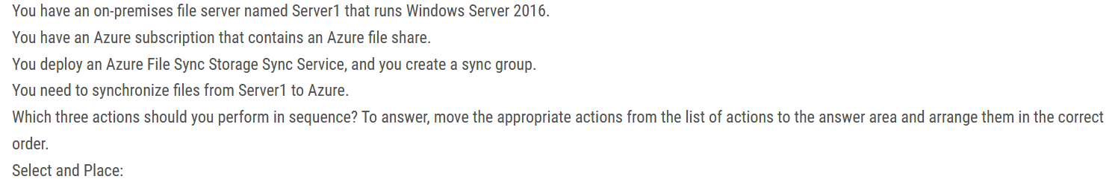

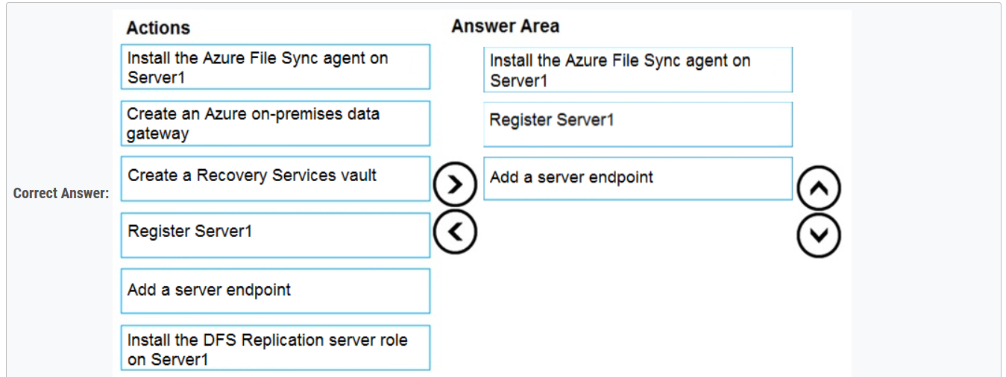

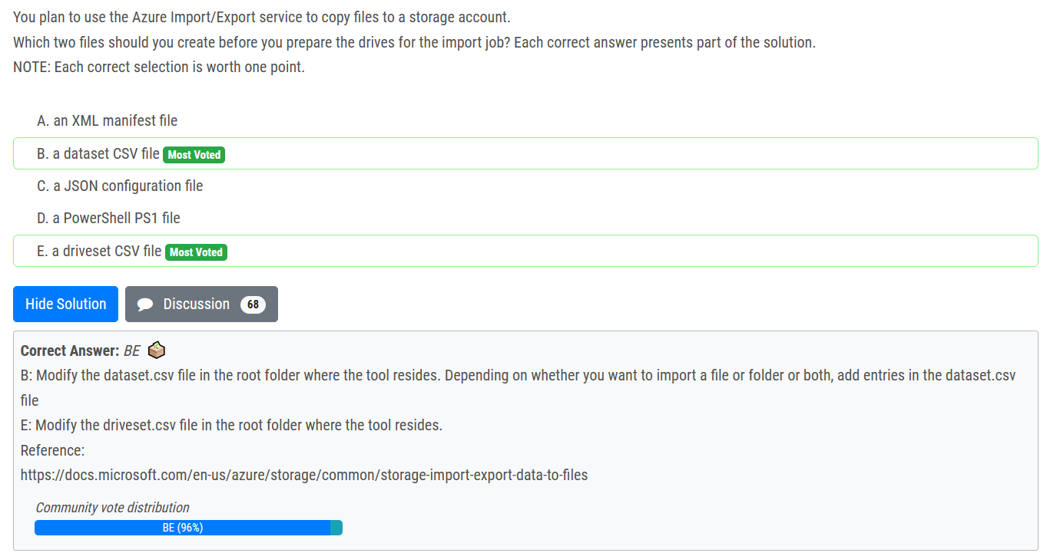

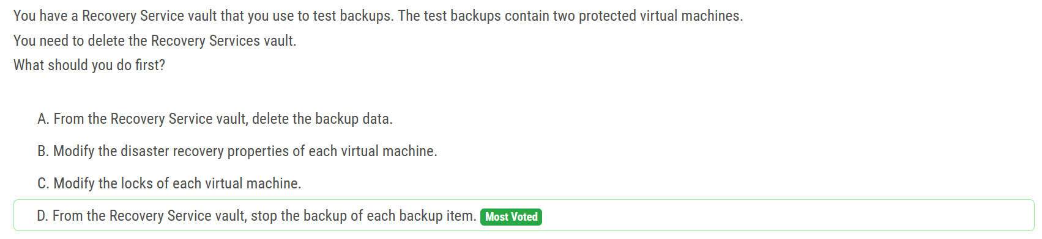

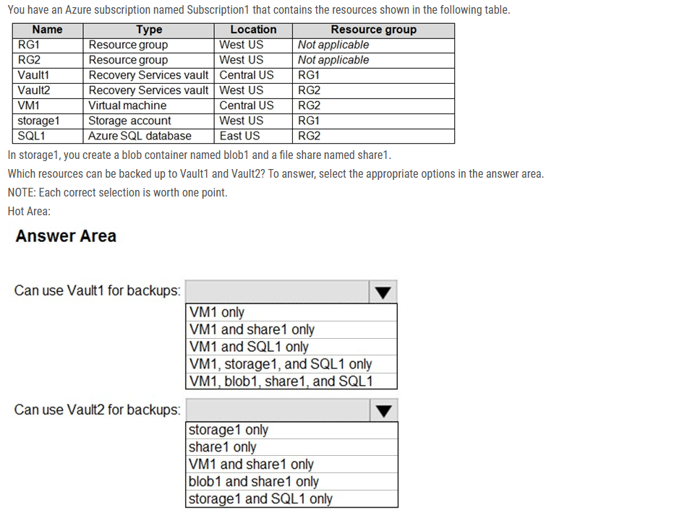

Box 1: VM1 only -  
VM1 is in the same region as Vault1

Box 2: Share1 only.

for Blob, you can use backup vault not recovery service vault to backup

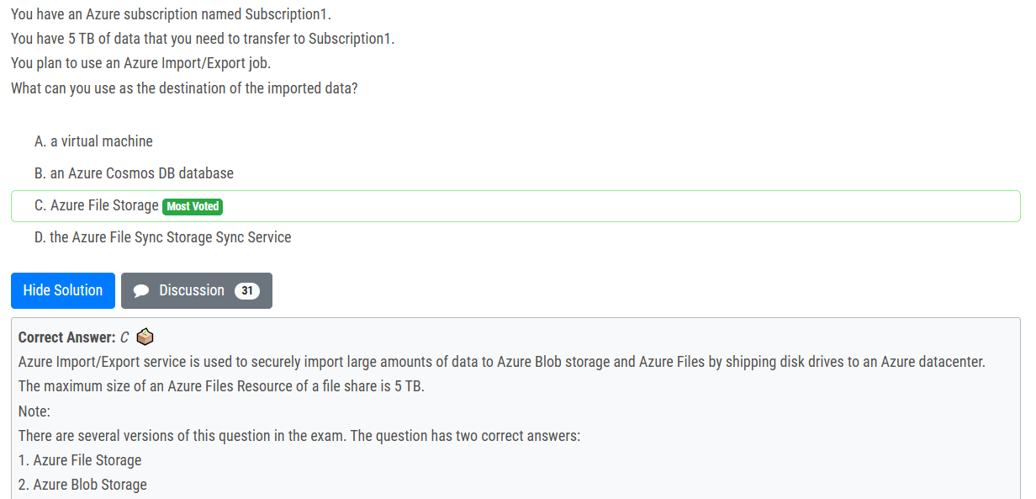

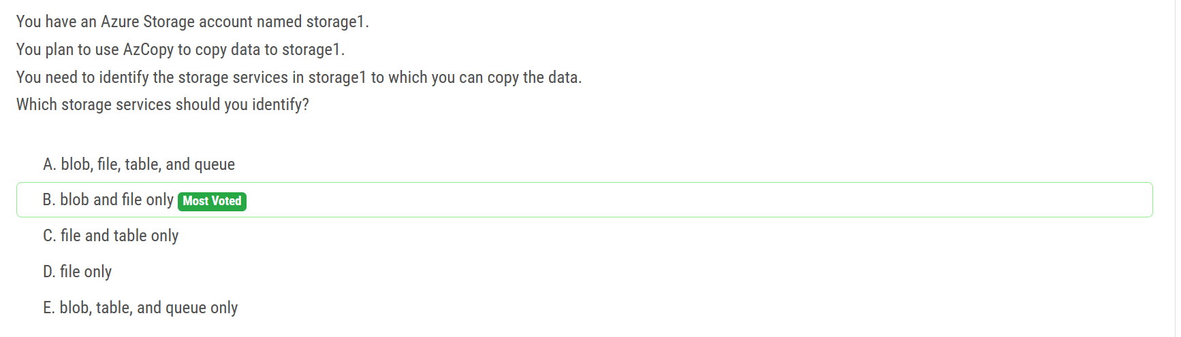

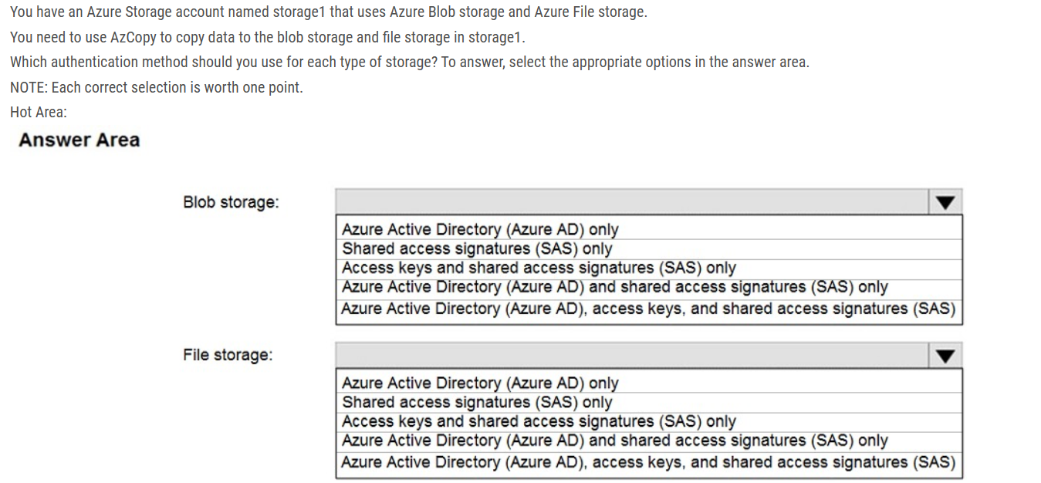

Box 1:  
Both Azure Active Directory (AD) and Shared Access Signature (SAS) token are supported for Blob storage.  
Box 2:  
Only Shared Access Signature (SAS) token is supported for File storage.

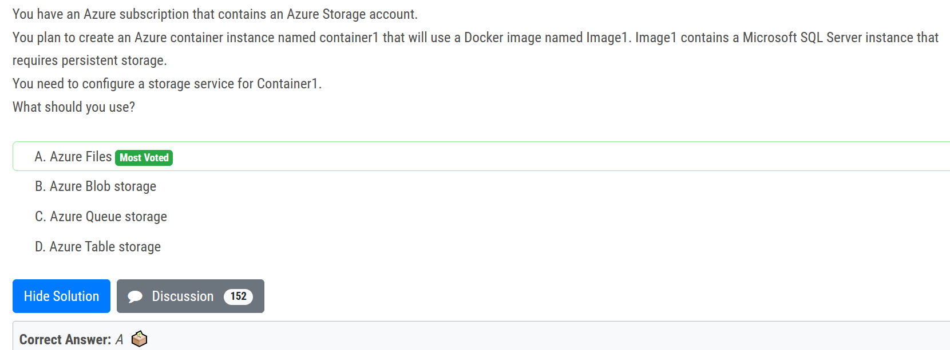

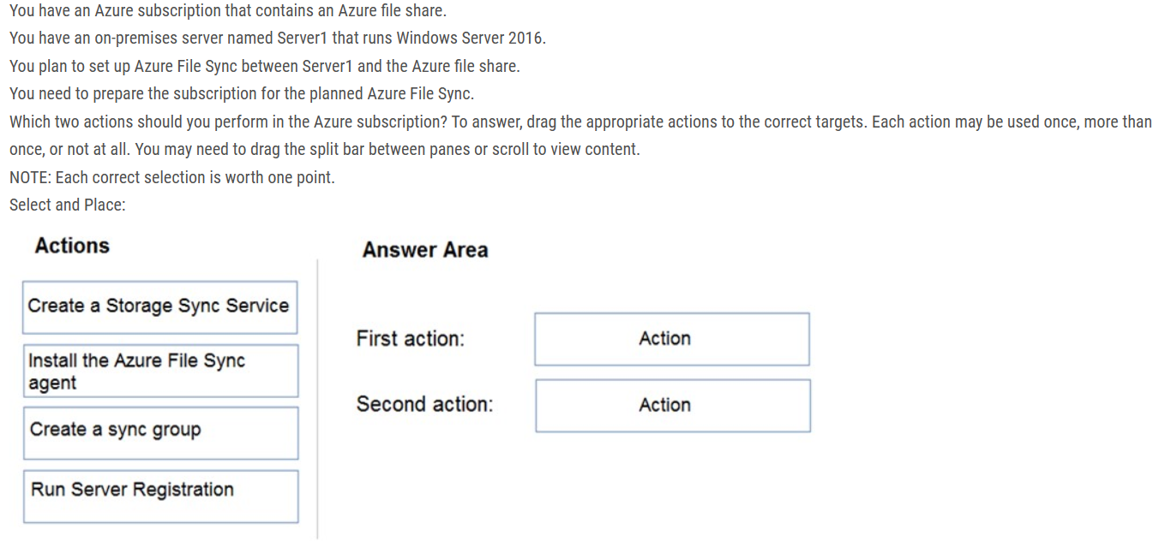

the question is very specific as to which actions to be performed in AZURE SUBSCRIPTION. The answer should be CREATE STORAGE SYNC SERVICE and CREATE SYNC GROUP. The installation of the agent will be on-premise server. So, this action is not taking place in Azure Subscription.

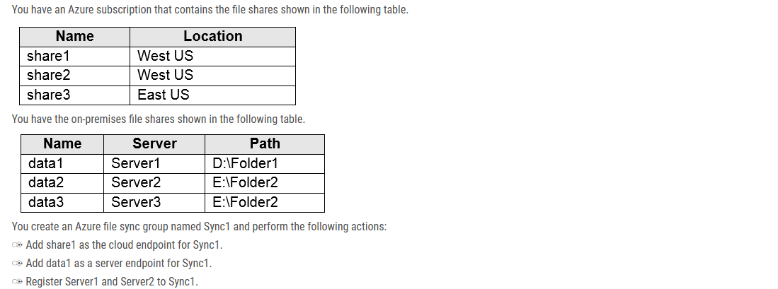

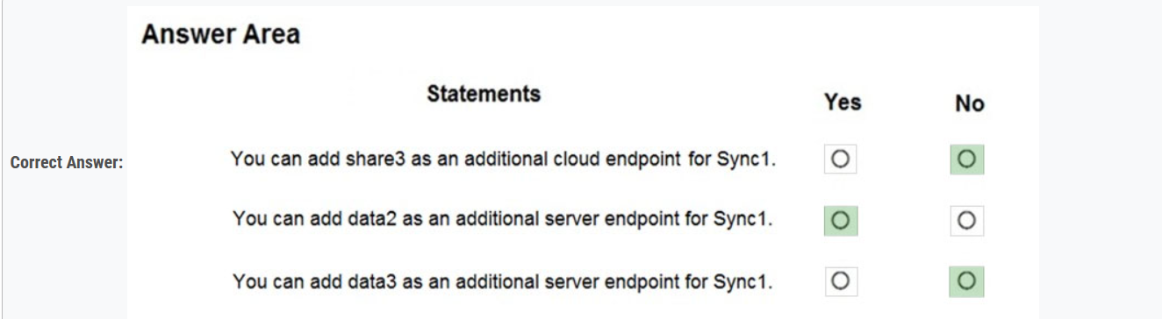

NO - only one cloud endpoint can be added to sync1

YES - Server2 has been registered to Sync1 but data2 is not added to server endpoint. So we can add data2 as additional server endpoint for Sync1

NO - We have to register Server3 first

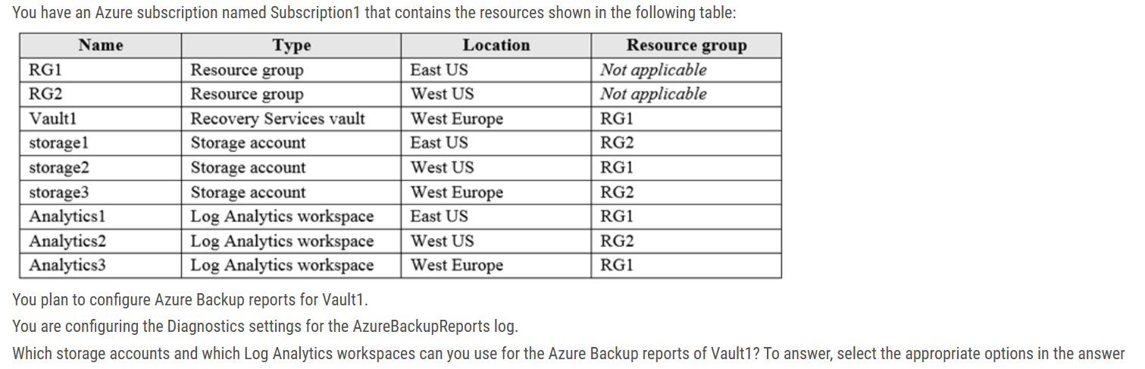

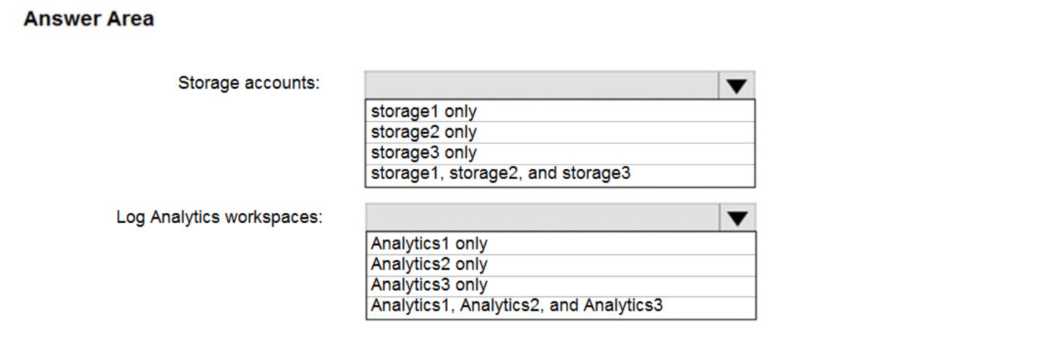

Storage accounts: Storage 3 only --Storage Account must be in the same Region as the Recovery Services Vault.

Log Analytics workspaces: Analytics1, Analytics2, and Analytics3 --Set up one or more Log Analytics workspaces to store your Backup reporting data. The location and subscription where this Log Analytics workspace can be created is independent of the location and subscription where your Vaults exist.

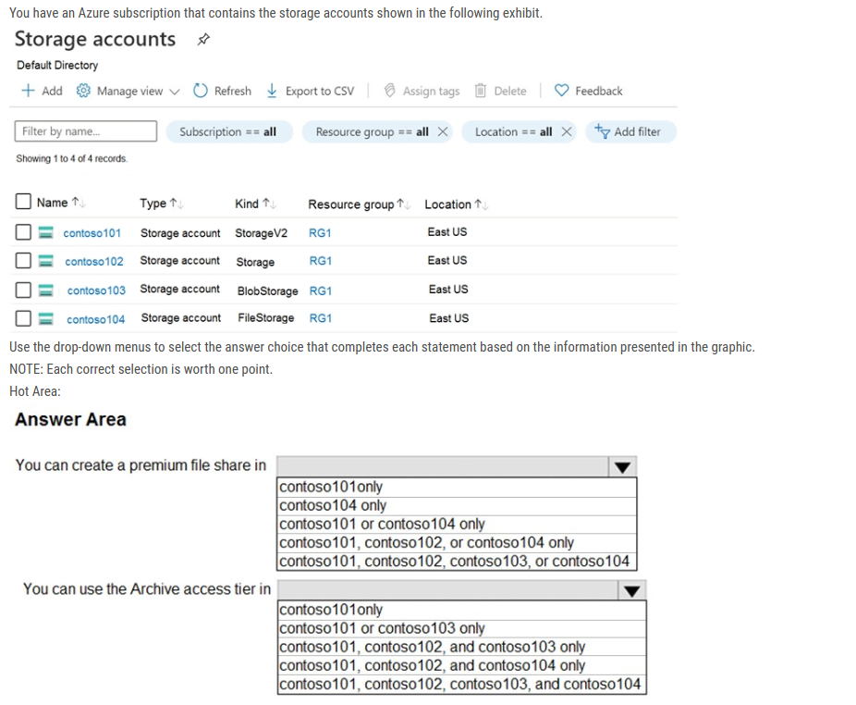

Box 1: contoso104 --only Premium file shares are hosted in a special purpose storage account kind, called a FileStorage account.

Box 2: contoso101 and contos103 only

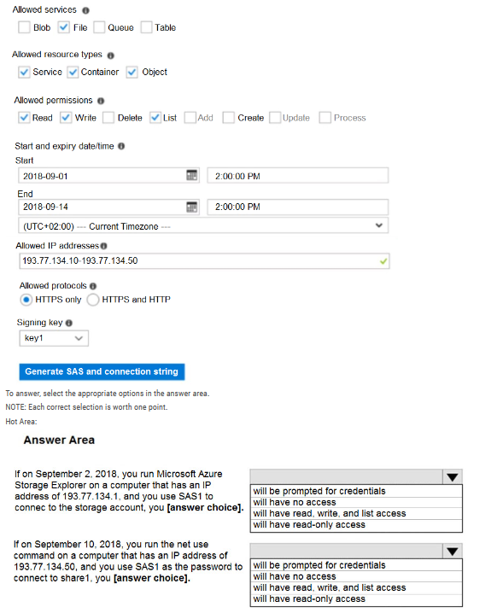

Box 1: will have no access The IP 193.77.134.1 does not have access on the SAS, because it is not matching the SAS requirements. IP is out of range.

Box 2: will have no access The SAS token is not supported in mounting Azure File share currently, it just supports the Azure storage account key. Since it is using "net use" where it uses SMB, the SMB (Server Message Broker) protocol does not support SAS. it still asks for username/password. Accordingly, it will give error wrong username/pass and will not provide access.

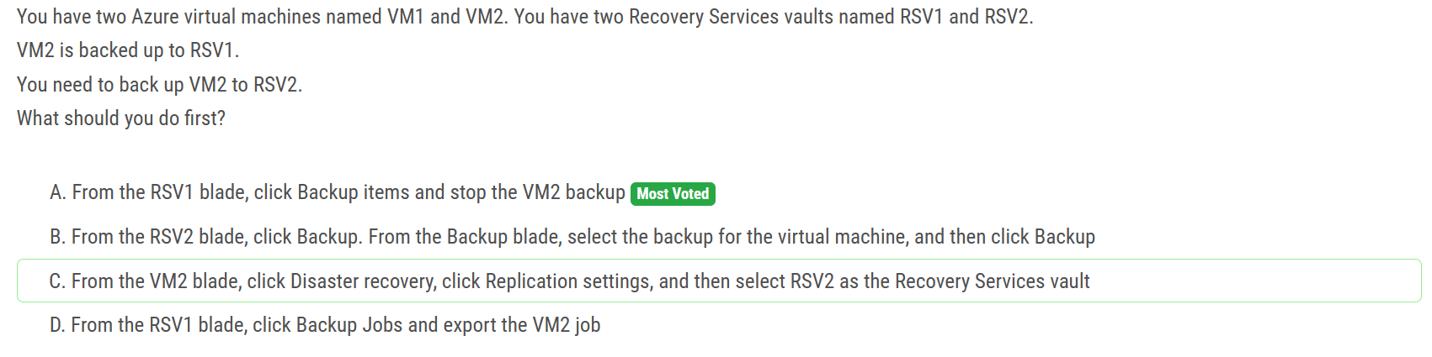

Ans is A : VMs can only be backed up in a single vault.

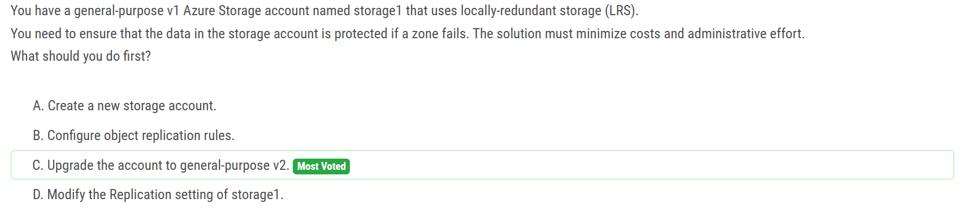

v1 supports GRS/RA-GRS but question was about least cost. Least cost is ZRS which is only supported for v2 and premium file/block storage.

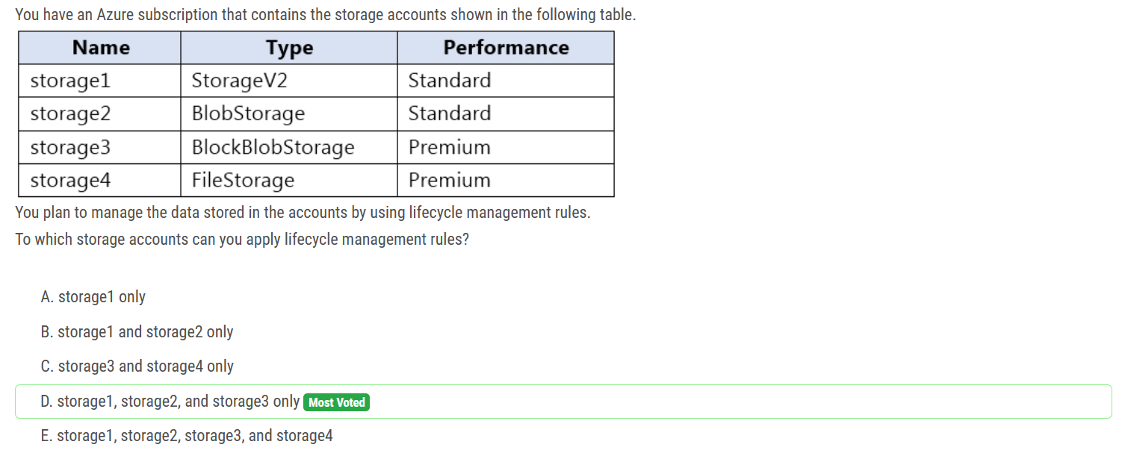

The lifecycle management feature is available in all Azure regions for general purpose v2 (GPv2) accounts, blob storage accounts, premium block blobs storage accounts, and Azure Data Lake Storage Gen2 accounts.

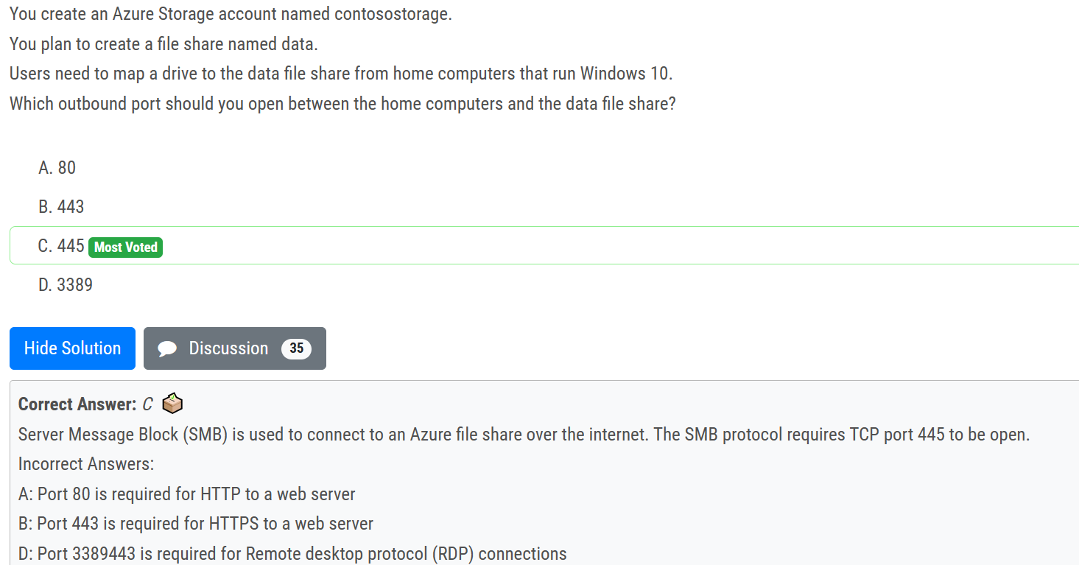

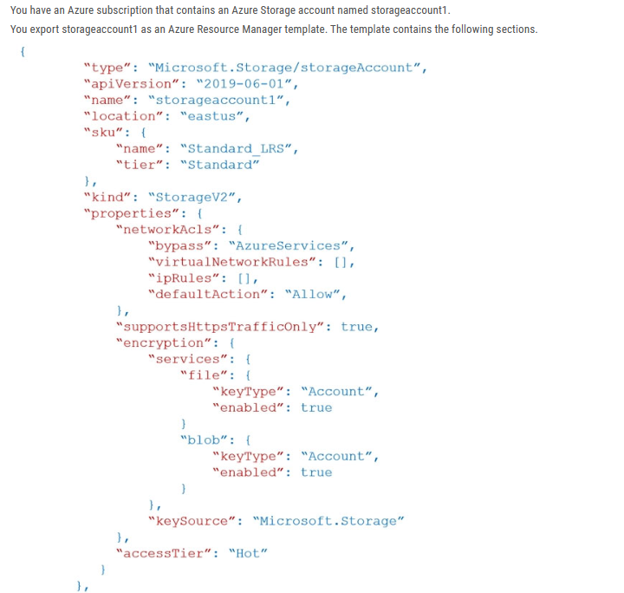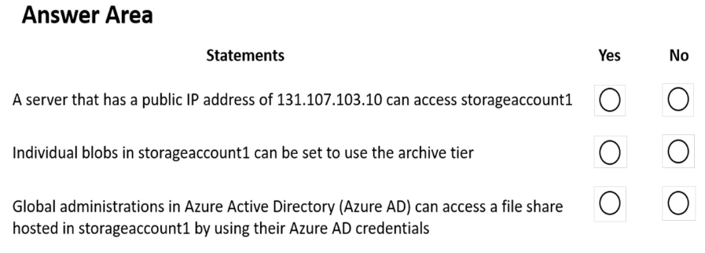

Yes - allow is set Yes - v2 can do tiering No - AAD roles are separated from the Subscription.

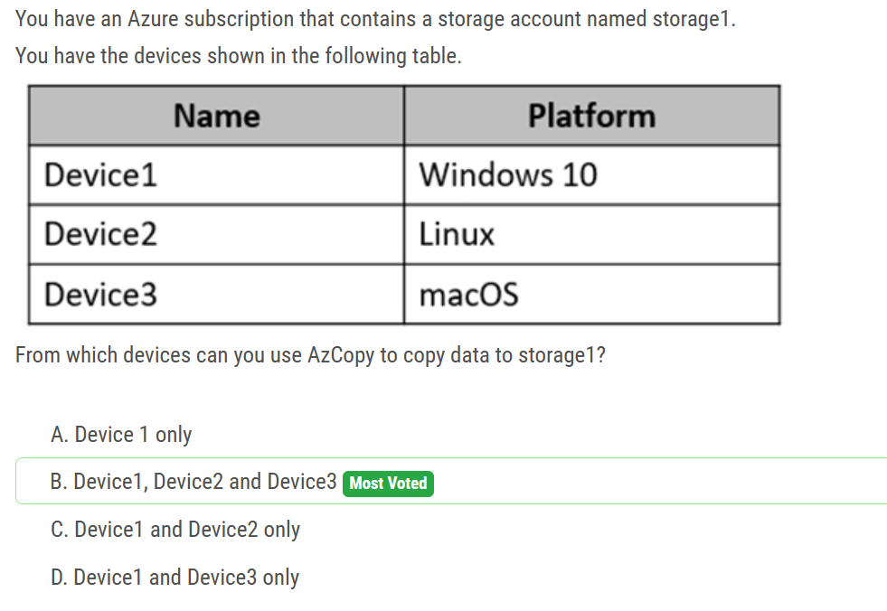

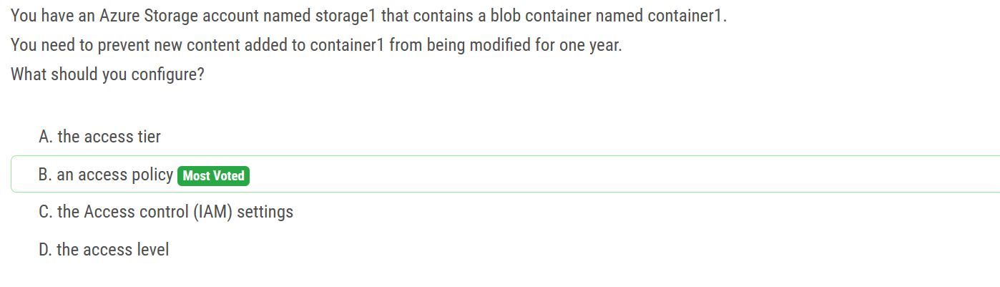

Access policy "While in a WORM state, data cannot be modified or deleted for a user-specified interval. By configuring immutability policies for blob data, you can protect your data from overwrites and deletes."

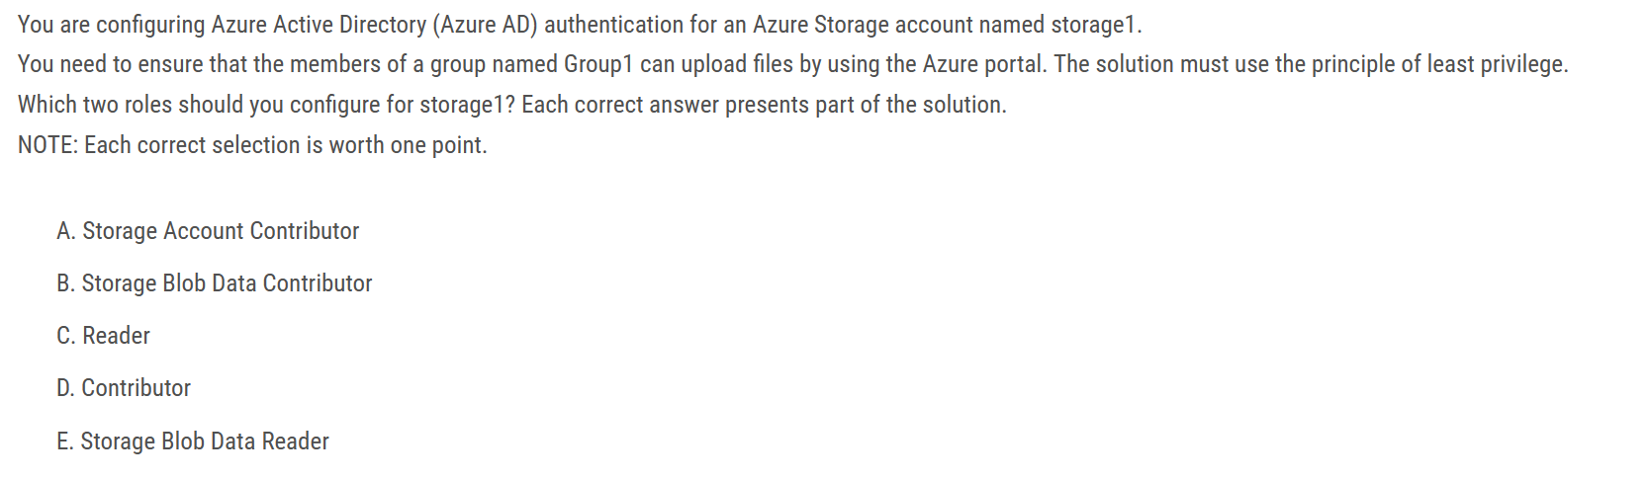

B) "Storage Blob Data Contributor" & C) "Reader" The following line says it all: "The Reader role is an Azure Resource Manager role that permits users to view storage account resources, but not modify them. It does not provide read permissions to data in Azure Storage, but only to account management resources. The Reader role is necessary so that users can navigate to blob containers in the Azure portal. For example, if you assign the Storage Blob Data Contributor role to user Mary at the level of a container named sample-container, then Mary is granted read, write, and delete access to all of the blobs in that container. However, if Mary wants to view a blob in the Azure portal, then the Storage Blob Data Contributor role by itself will not provide sufficient permissions to navigate through the portal to the blob in order to view it. The additional permissions are required to navigate through the portal and view the other resources that are visible there."

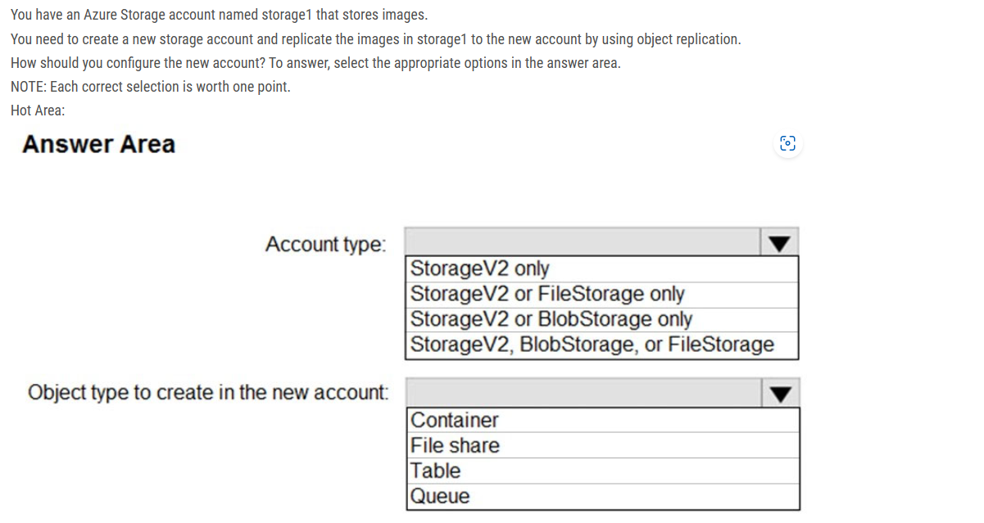

Account type: StorageV2 only, Object type to create in the new account: Container

Object Replication supports General Purpose V2 and Premium Blob accounts. Blob versioning should be enabled on both the source and destination storage account. Change feed is enabled on the source storage account.

Legacy Block blob storage does not support object replication. BlobStorage specifically refers to Legacy Block Blob storage while Premium Block Blob storage is always referenced as BlockBlobStorage

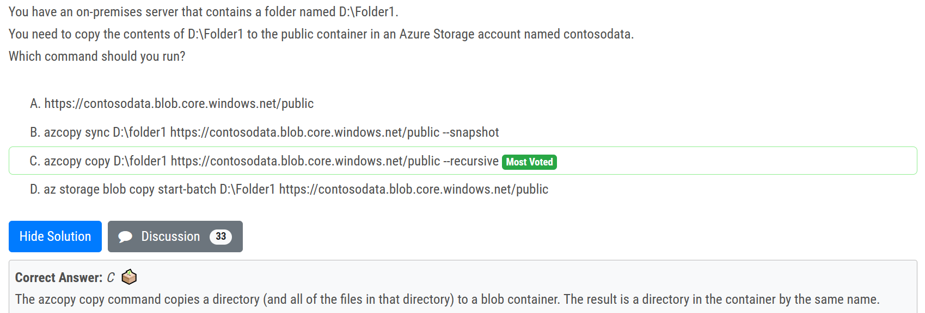

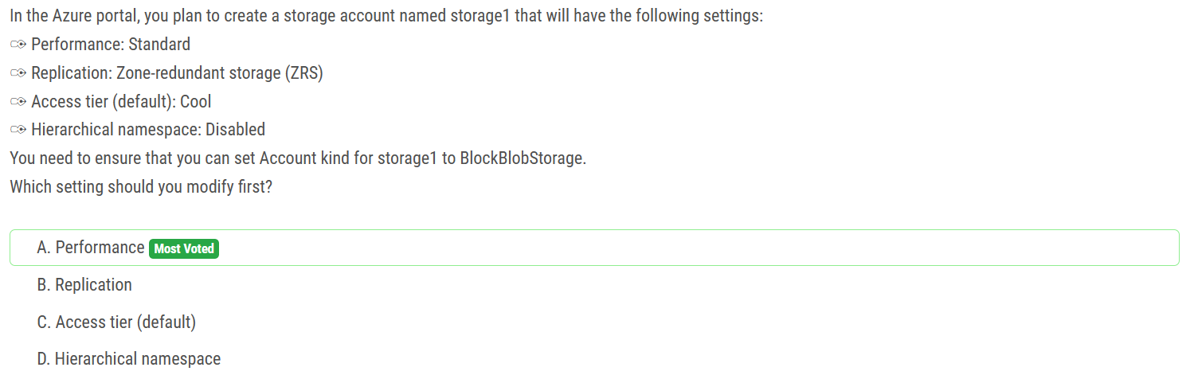

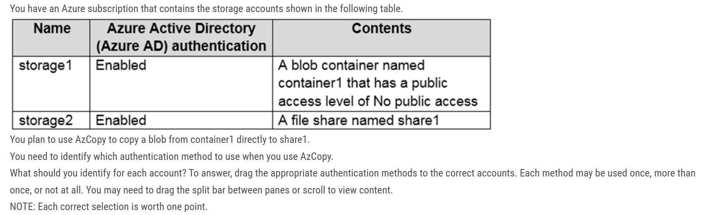

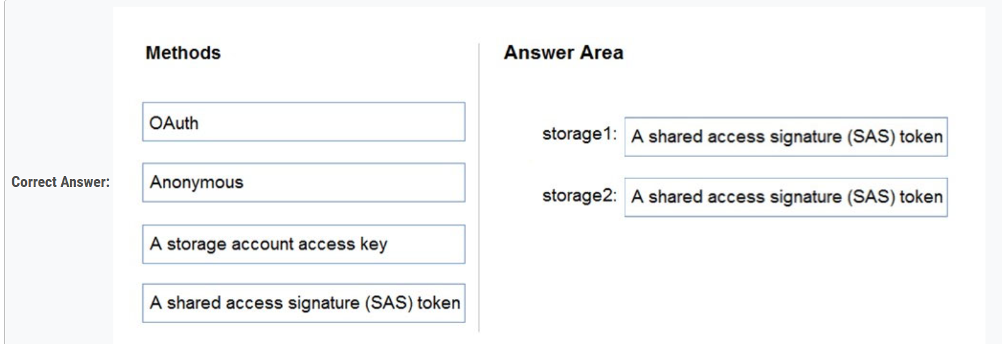

Blob Storage: Support both Azure Active Directory (AD) and Shared Access Signature (SAS) token. File Storage: Only Shared Access Signature (SAS) token is supported.

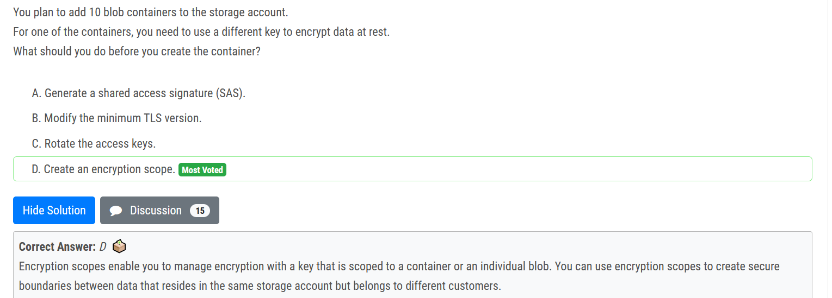

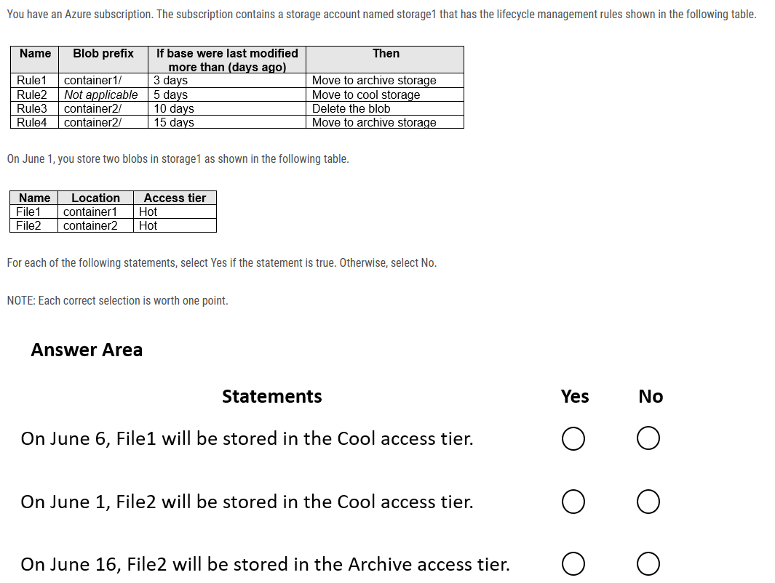

N-N-N

On June 6, File1 will be in archive because File1 is in container 1, and rule 1 applies 3 days after june 1. Once a blob is in the archive can't move until rehydration;

On June 1, File2 will still be in Hot tier because File2 is in container2, Rule3 and Rule4 havent hit yet.

On June 16, File2 will be deleted because Rule3 applies 10 days after June 1.

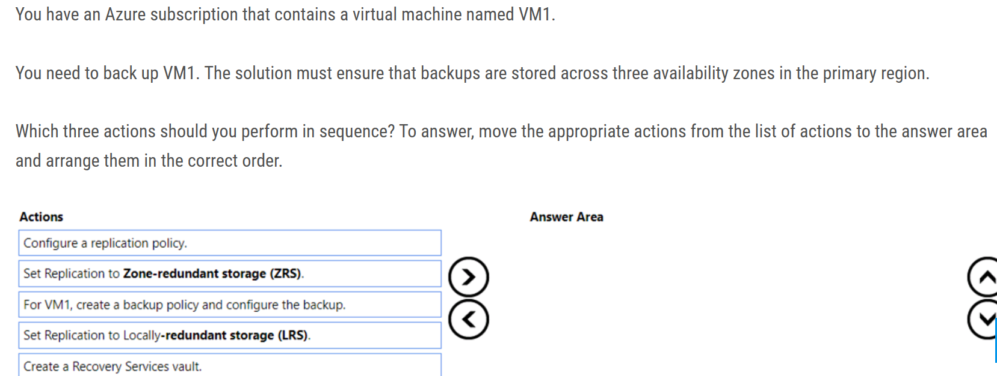

1. Create Recovery Services Vault, 2. Set Replication Policy to ZRS (because of the requirement for having in three separate zones) 3. For VM1, create a backup policy

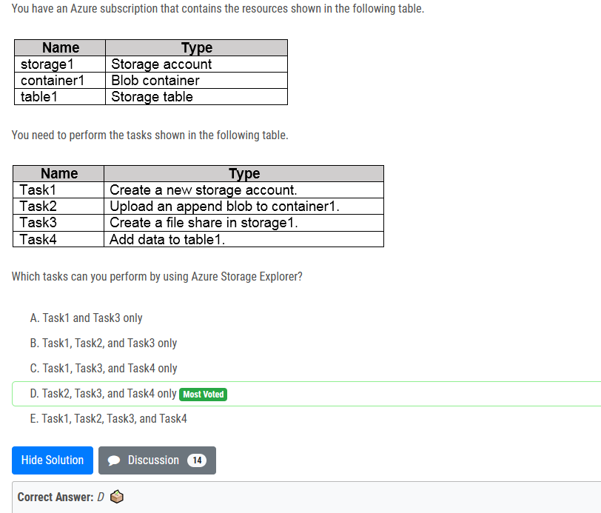

Azure Storage Explorer does what is states, it explores Storage, not create it.

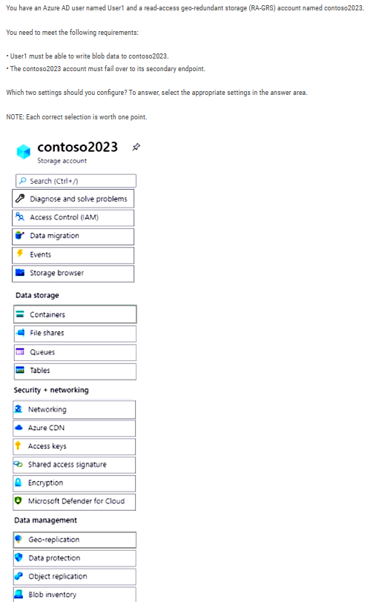

IAM to give user the access. GEO Replication to set the policy;

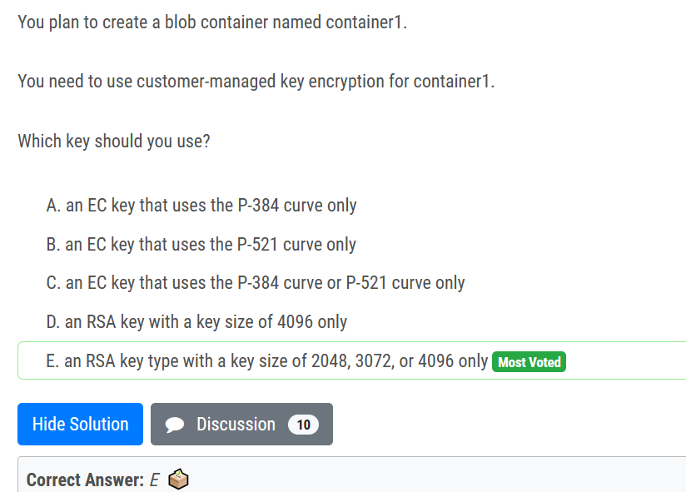

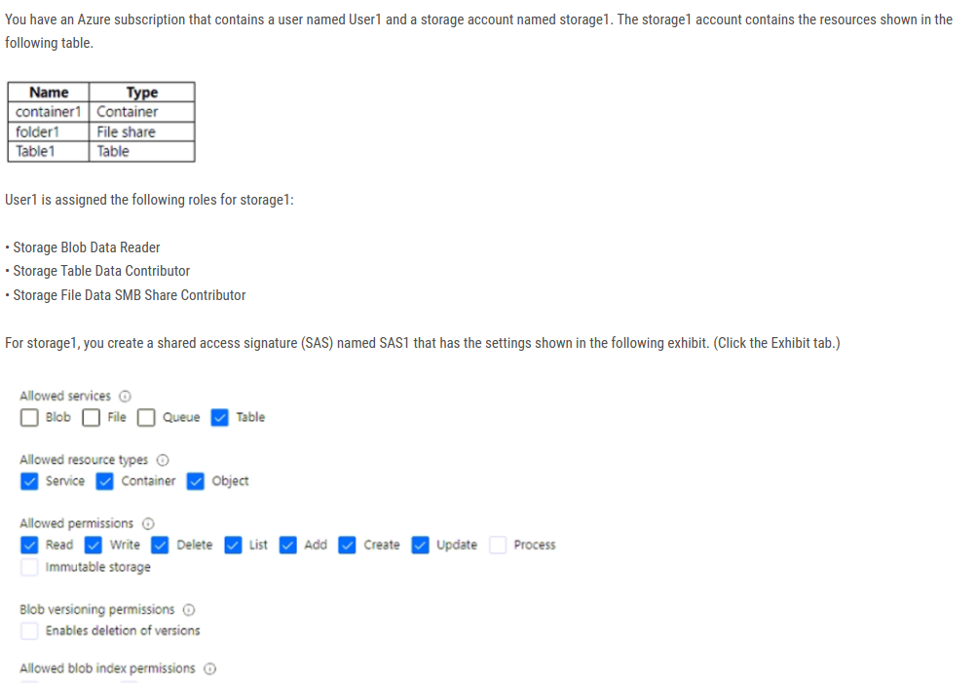

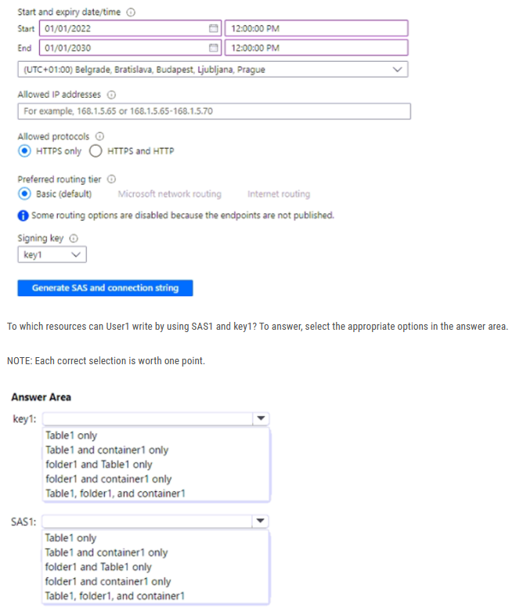

- key1 - full access to entire storage (RBAC roles doesn't apply here)

- SAS - table1 only

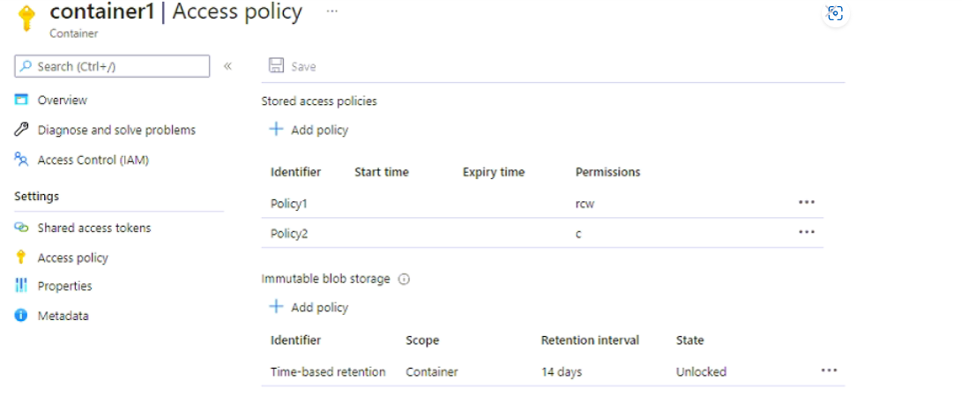

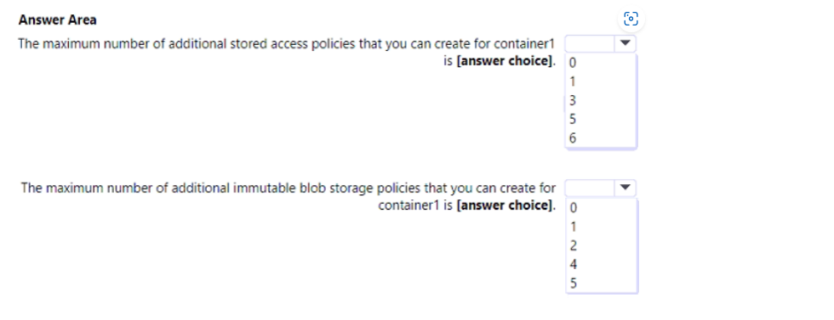

Ans : 3 1

Maximum number of Stored access policies is 5

Maximum number of Immutable blob storage is 2 -- one Legal hold policy and one Time-based retention policy

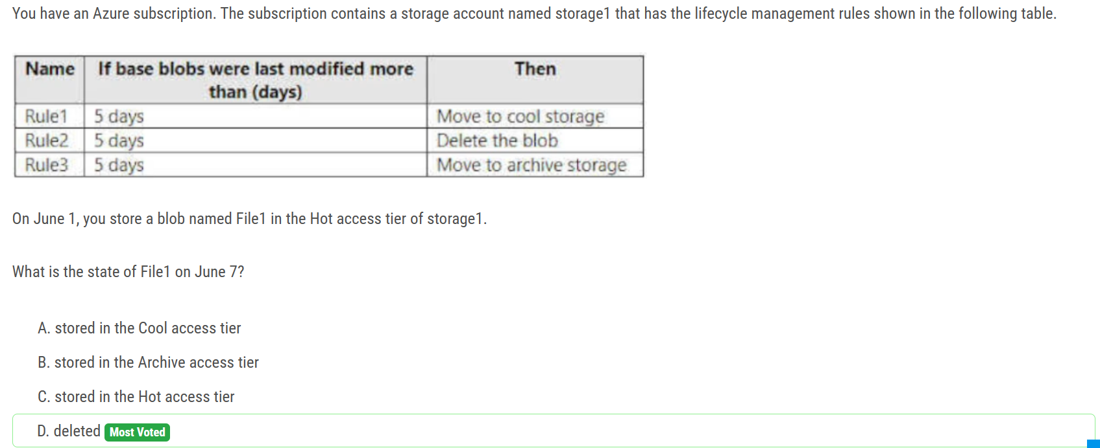

If you define more than one action on the same blob, lifecycle management applies the least expensive action to the blob. For example, action delete is cheaper than action tierToArchive. Action tierToArchive is cheaper than action tierToCool.

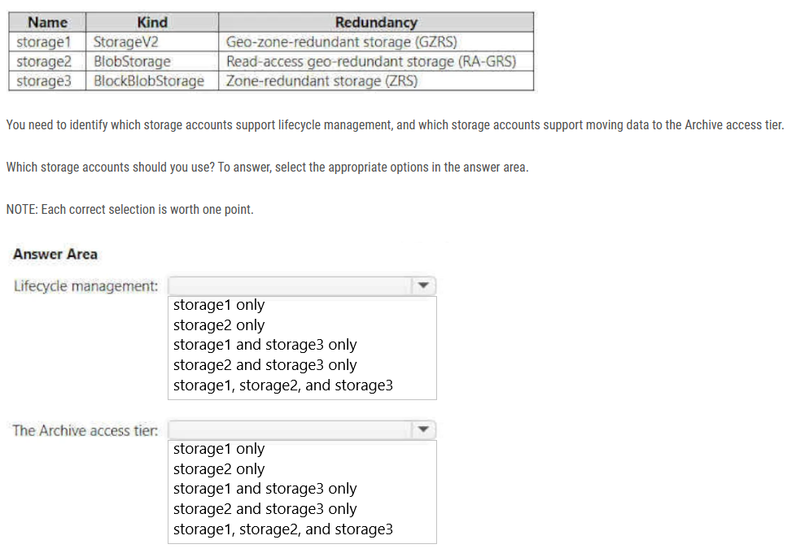

1 - storage1, storage2, storage3-- Lifecycle management policies are supported for block blobs and append blobs in general-purpose v2, premium block blob, and Blob Storage accounts.

2 - storage2 Only storage accounts that are configured for LRS, GRS, or RA-GRS support moving blobs to the archive tier. The archive tier isn't supported for ZRS, GZRS, or RA-GZRS accounts.

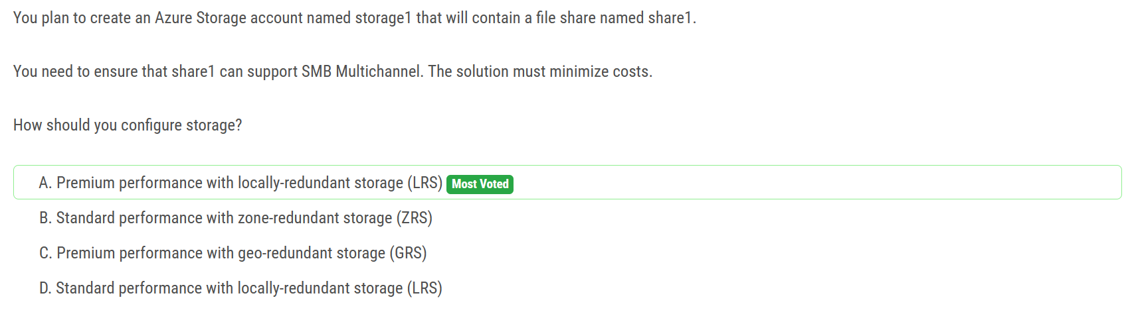

According to documentation only Premium file shares (FileStorage), LRS/ZRS are supported for SMB.

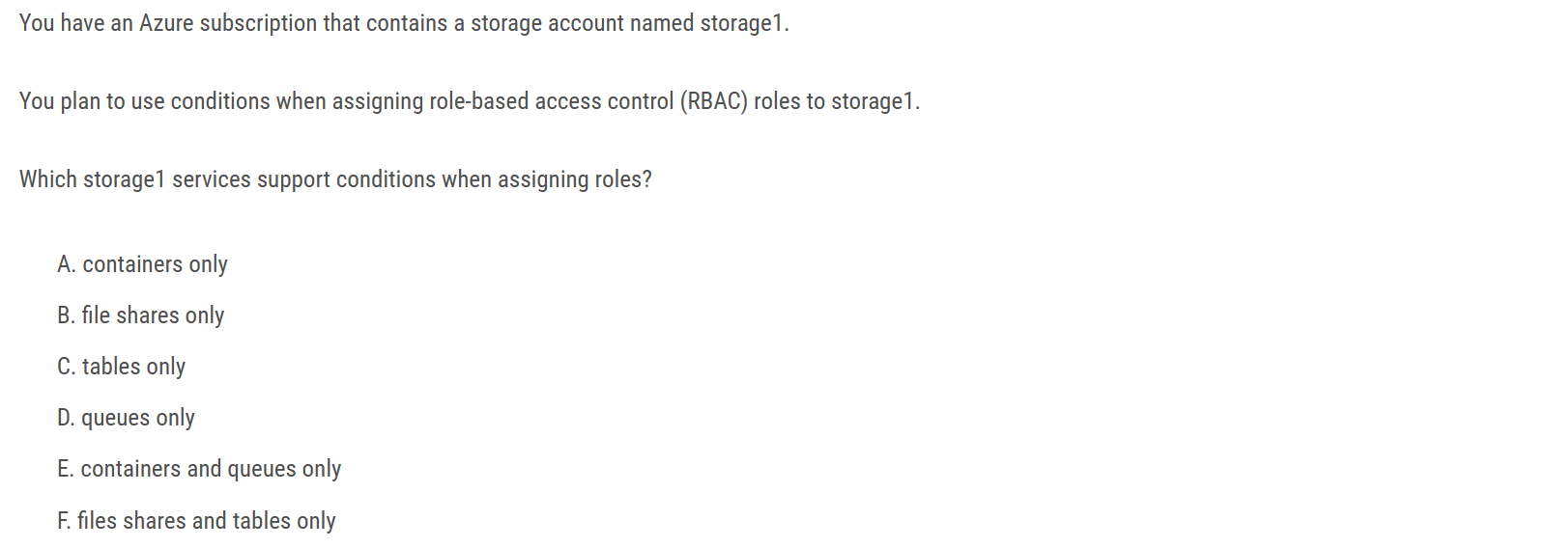

Ans: E

Currently, conditions can be added to built-in or custom role assignments that have blob storage or queue storage data actions

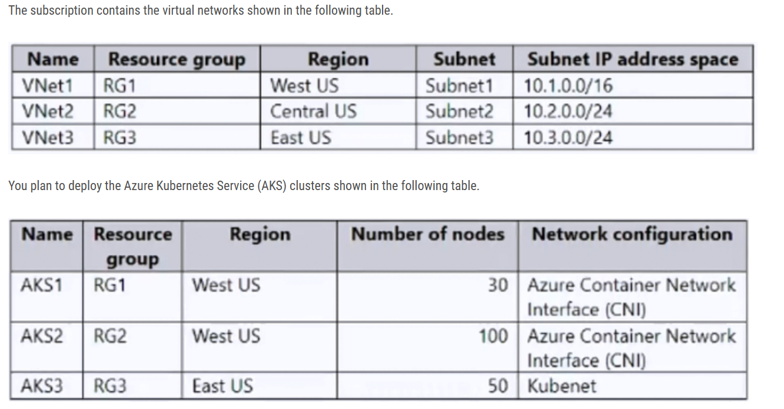

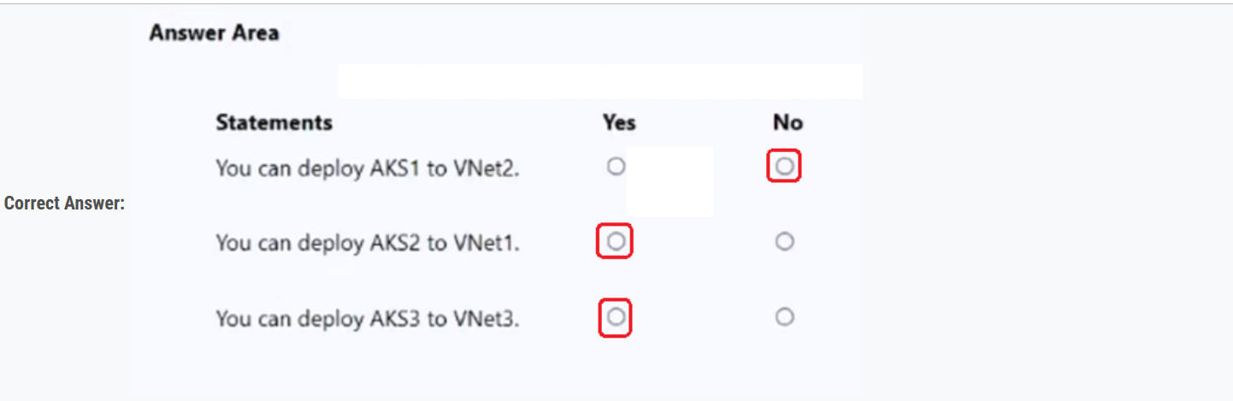

1. N subnet is not in the same location as cluster "If you want to select an existing virtual network, make sure it's in the same location and Azure subscription as your Kubernetes cluster."

2. Y azure cni network in same loacation as cluster and within the total pod no. limit

3. Y "Bring your own subnet and route table with kubenet .With kubenet, a route table must exist on your cluster subnet(s). AKS supports bringing your own existing subnet and route table."

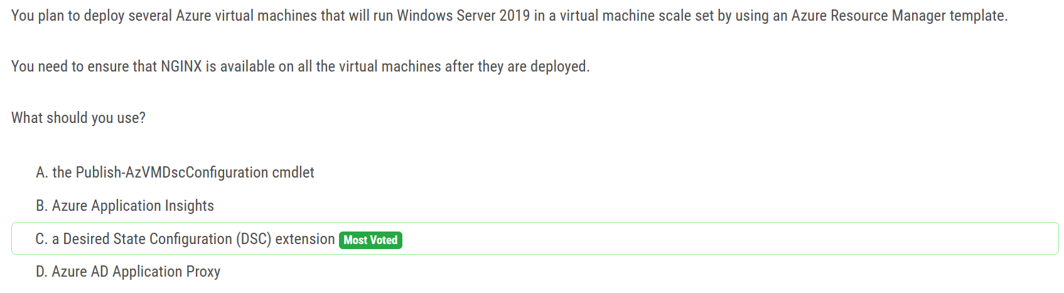

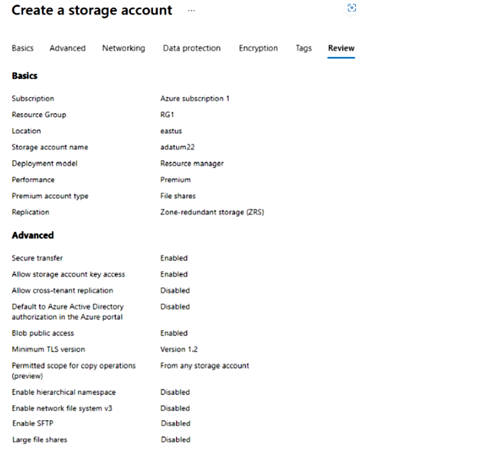

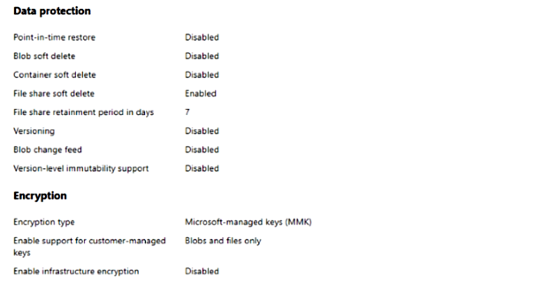

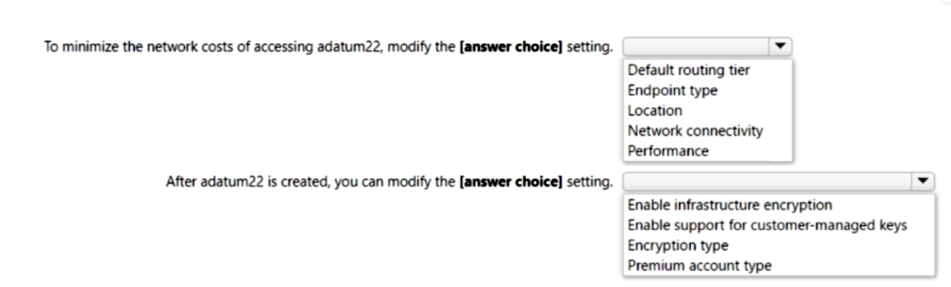

Minimize network cost - Default routing tier to Internet Routing

After creation you can modify - Encryption type

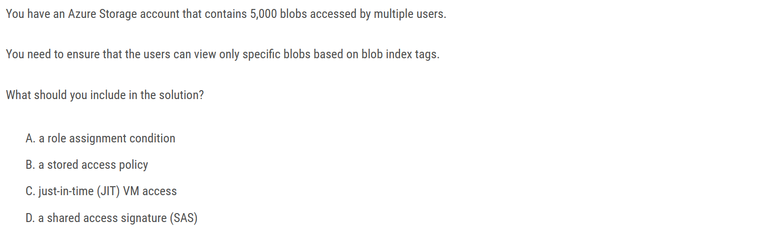

Ans : A

Azure ABAC builds on Azure RBAC by adding role assignment conditions based on attributes in the context of specific actions. A role assignment condition is an additional check that you can optionally add to your role assignment to provide more fine-grained access control. A condition filters down permissions granted as a part of the role definition and role assignment. For example, you can add a condition that requires an object to have a specific tag to read the object. You cannot explicitly deny access to specific resources using conditions.

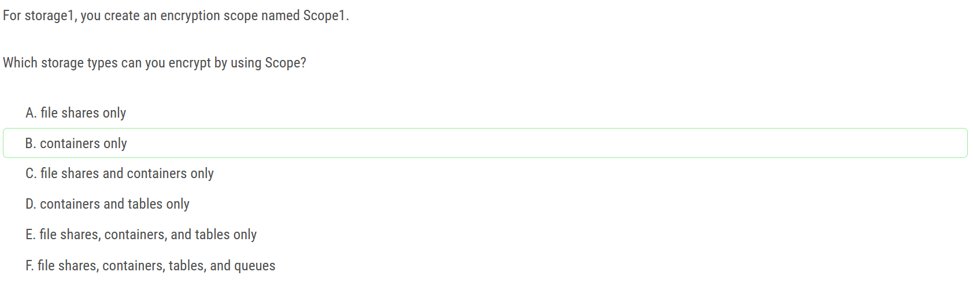

"Encryption scopes enable you to manage encryption at the level of an individual blob or container."

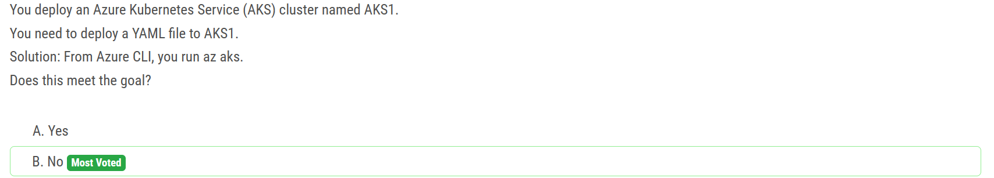

To deploy the YAML file you need to runs kubectl apply -f file_name.yaml

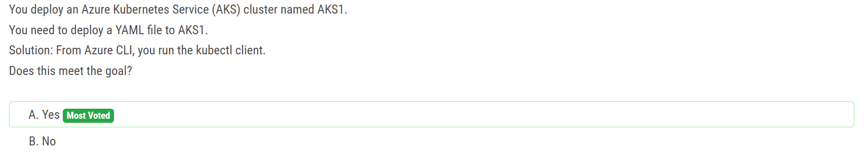

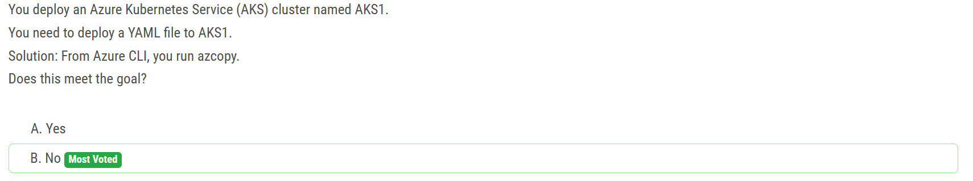

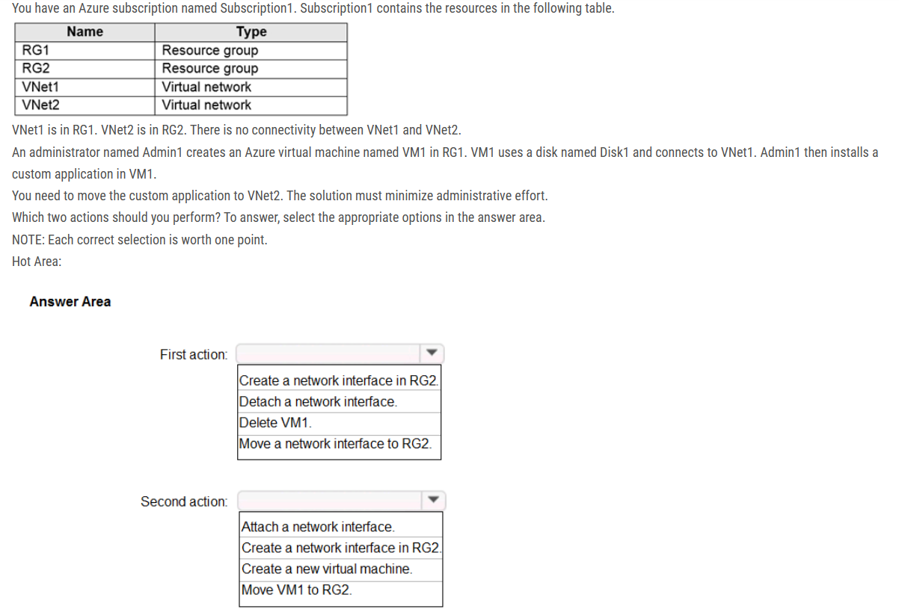

We cannot just move a virtual machine between networks. What we need to do is identify the disk used by the VM, delete the VM itself while retaining the disk, and recreate the VM in the target virtual network and then attach the original disk to it.

You can change the subnet a VM is connected to after it's created, but you cannot change the VNet

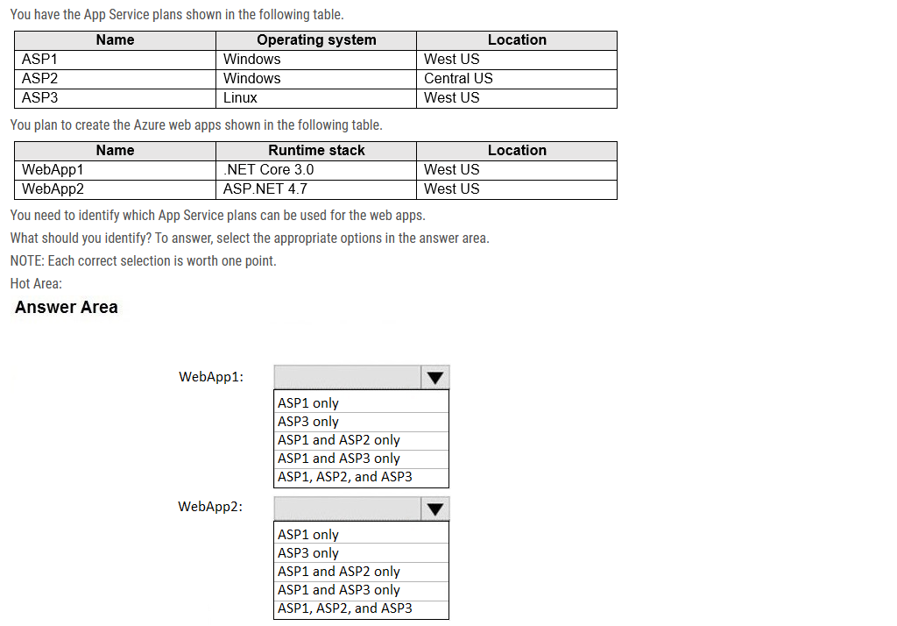

Box 1: ASP1 and ASP3 --only ASP.NET Core apps can be hosted both on Windows or Linux. The region in which your app runs is the region of the App Service Plan is in. ASP2 is in Central US, not the same as WebApp1. Different locations.

Box 2: ASP1 only ASP.NET apps can be hosted on Windows only. Only ASP1 is in the same Location as the WebApp2 (West US).

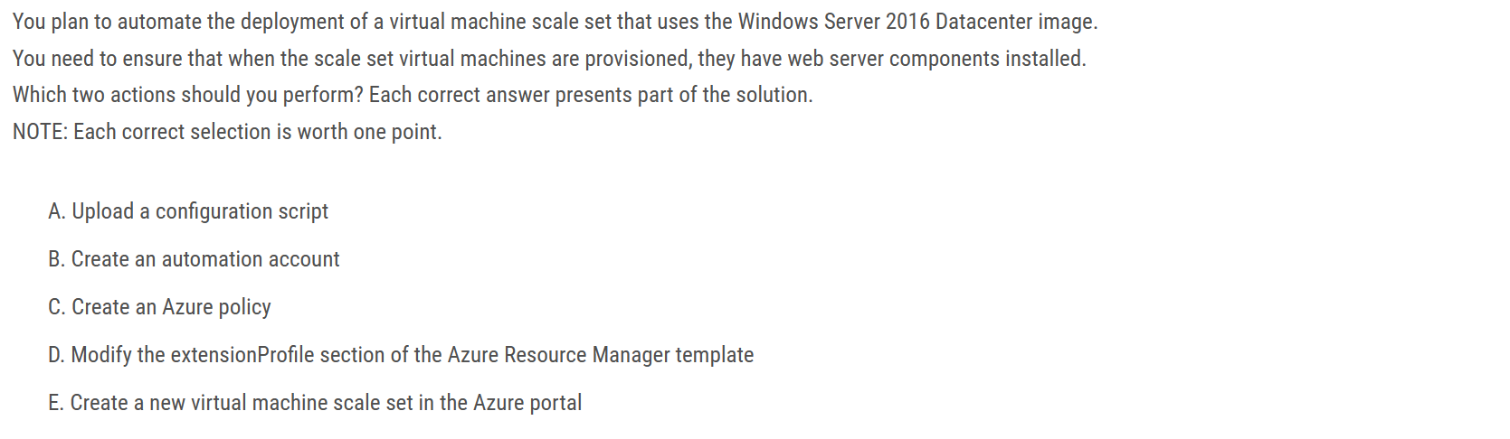

Ans : A - D

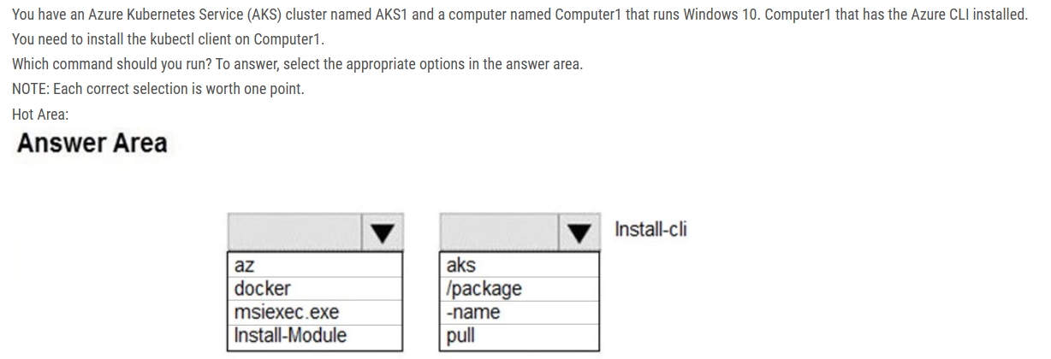

To install kubectl locally, use the az aks install-cli command.

Note: Azure cli commands start with az. We use Install-Module to install a Powershell module.

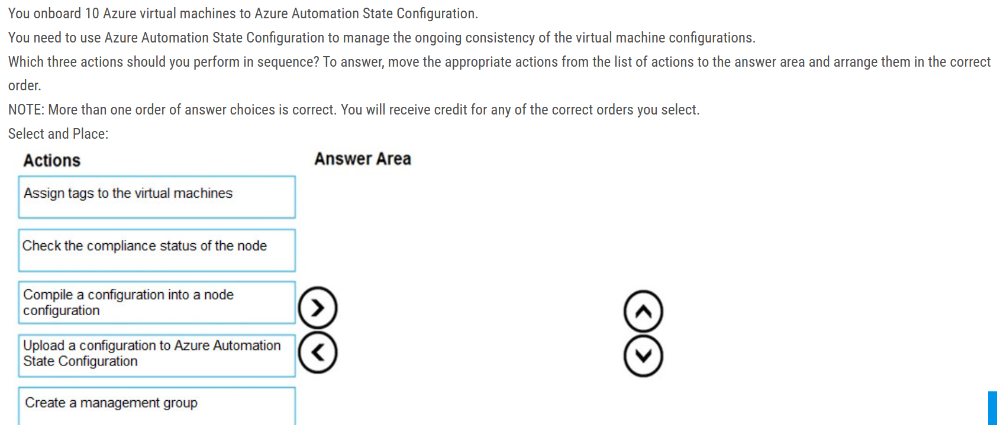

1. Upload a configuration to Azure Automation State Configuration 2. Compile a configuration into a node configuration 3. Check the compliance status of the node.

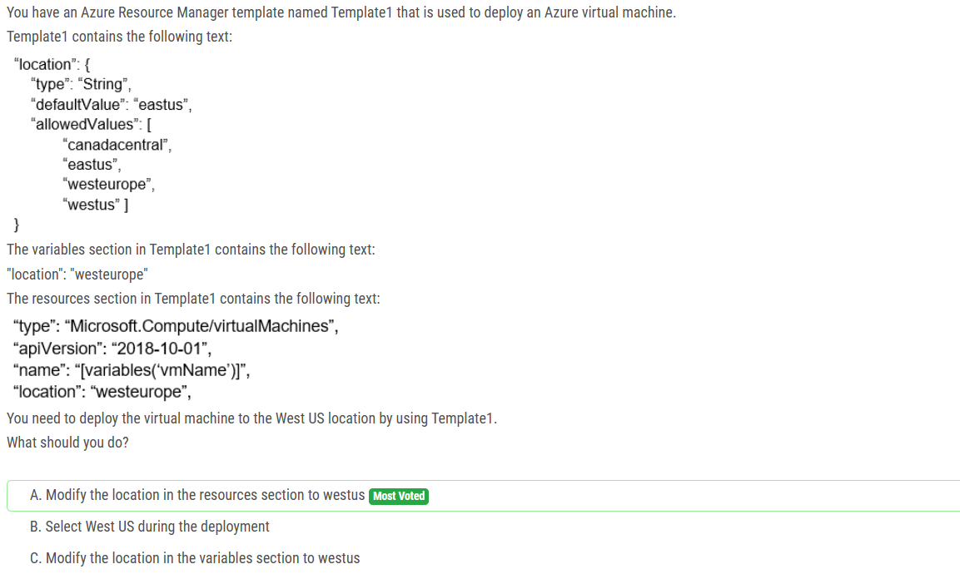

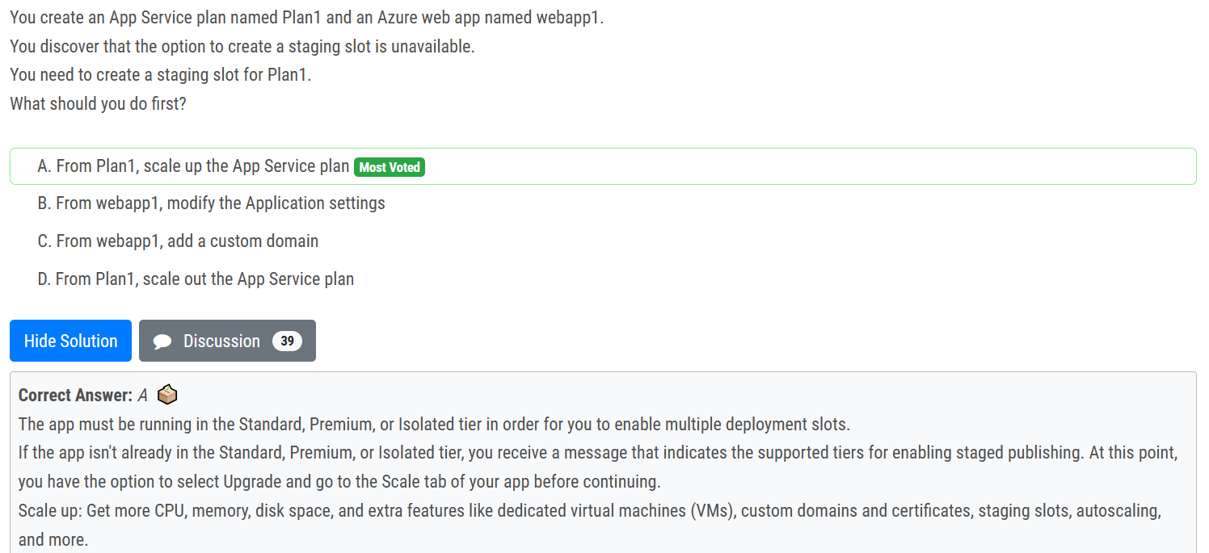

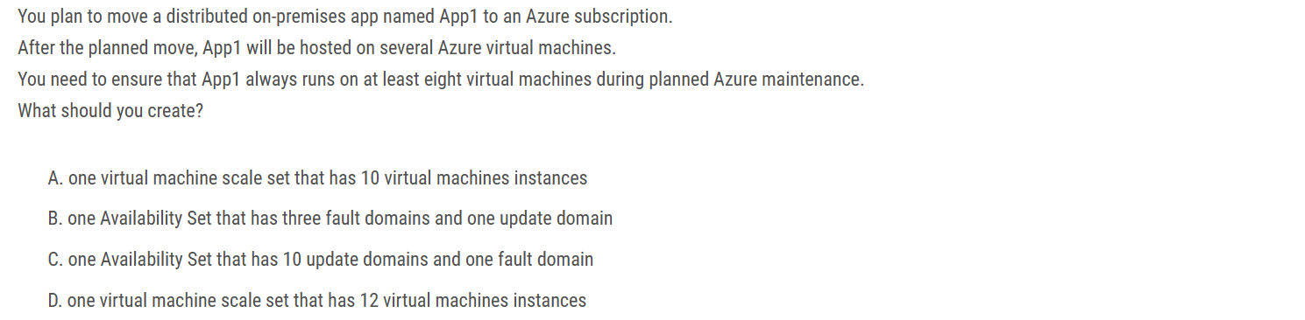

The correct Answer is A. First: in case you created on fault domain, you are limited with one update domain. You can test this. Second: By default, Azure uses 5 update domains and up to 3 fault domains. So, In case you created 10 vm in scale set. then you will have 2 vm in each update domain. So once one update domain is not available, then you get 4 domains with 8 vms as required.

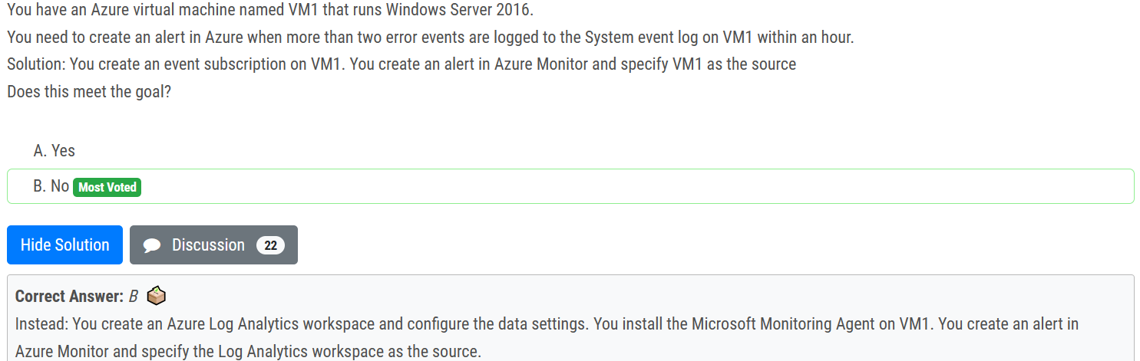

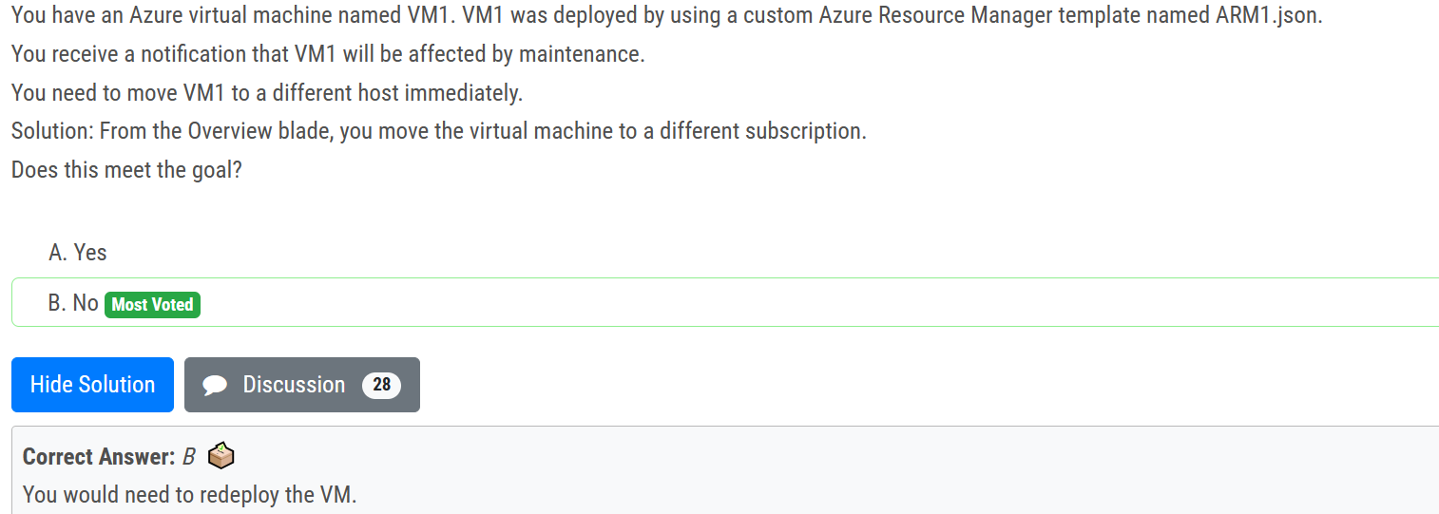

Changing Subscription won't affect the downtime, it will just you change the billing. You would need to redeploy the VM. After you redeploy a VM, the temporary disk is lost, and dynamic IP addresses associated with virtual network interface are updated.

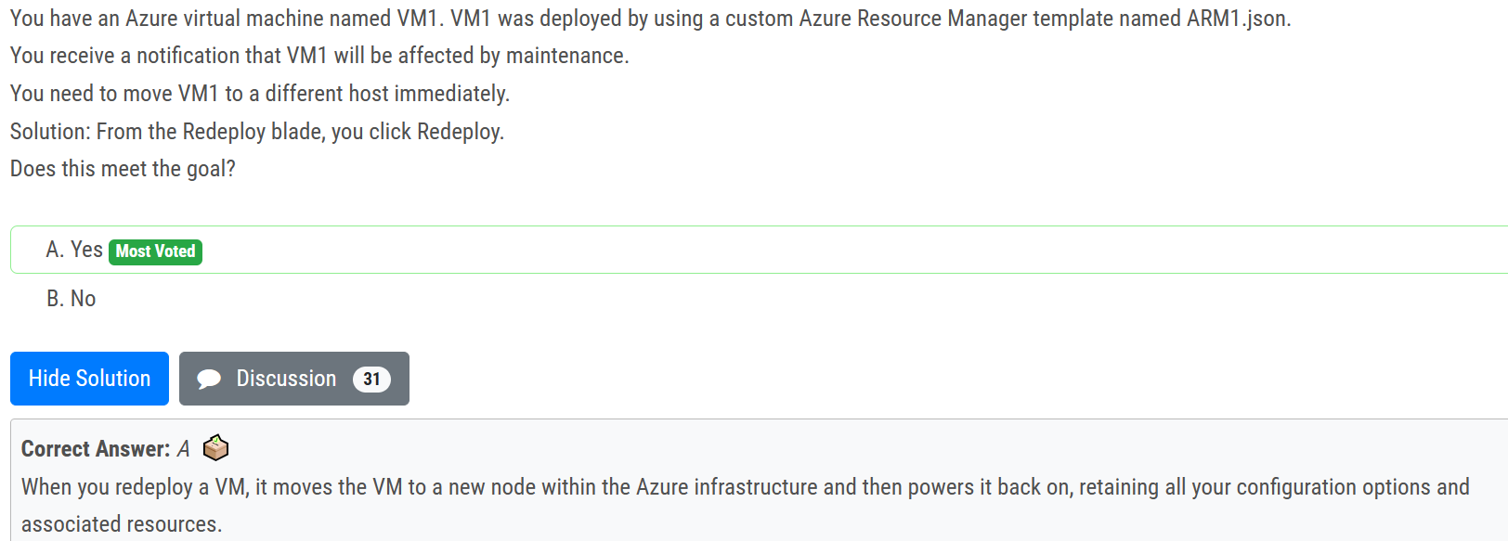

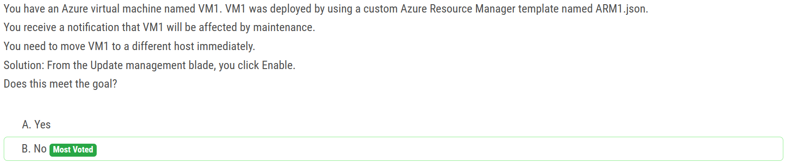

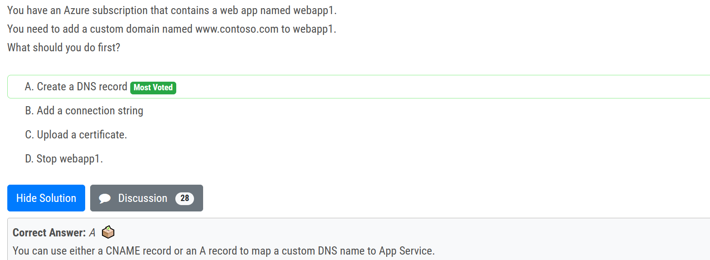

U can use either a CNAME record or an A record to map a custom DNS name to App Service and as per traditional AD DS, always best use CNAMEs for custom records except the root record--- Also as NOTE: dont confuse this app service custom domain with Azure custom domains where the later requires either MX or TXT record

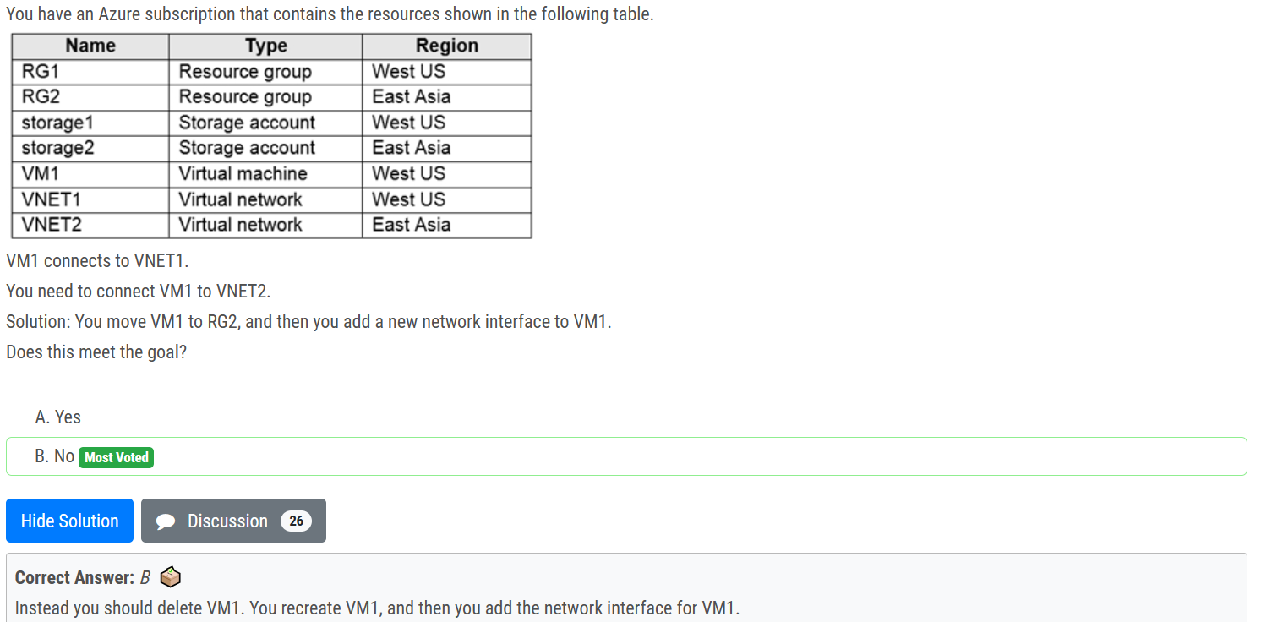

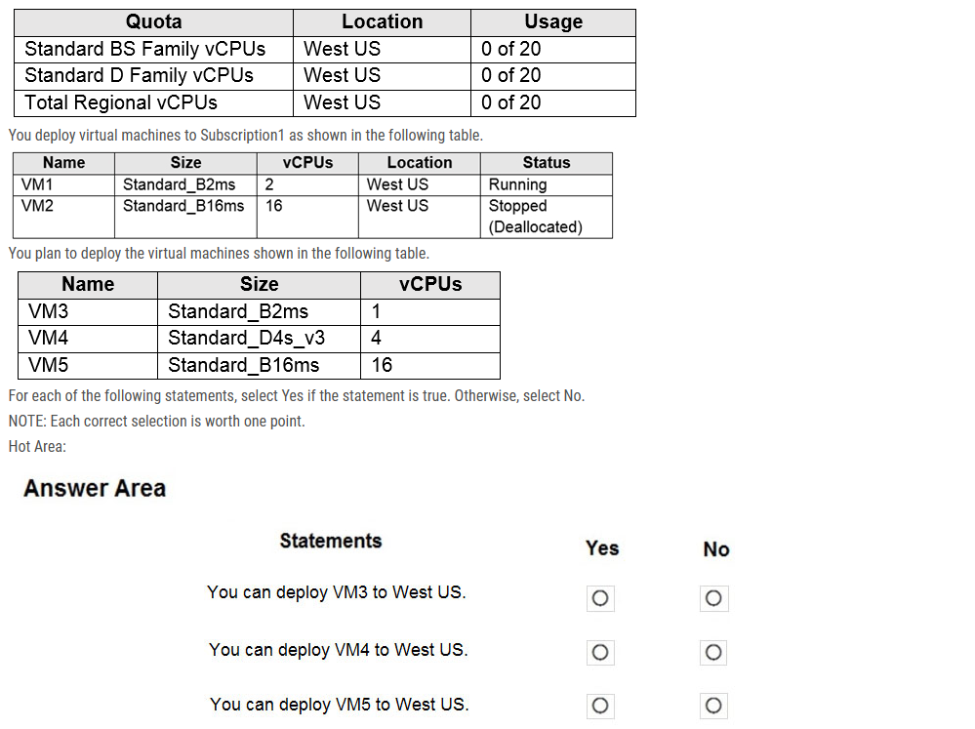

Box 1: Yes We can add 1 vCPU. 2 vCPUs (VM1) + 16 vCPUs (VM20) + 1 vCPU (VM3) = 19 vCPUs

Box 2: No We cannot add 4 vCPUs. 2 vCPUs (VM1) + 16 vCPUs (VM20) + 4 vCPU (VM4) = 22 vCPUs

Box 3: No We cannot add 16 vCPU. 2 vCPUs (VM1) + 16 vCPUs (VM20) + 16 vCPU (VM5) = 34 vCPUs

The deallocated VM are still using and reserving the used 16 vCPU + 2 vCPU ,so in total we only have 2 vCPU available in the region

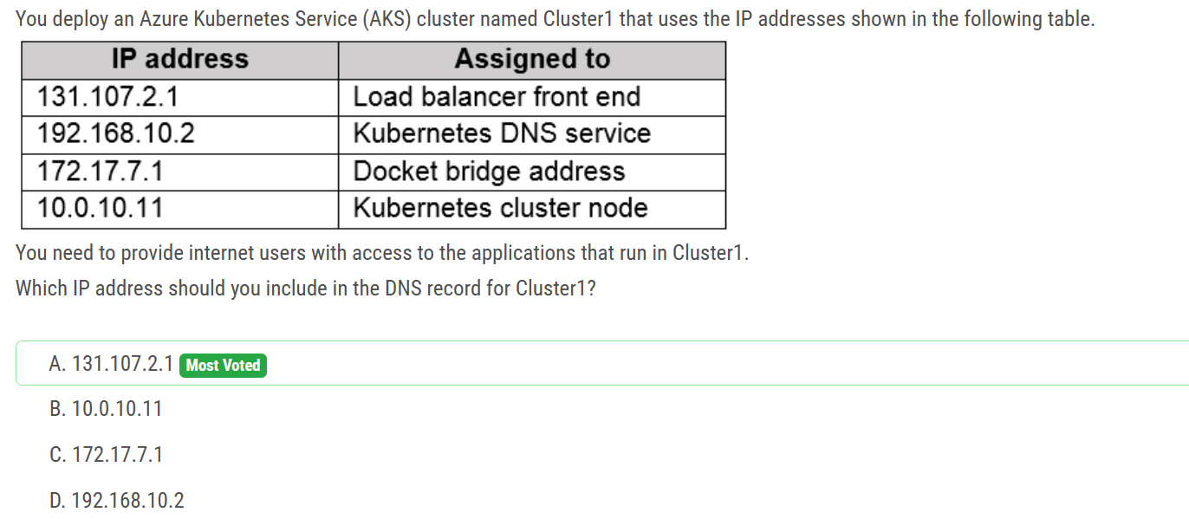

To be able to access applications on kubernetes , you need a application Load Balancer created by Azure which have public ip.

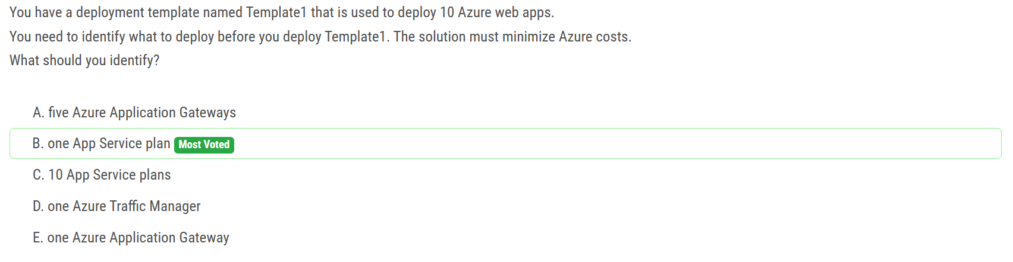

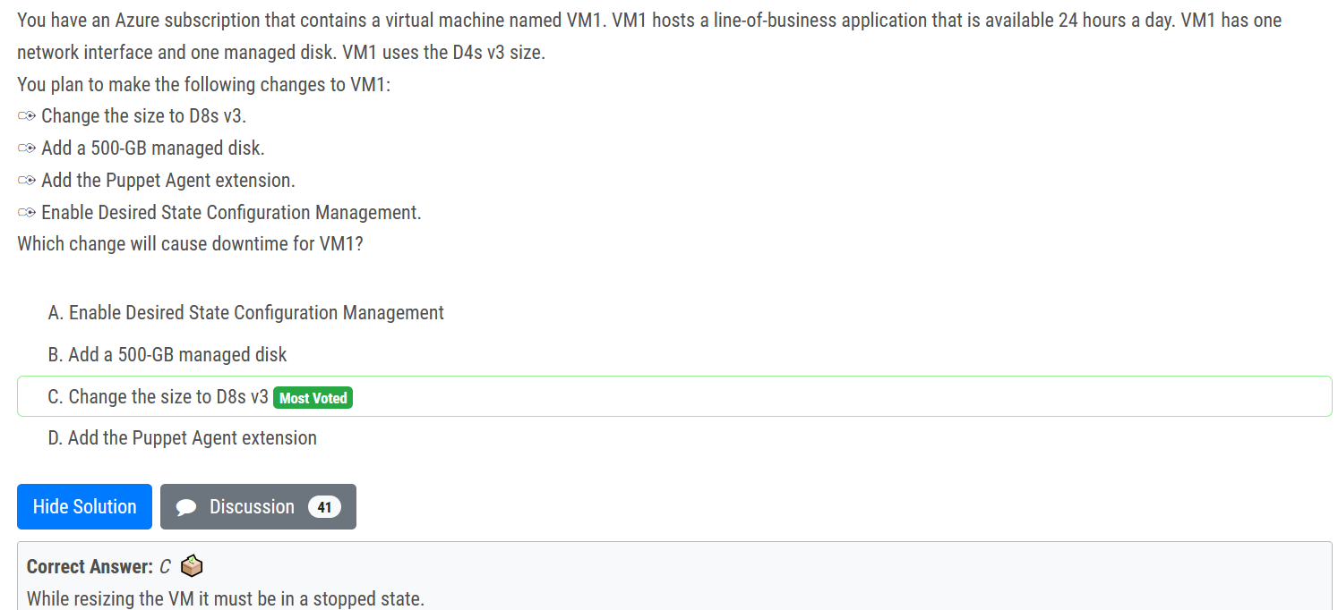

Nowadays you don't need to stop the vm prior to resizing, even if the vm is running, you may resize, but it will restart the vm causing downtime anyway. Also another advantage of stopping vm prior to resizing is that it gives more choices to choose from in the vm list.

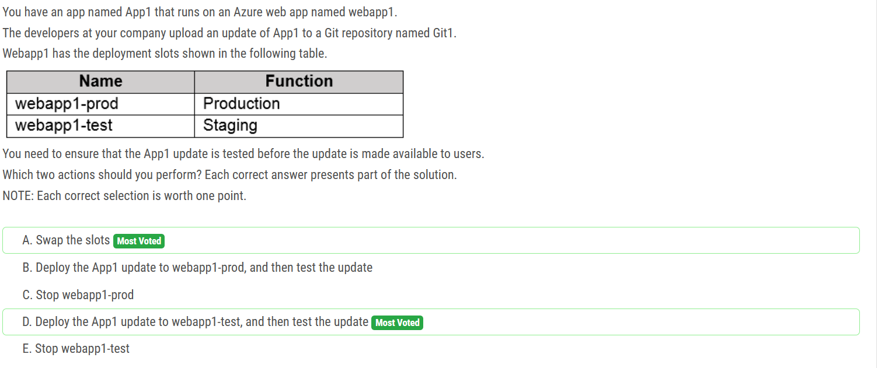

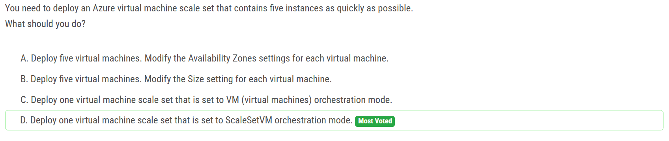

The oschestration mode have different names at the present: In flexible orchestration mode, you manually create and add a virtual machine of any configuration to the scale set. In uniform orchestration mode, you define a virtual machine model and Azure will generate identical instances based on that model.

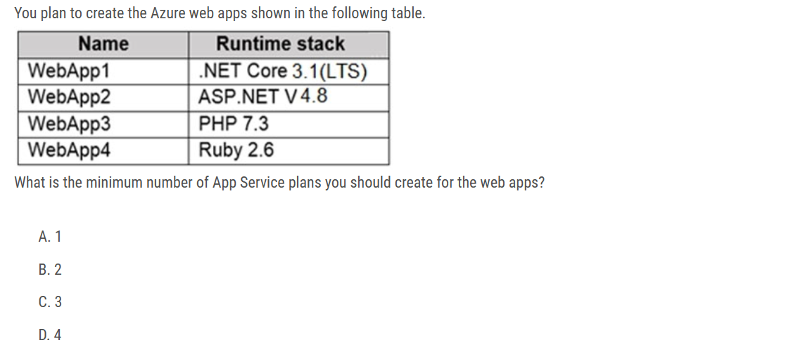

Correct Answer: B .NET Core 3.0: Windows and Linux ASP .NET V4.7: Windows only PHP 7.3: Windows and Linux Ruby 2.6: Linux only Also, you can’t use Windows and Linux Apps in the same App Service Plan, because when you create a new App Service plan you have to choose the OS type. You can't mix Windows and Linux apps in the same App Service plan. So, you need 2 ASPs.

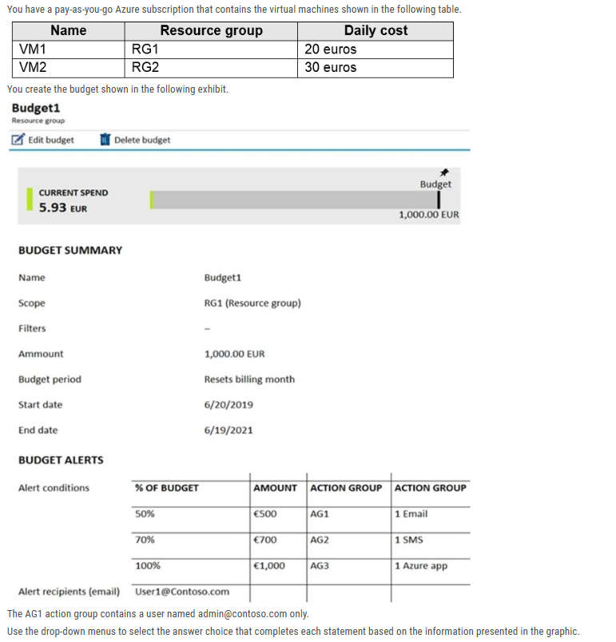

Box 1: VM1 and VM2 continue to run The Budget’s scope is RG1, so only VM1 will be handled. When the budget thresholds you've created are exceeded, only notifications are triggered. To stop resources, you need to setup additional things, none of which are mentioned in the question.

Box 2: one email notification will be sent each month. Budget alerts have scope in Resource Group RG1, which includes VM1, but not VM2. VM1 consumes 20 Euro/day, so 20 euros * 30 days = 600 euros. The 50%, 500 Euro limit, will be reached in 25 days (25*20 = 500), so an email will be sent. The 70% and 100% alert conditions will not be reached within a month, and they don't trigger email actions anyway, because AG1 action group contains a user.

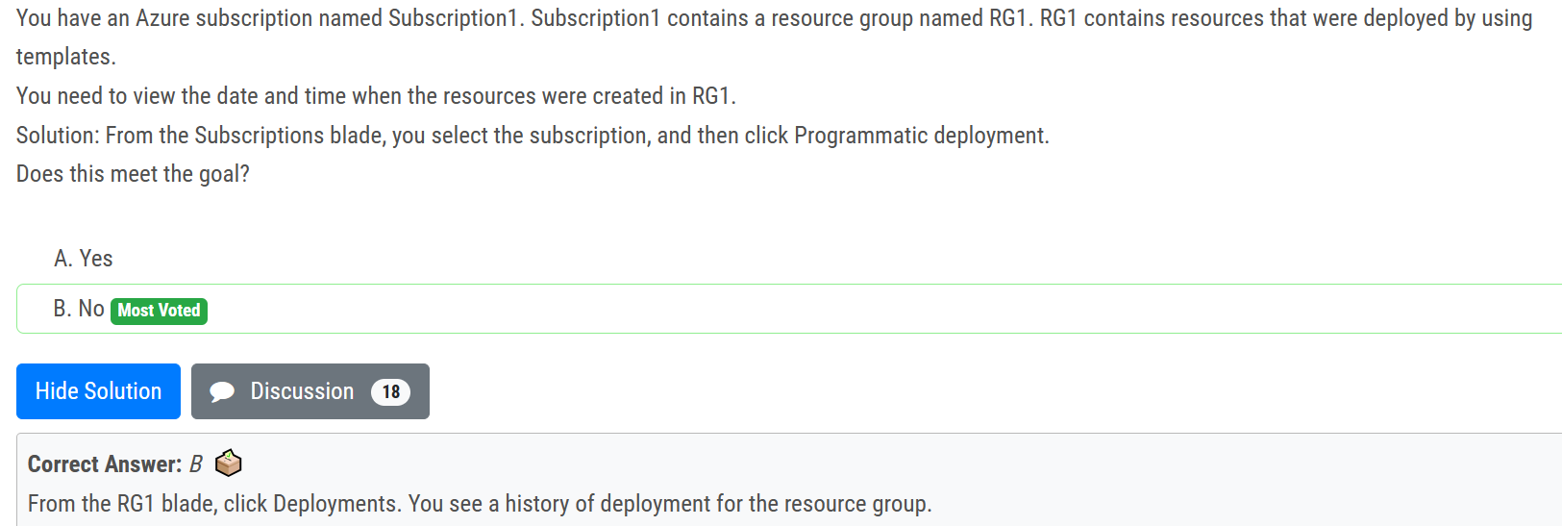

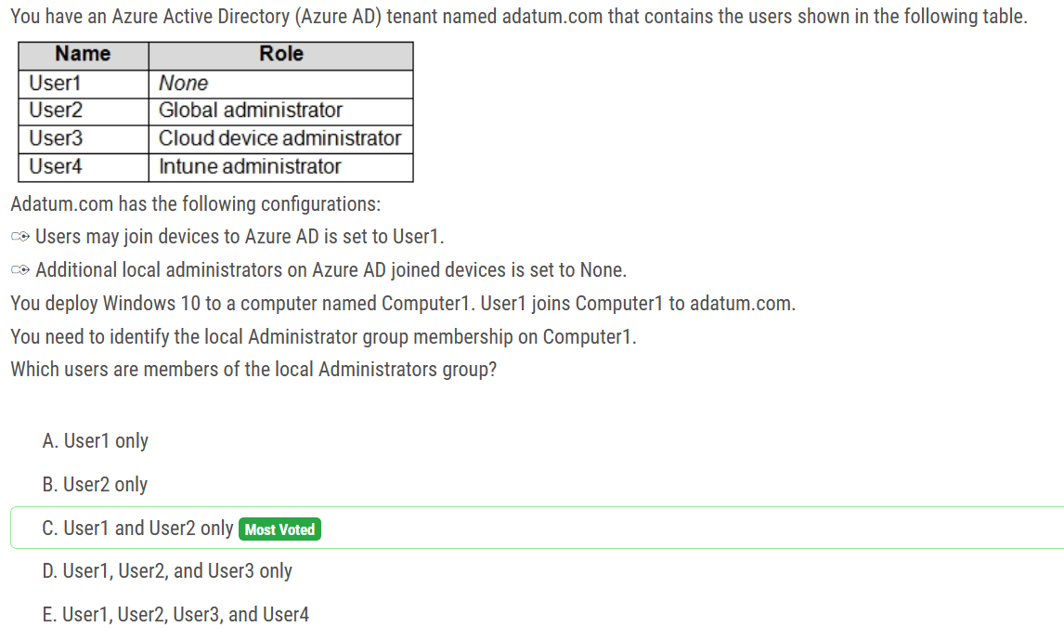

Answer is correct . User 1 and User 2 only. First the only user who can join Azure AD devices is User 1 . since User1 is admin on machine. So, the machine can be added. Second, the ones that can be local admins on Windows 10 are managed under "Additional local administrators" , since this is not mentioned, so we can assume default. By default, the ones are global administrator and device owners (device administrators)

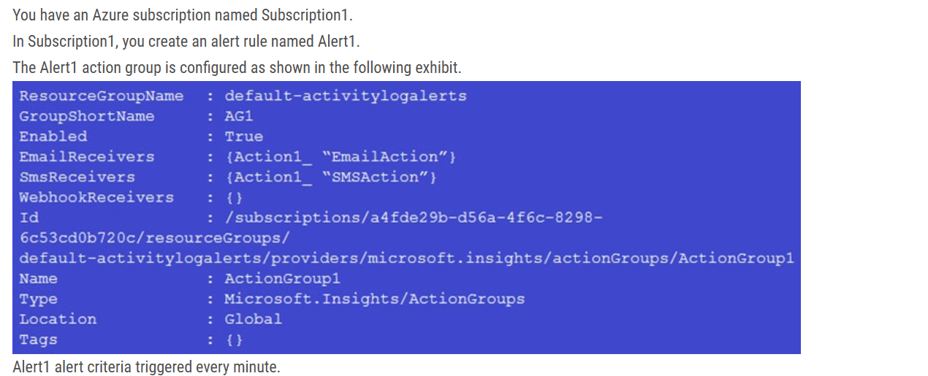

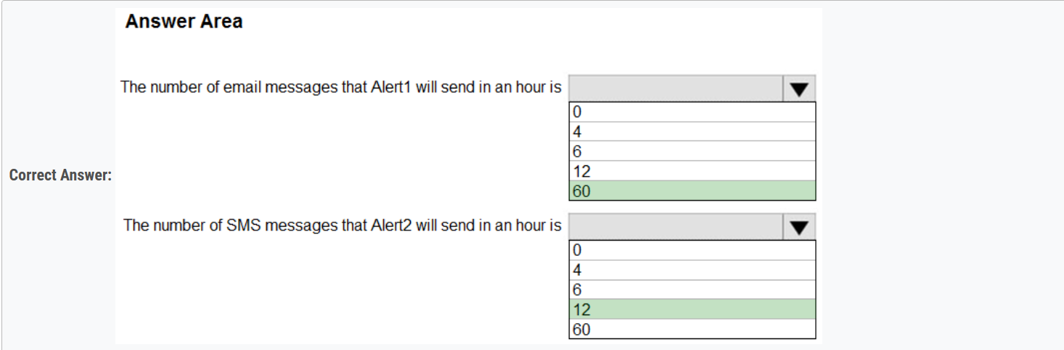

The rate limit thresholds are: ✑ SMS: No more than 1 SMS every 5 minutes.

✑ Voice: No more than 1 Voice call every 5 minutes.

✑ Email: No more than 100 emails in an hour.

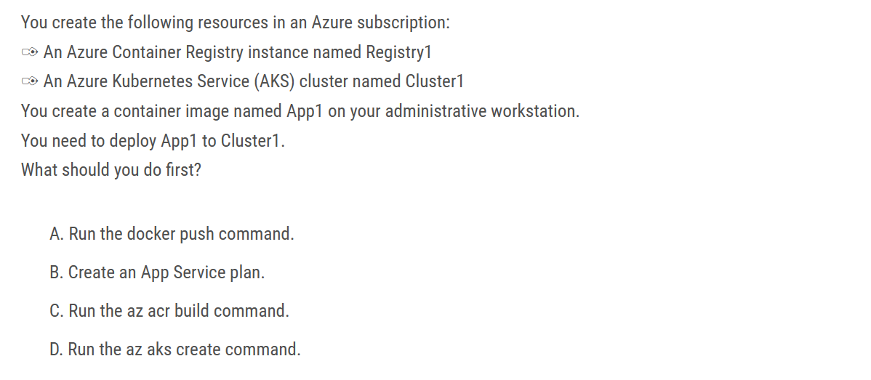

Ans : A

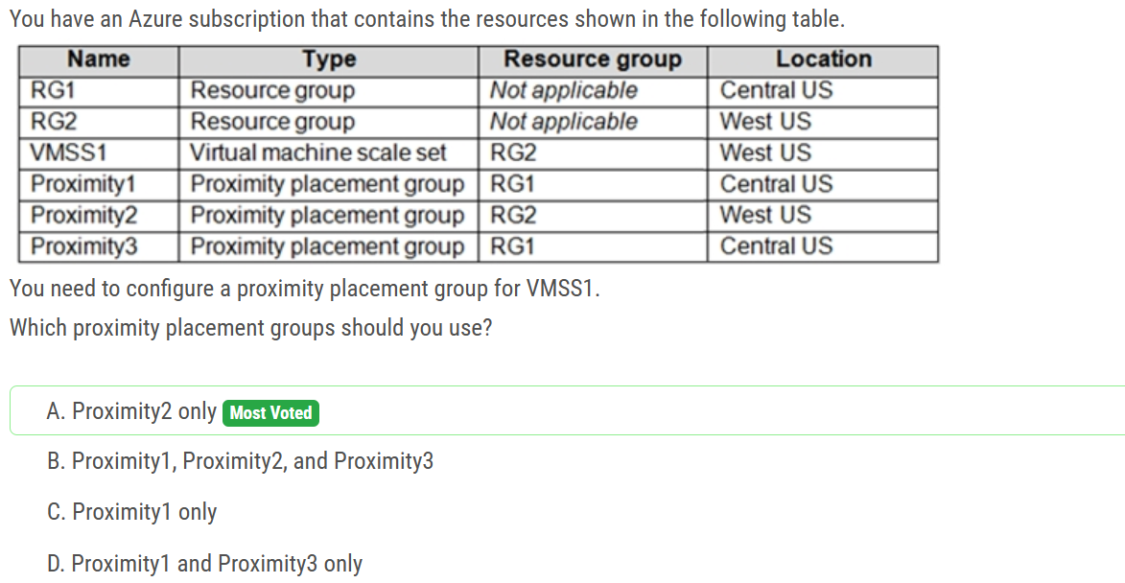

Basically the proximity group and the VMSS1 should be in the same region.